Connectors
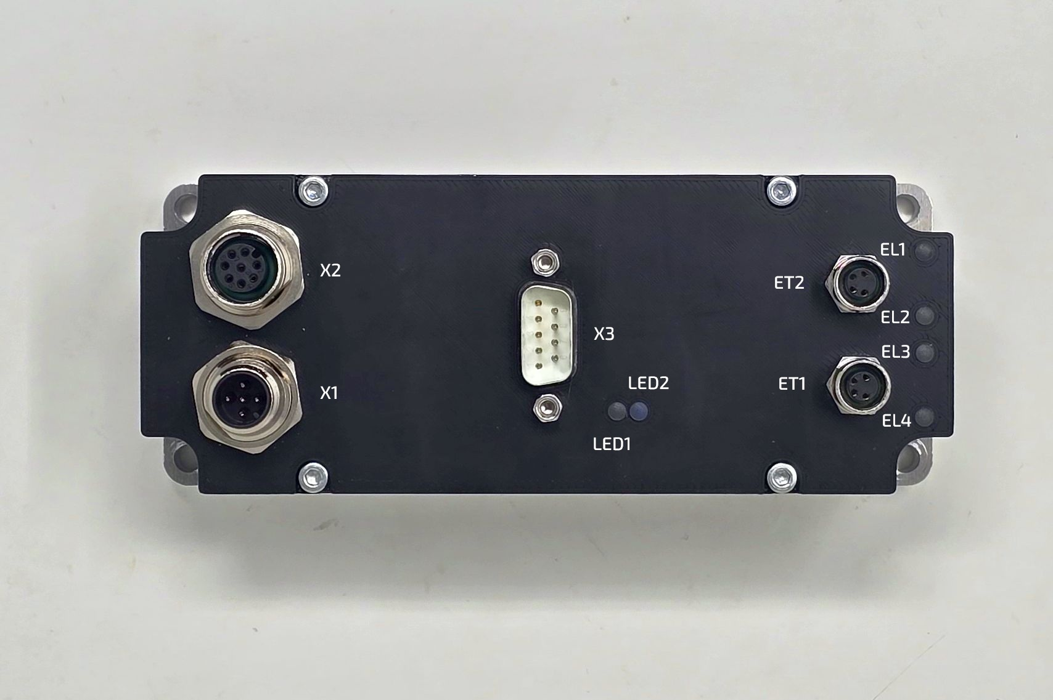epulse10_photo_azimut_1.jpg

LED Indicators
Indicators | Function | States | Color
LED1 | EtherCAT Slave status | EtherCAT Ready - Led Active  PreOP state - Led flashing  INIT state - Led off  SafeOP - Single flash | Green
LED2 | EtherCAT Slave error status | EtherCAT Configuration Error - Led Blinking  NO Error - Led off  Unsolicited State Change - Led single flash  Application Watchdog Timeout - Led Double flash  PDI Watchdog Timeout - Led Active | Red
EL1 | EtherCAT communication | Active - Connection to Ethercat | Orange
EL2 | EtherCAT communication | Blinking - Link port activity | Green
EL3 | EtherCAT communication | Active - Connection to Ethercat | Orange
EL4 | EtherCAT communication | Blinking - Link port activity | Green

Connectors

X1 connector - 24VDC Power (M12 4 poles male)
M12 Power cable female DA00022011 flying leads.
The power cable terminates with two wire: RED (+24VDC), BLACK (GROUND).
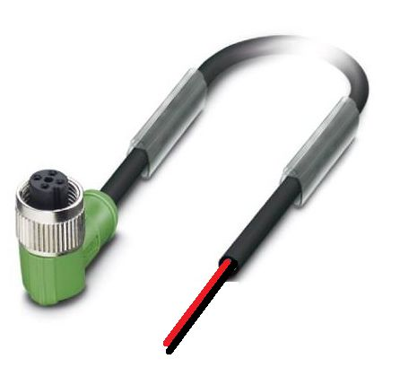da00022011_image.jpg

X2 connector - Signal and communication (M12 8 poles female)
Signal cable male DA00012011 with D-SUB 15 male
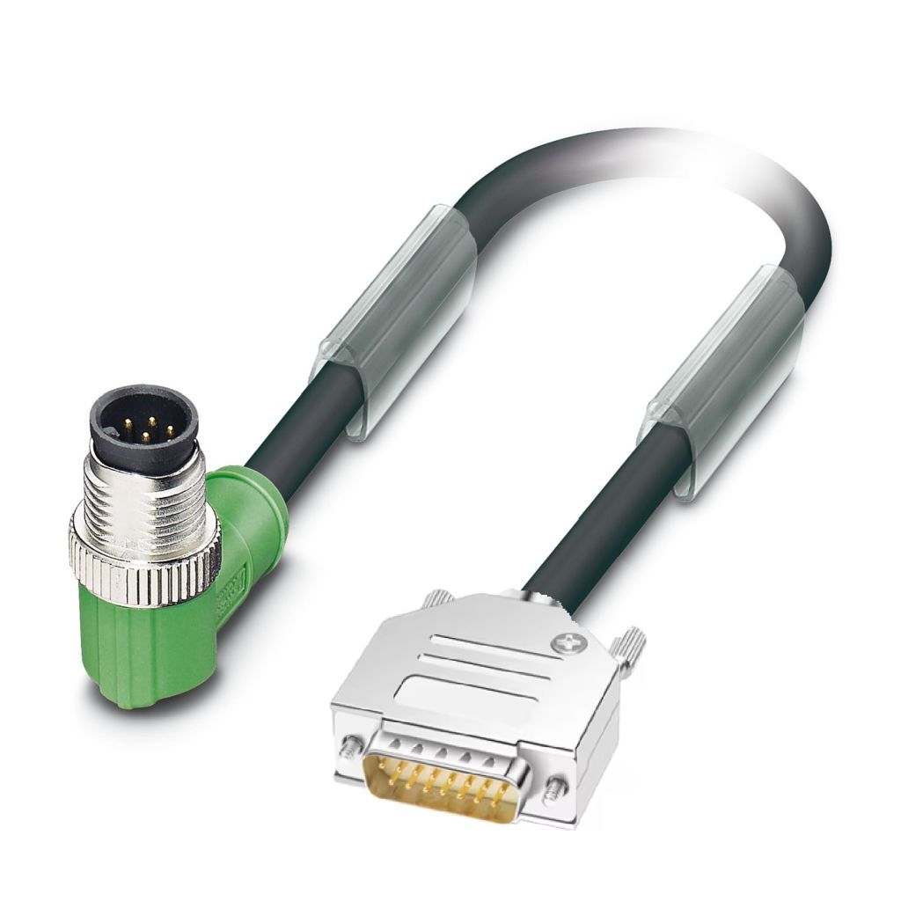da0012011_image.jpg
D-SUB 15  Pinout | SIGNAL | DESCRIPTION | FUNCTION
1 | RS485_B | Modbus B
2 | RS485_A | Modbus A
3 | GND | Ground
4 | NC | Not connected
5 | NC | Not connected
6 | GND | Ground
7 | GND | Ground
8 | DIG_IN_0 | Digital Input 0 (24V logic) | Enable/Homing
9 | DIG_IN_1 | Digital Input 1 (24V logic) | Motion trigger
10 | DIG_OUT_0 | Digital output 0 (24V logic, PNP) | Motor running
11 | DIG_OUT_1 | Digital output 1 (24V logic, PNP) | Motor fault
12 | DIG_OUT_2 | Digital output 2 (24V logic, PNP) | Programmable
The programmable output have the following options: In Position, Homing in progress, Overtemp fa

X3 Motor phases and Feedback connector
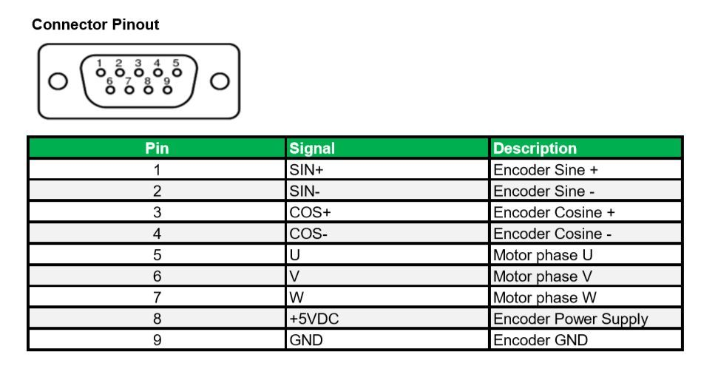pinout_miniature.jpg

ETH1 connector - EtherCAT IN (M8 4 poles female) DA0002911
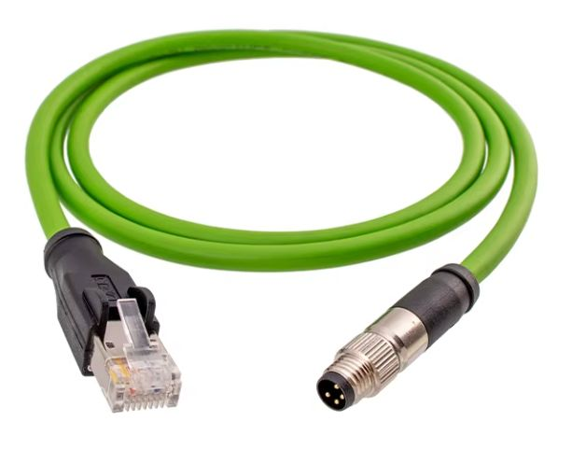da0002911_image.jpg

ETH2 connector - EtherCAT OUT (M8 4 poles female) - PATCH CABLE DA0003911
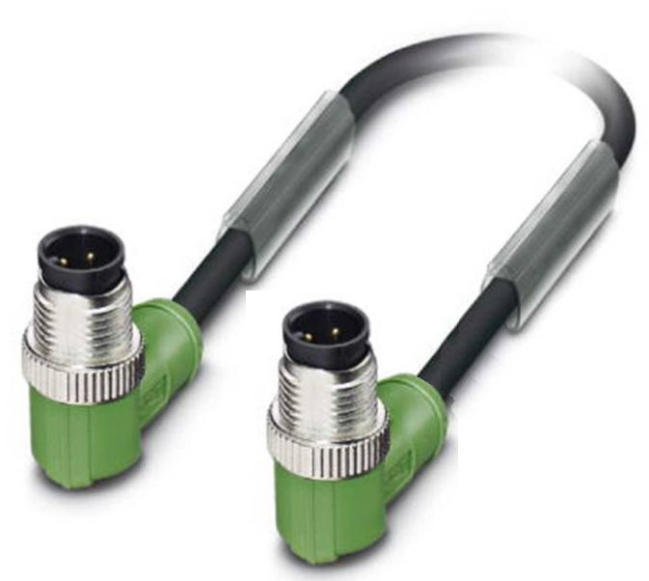da003911_image.jpg

