Error messages
All error messages disable the converter final stage (the motor has no torque). Type R alarms can be reset by the user, type B alarms are blockers. In the latter case, to reset the alarm, the converter must be switched off and on again (C2-16, CONTROL SUPPLY) to reset the alarm.
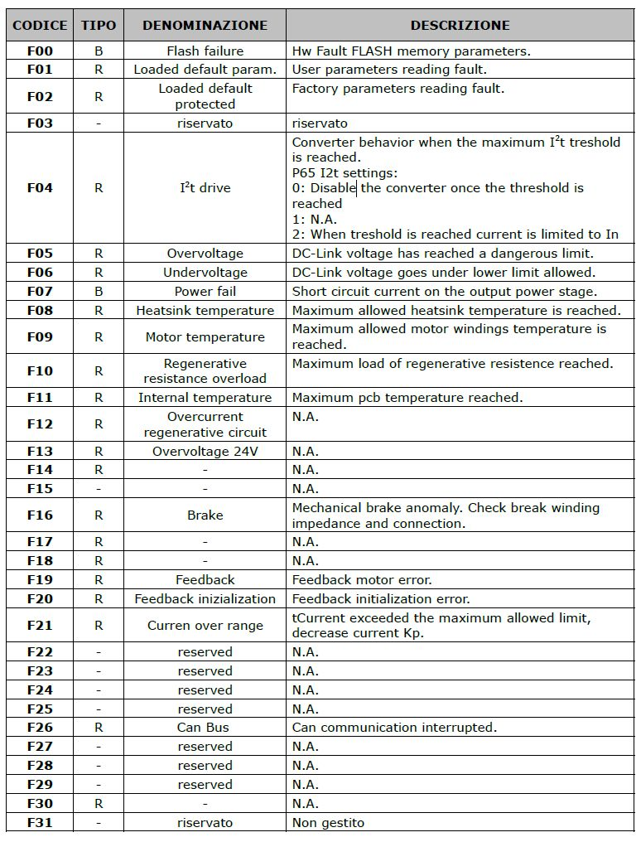error.jpg

