Inputs and outputs connection
In Epulse50 are available 2 programmable digital inputs, 2 analog inputs, CanOPEN for communication and an interlock safety input.
In order to use the CanOPEN termination, please make a connection (jumper) between pin 1 and pin 9.
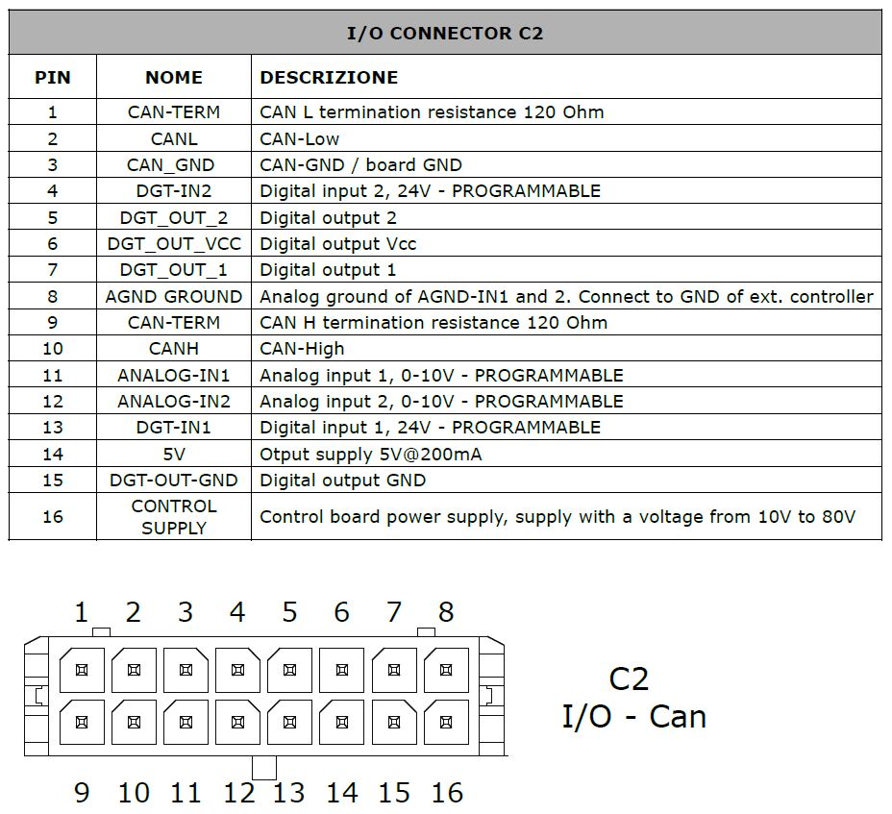io_con.jpg
Port | Ordering Code | Brand | Description
C2 | 43025-1600 | Molex | 16 poles male, for input/output/can (Receptacle Housing)

Outputs electrical charateristics
Paramter | Epulse30 | Epulse50 | Epulse 100 | Unit
Output type | open collector NPN | open collector NPN | open collector NPN | -
Output current | 0,5 | 2 | 2 | A
Pulse peak current | 1,0 | 4 | 4 | A
Control input current | 30mA @ 24VDC | 30mA @ 24VDC | 30mA@24VDC | -

Output signal schematics
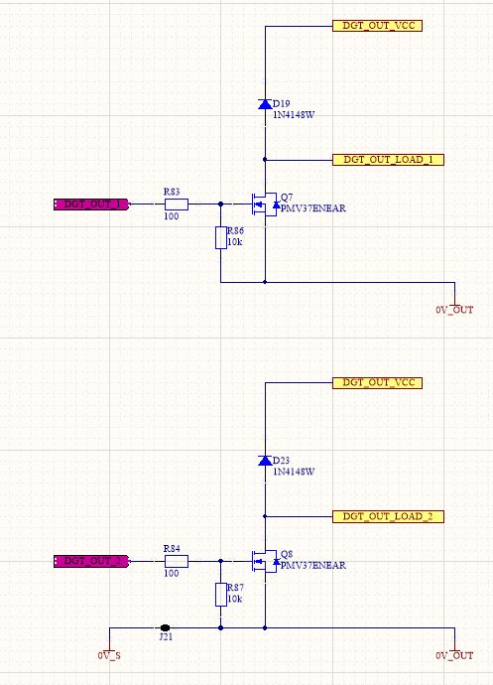output_circuit.jpg

