Epulse30 Mechanical Dimensions
3D Model (Step format): :epulse50_dc_servodrive:ftd30_20200618.zip
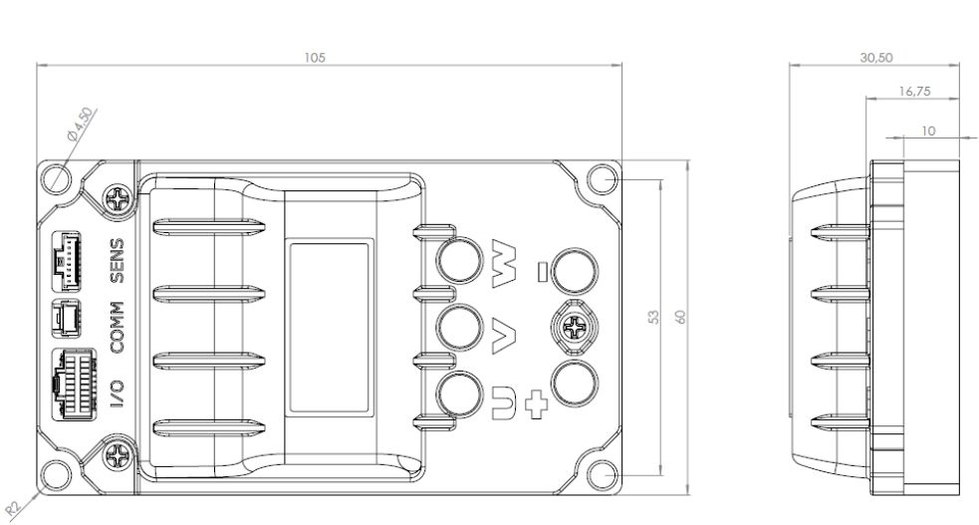epulse30_dim.jpg

