Serial communication
The communication connector consists in a 4 pin connector with a serial UART,
Note that you need a communication cable with USB to UART with 3.3V level.
this connector must be connected with a proprietary board that has the
following functions:
• grant a communication with a PC by USB
• gateway from drive to Wi-Fi
• upgrade drive firmware by pen drive

Serial communication connections
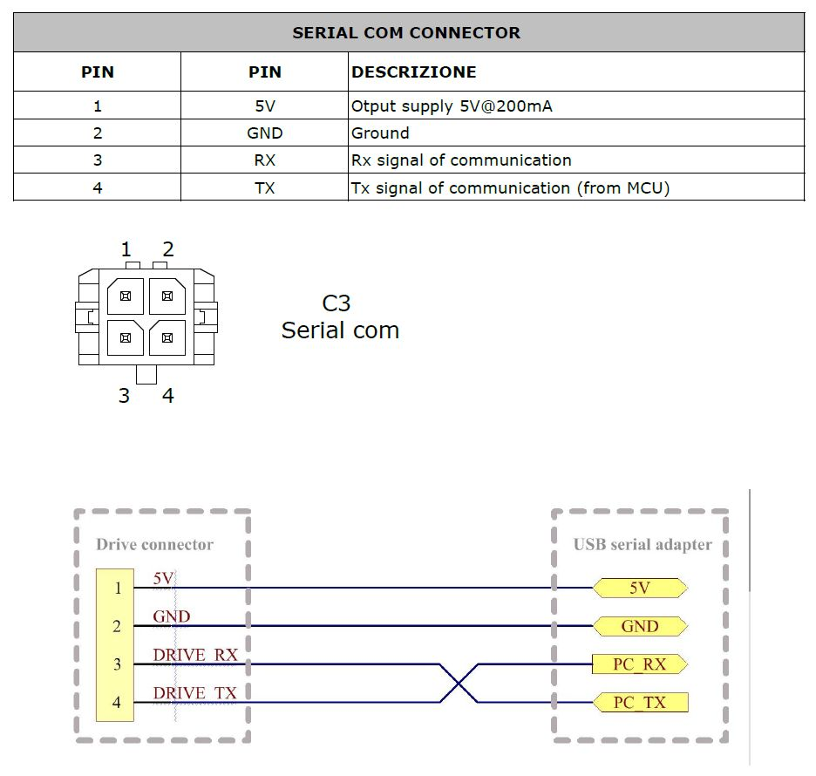serial_con.jpg
Port | Ordering Code | Brand | Description
C3 | 43025-0400 | Molex | 4 poles male, for serial communication (Receptacle Housing)
– | TTL-232R-3V3-WE | NiLAB | UART/TTL3V3 Converter.

