Force vs. speed curve
The characteristic force vs. speed curve below shows the limiting curve. The shapes of these characteristic curves are defined by the DC bus voltage and the relevant motor-specific data, e.g. inductance, resistance and the motor constants. Varying the DC bus voltage (using different drives, power supplies or supply voltages) and/or using different motor windings will result in different characteristic curves.
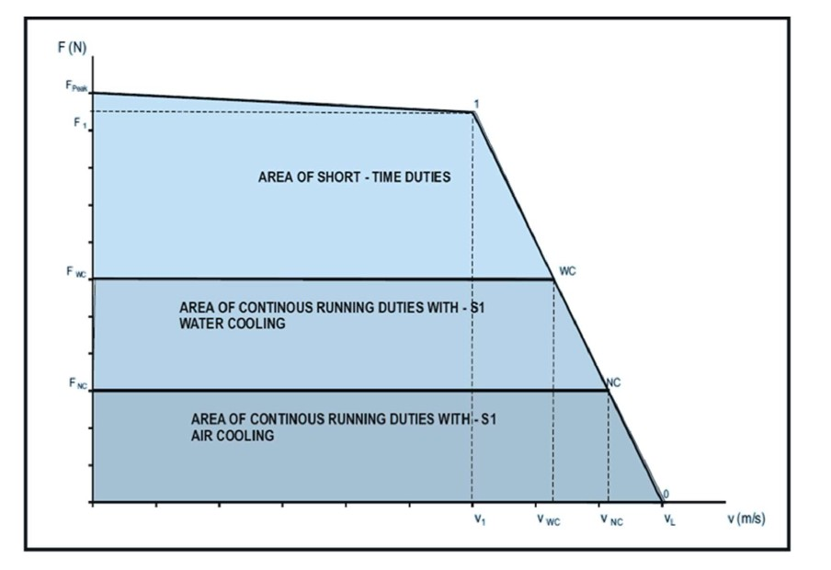force_speed_curve.jpg
When the velocity rises, the available DC bus voltage is reduced by the Back EMF of the motor. This leads to a reduction of the maximum feed force at higher velocities. The characteristic curves are specified up to the continuous nominal force. The velocity that belongs to the continuous nominal force is known as nominal velocity, vNC.
Note: If the connection voltages or mains voltages are different, the specified characteristic curves can be converted linearly according to the existing voltages. Where power supply motors with unregulated DC bus voltage are concerned, voltage drops – from simultaneous acceleration of several axes, for example - must be taken into consideration.

