GDi ISO Integrated linear motor
The GDI-i motor series consists of a tubular linear motor and an integrated drive. Due to this concept the controller is eliminated from the electrical cabinet which reduces installation time and effort. Furthermore, several devices can be connected in a daisy chain, implementing the concept of modular machines.
The GDI-i motors are tubular linear motors with a high precision encoder and a servo drive. This motor range can produce a peak force of 1700N and a peak speed of 5m/s.
The RS485 configuration interface is available for commissioning the motor using NiLAB Starter PC software in combination with MODBUS RTU protocol.
This motor can be controlled with Digital I/O.
The GDI-i motors series with integrated drive guarantees the protection class IP65 to prevent dust and water spray contamination.
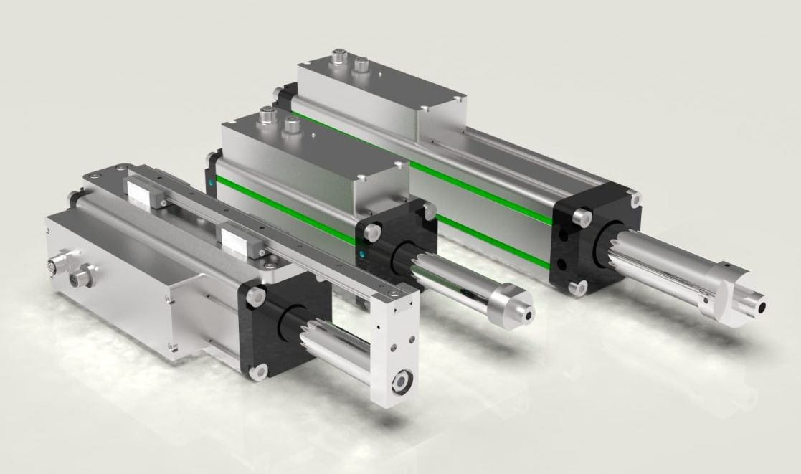gdi_integrated_family.jpg
Please use all the information relalted to the NLi family as reference for this family of motors.

