Encoder type
GDM linear unit can be equipped with different types of linear encoders: Incremental, Digital and Absolute Hiperface

Incremental magnetic SIN/COS 1Vpp (Default)
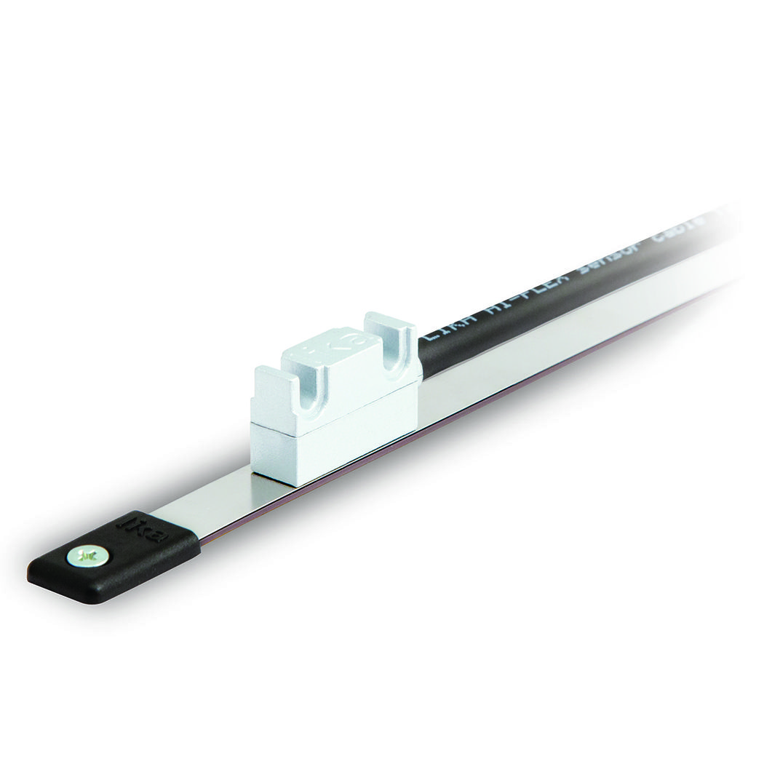smsr-1.jpg

Performance
Parameter | Value
Repeatability | +/- 1 increment (with 12 Bit ⇒ +/-1 microns)
Accuracy | max 1% of period length (with MT10 ⇒ +/- 10 microns)
Power consumption | 25mA typ, 50mA max

Pinout
Function | Cable wire colors
0 VDC | Black
+5VDC +/-5% | Red
SIN+ | Yellow
SIN- | Blue
COS+ | Green
COS- | Orange
Shielding | Shield

