GDM Tubular Linear Stage
The Green Drive tubular linear motor can also be used in the module version GDM with carriage (also with multi-carriage configuration) in movement. The Green Drive GDM has an integrated linear guide system and an integrated magnet type encoder. This assembly is useful in applications where the payload is out of axis or in multi-axis systems. On request, there is also the version with bellows available.
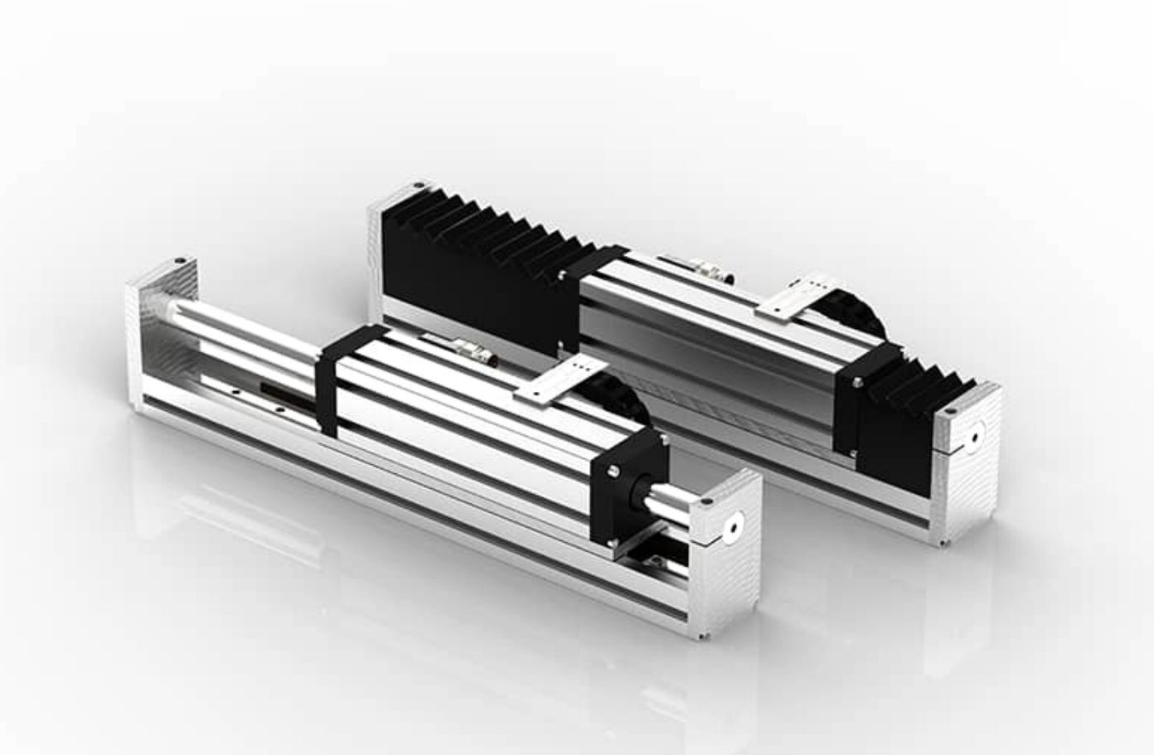gdm_photo.jpg

