Cable configuration
The green drive tubular linear motors are provided with signal and power cable ready to be connected to different servo drives.
Two set of connectors are used M23 (power) and M17 (signal) speedtec and M15 (ytec) for smaller motors.
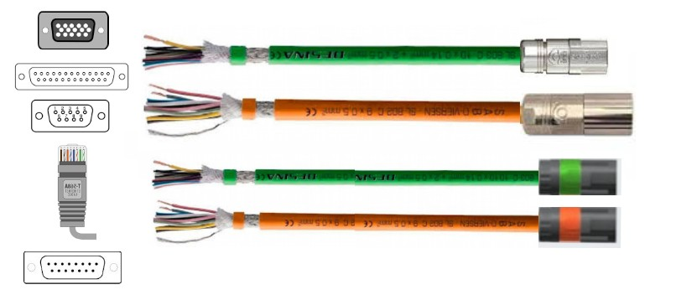cables.jpg

Signal cable
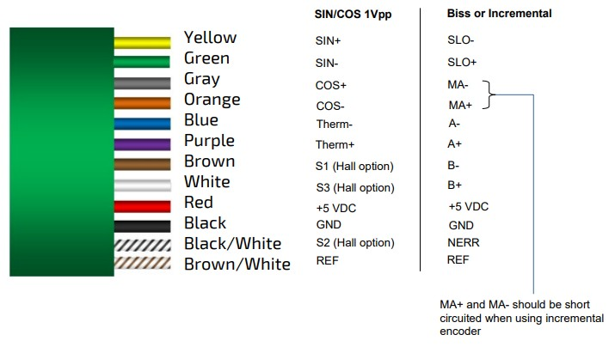signal_cable.jpg

Hall signal for commutation option
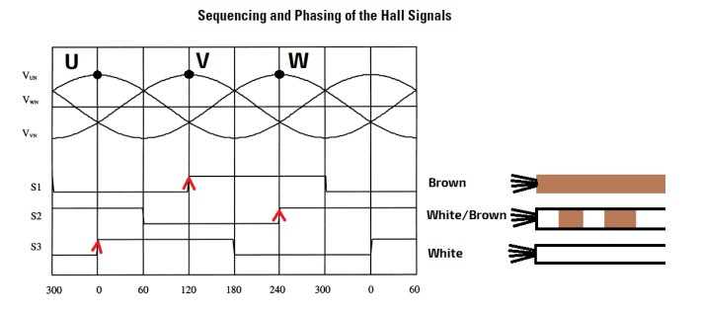hall_signal_option.jpg

Power cable
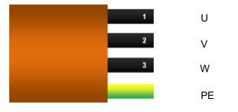power_cable.jpg

