Integrated Encoder

SIN/COS 1Vpp (Default)
The green drive tubular linear motor is equipped with integrated SIN/COS 1Vpp encoder. The signal output is differential type with a refernce of 2.5V. The signal period corresponds to 1 electrical cycle of the motor (60mm).
Here below the 4 outputs lines : SIN+, SIN-, COS+, COS- that represent the output of the encoder system.
The integrated encoder must be powered by +5VDC +/-10%.
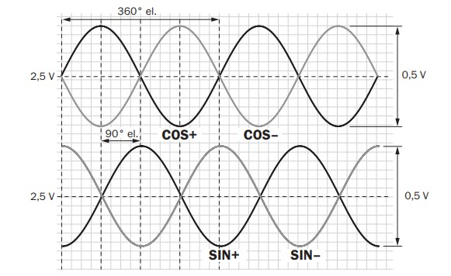sin_cos_1vpp.jpg

Digital AB TTL 5V + BiSS C interface
the green drive tubular linear motor can be equipped with integrated digital interpolator. Using this electronics, the output signal is programmable up to 8192 increments per pole pitch (60mm), providing a maximum resolution of 7.3 microns.

The signal output is differential type A+/A- and B+, B- TTL 5V. BiSS-C interface is used to program the resolution, the filter function and to provide the position information also in digital way.
The BiSS-C interface output is single turn absolute (single turn corresponds to a pole pitch of 60mm). This encoder type is used in combination with the servo drive that uses digital encoder feedback instead of analog SIN/COS type.
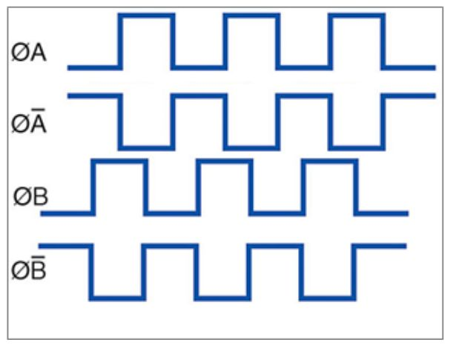incremental.jpg

