How to mount the stator

GDI250..
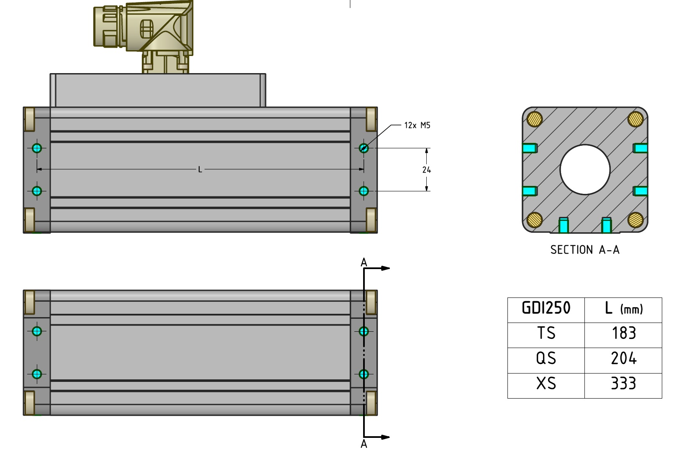gdi250_fixing.jpg

GDI350..
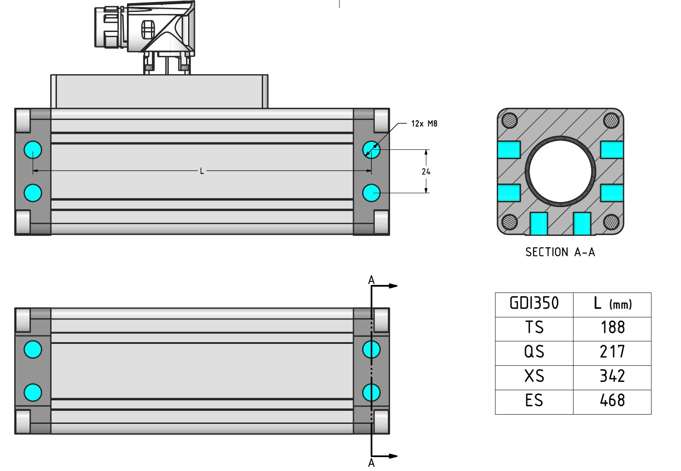gdi350_fixing.jpg

