Thermal Sensor
The Green Drive ISO tubular linear motor uses PTC600 as standard thermal sensor.
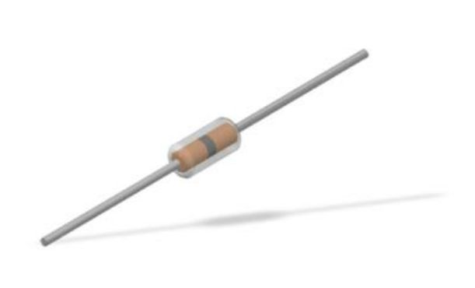ptc600_image.jpg
Here the characteristics resistance value vs temperature detected.
Standard value for waring threshold is 1kohm and for alarm threshold 1.1kohm.
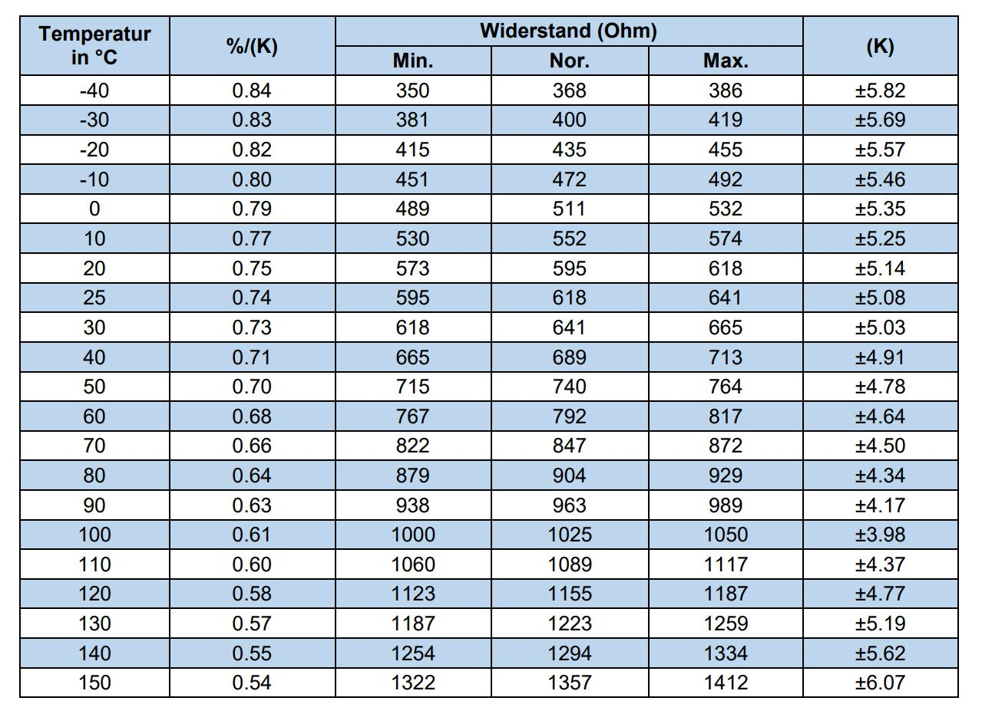ptc600_table.jpg

