B&R Servo Drive

Linear motor side
Plug-in modules: https://www.nilab.at/dokuwiki/doku.php?id=green_drive_iso:b_r_drive|

Rotary motor side

ACOPOS Multi
Plug-in module: 8BAC0122.000-1
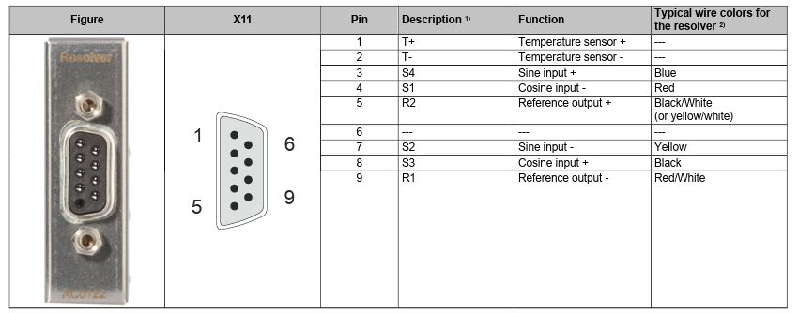acopos_multi_resolver.jpg

ACOPOS Standard
Plug-in module: 8AC122.60-3
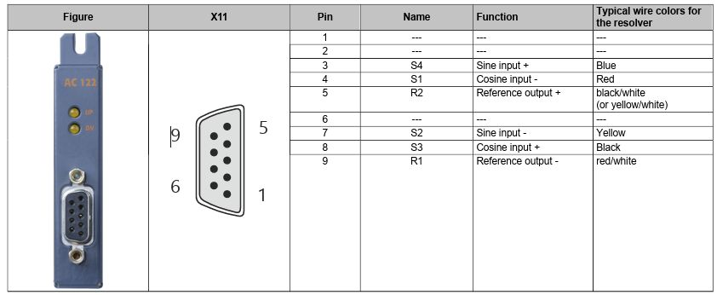acopos_resolver.jpg

ACOPOS P3
Plug-in module: 8EAC0122.001-1


