Connectors and Pinout

Linear motor side

Stator side with Speedtec M23 and M17
PIN | FUNCTION | CONNECTOR VIEW FRONT | PIN | FUNCTION
12 | SIN+/SLO+ | 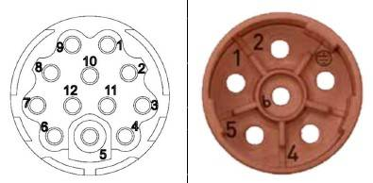m23_m17_connector.jpg | 1 | U
11 | SIN-/SLO- |  | 2 | V
10 | COS+/MA- |  | Earth | PE
9 | COS-/MA+ |  | 4 | -
8 | PTC-/A- |  | 5 | -
7 | PTC+/A+ |  | 6 | W
6 | +5VDC
5 | GND
4 | -
3 | -/B-
2 | -/B+
1
Connectors: Intercontec Speedtec AEDC047NN0000051A000 (M17) + BEDC106NN00000201000 (M23)

Rotary motor side
Encoder type: Resolver 2p 7V 10KHz
Function | Pin
Ref+ | 10
Ref- | 7
Cos+ | 2
Cos- | 1
Sin+ | 11
Sin- | 12
PTC+ Sensor | 8
PTC- Sensor | 9

M23 type connectors
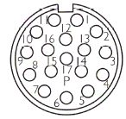m23_1.jpg | 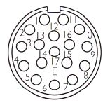m23_2.jpg | 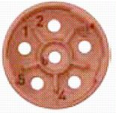m23_3.jpg | 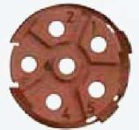m23_4.jpg
Fixed side  Feeedback E - external view | Flying side  Feedback P - external view | Fixed side  Motor phases - external view | Flying side  Motor phases - external view
 | ASTA 014 - 09010005 |  | BSTA 085 - 09020004
Function | Pin
U | 1
V | 2
W | 6
PE | Earth
- | 4
- | 5

