CB Test Certificate
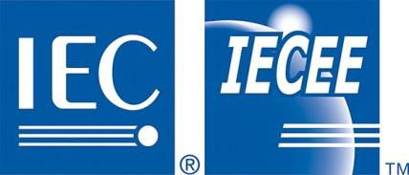iec_logo.jpg
The Green drive tubular linear motor are ceertified following IEC, IECEE IEC SYSTEM FOR MUTUAL RECOGNITION OF TEST CERTIFICATES FOR ELECTRICAL EQUIPMENT (IECEE) CB Scheme. Additional information here: https://www.iecee.org/who-we-are/cb-scheme
Conformity test related to IEC 61800-5-1:2007 + A1:2016 - Adjustable speed electrical power drive systems - Part 5-1: Safety requirements - Electrical, thermal and energy
Here you can download the certificate: :green_drive_motors:si-12320.pdf

