B&R Servo Drive

ACOPOS MULTI
Plug-in Module: ENDAT 8BAC0120.000-1
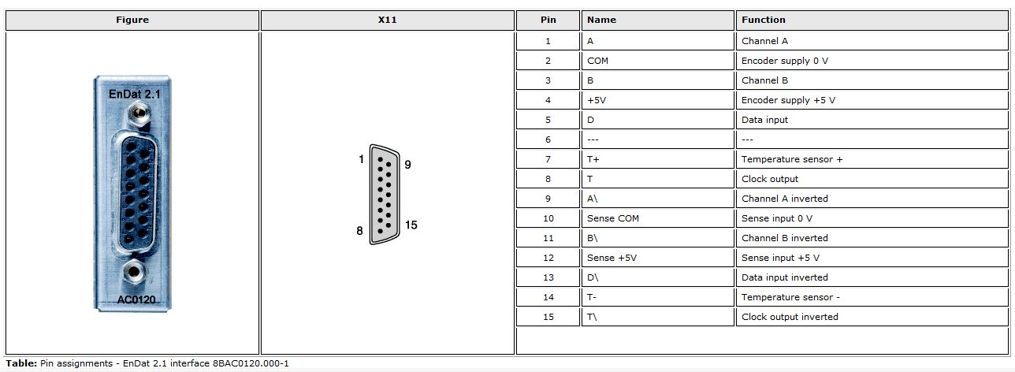acopos_multi_1.jpg
Plug-in Module: SIN/COS 8BAC0124.000-1
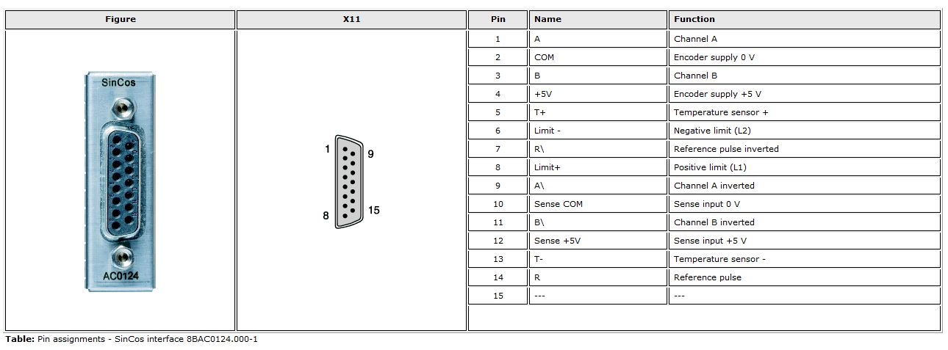acopos_multi_2.jpg

Acopos
Plug-in Module:8AC120.60-1
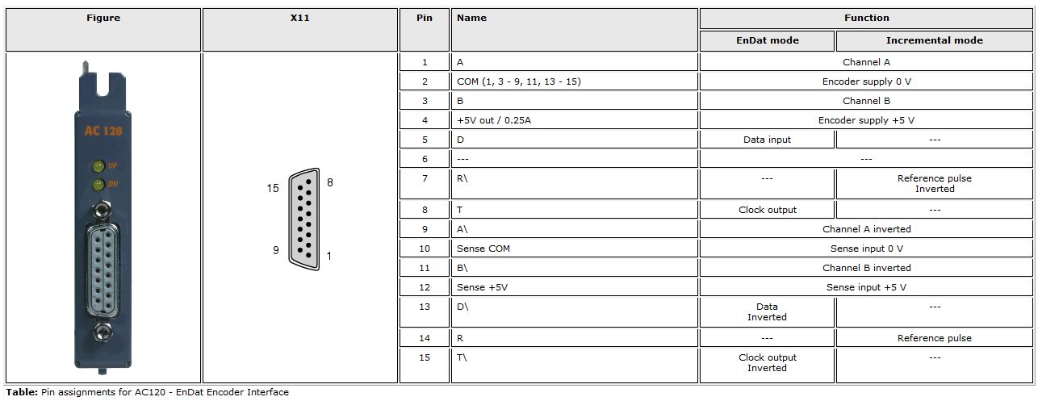acopos_standard.jpg

Acopos P3
Plug-in Module: 8EAC0152.001-1
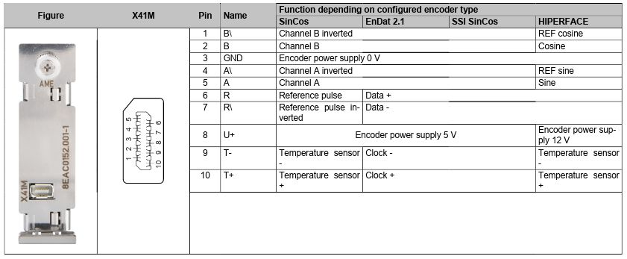acopos_p3.jpg

Parametrization example
Motor : GD250XS
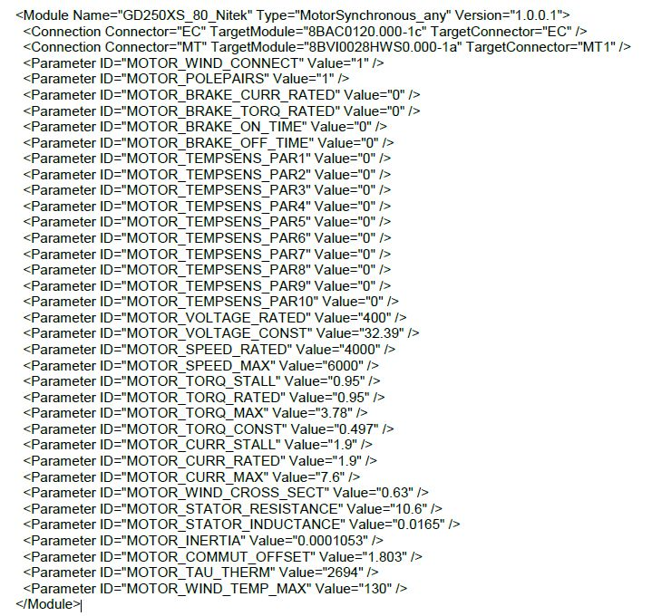gd250xs_param.jpg

Encoder configuration
Incremental encoder (ncINC) with ParID 109 = 16384 (Intrpolation factor)

Motor phases
V and W phase inverted.

