Green Drive in Parallel drive
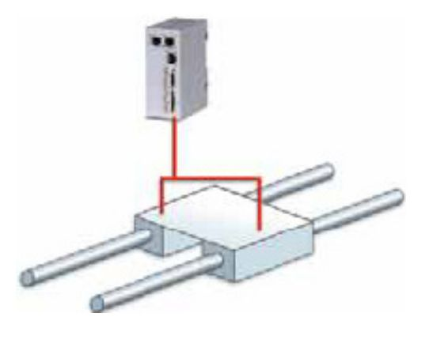par.jpg
With the Green Drive Motor, you have the ability to drive two motors in parallel using only one encoder and one amplifier. All other systems require two drives, two controllers and two encoders, connected together. The major issue with all parallel drive systems (e.g., gantries) is orthogonal alignment (the ability to keep the parallel axis square). In mechanical driven systems (screw driven, rack and pinion, belt, and chain drive, to name a few) the main issue that arises is binding of the system due to misalignment or stacked up tolerances of the mechanical system. In direct drive systems there is an added issue of sine error that is introduced due to installation errors and variances in the linear motors themselves. To overcome these issues, the common practice is to drive and control each side of the parallel system and electronically sync them. First, the cost of such a system is higher since it requires twice the electronics (drivers and feedback, etc.) when compared to a single-axis system. This type of tracking control system can also add synchronization and tracking errors, which adversely affects the performance of the system.

Sine Error
Sine error is the force differences that are produced due to misalignment of a motor's coils or magnetic tracks.
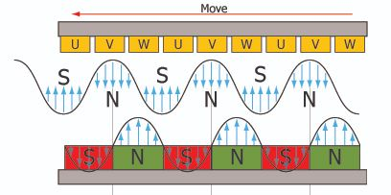field.jpg
In linear motors, current is applied to the coil to form an electromagnet. The coil then synchronizes itself to the magnet field generated by the permanent magnets in the magnet track. Force is generated due to the relative strength of these magnetic fields and the angle of their intentional misalignment. In a parallel drive system, when the magnetic fields to all the coils are perfectly aligned and all the magnetic fields in all the magnetic tracks are perfectly aligned, they become – in effect – a single motor without any differences of force generation. However, any misalignment of the coils or magnetic tracks will cause the angle of misalignment of the magnetic fields in the motors to differ from one another, producing different forces in each motor. This force can, in turn, cause binding in the system.
Sine error can be calculated by the following formula:
where Fdif is Force difference between the two coils, Fgen is the force generated, Dfid is length of misaligment and MPn-n is the pole pitch (N-N). Most linear motors are designed with a north-to-north magnetic pitch in the range of 25 to 60mm long under the guise of trying to reduce IR losses and the electrical time constant. So, for example, a misalignment of just 1mm in a linear motor with a 30mm N-N pitch will cause a loss of about 21 percent of its power. On the other hand, the Linear Shaft Motor uses a much longer north-to-north magnetic pitch in order to reduce the effect of sine error due to accidental misalignment. Therefore, the same misalignment of 1mm in a Linear Shaft Motor with a 90mm N-N pitch will only result in a 7 percent loss of power.
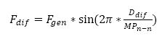formula.jpg

How to mount the motor to avoid sine error
The forcers and shafts in a parallel drive system must be physically coupled with a mechanism that, when applied, allows the moving axis to realize one-degree-of-freedom movement.
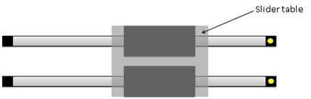parallel_1.jpg
Both forcers must be oriented in the same direction on their shafts. It is suggested that the end of the forcer that has the serial number be pointing toward the end of the shaft that is marked with yellow paint. If the orientation of the coils is different, it is possible to have a totally inoperable or a runaway system, or it will cause significant loss of thrust. The standard for parallel drive system is mirrored cable exit locations. See drawing below.
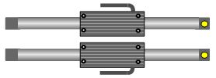parallel_3.jpg

How to found the orientation of the shaft without marking
Using a screwdrive check the positioning of the first magnet inside the slider. The screwdriver will be captured from the magnetic field of the magnets.
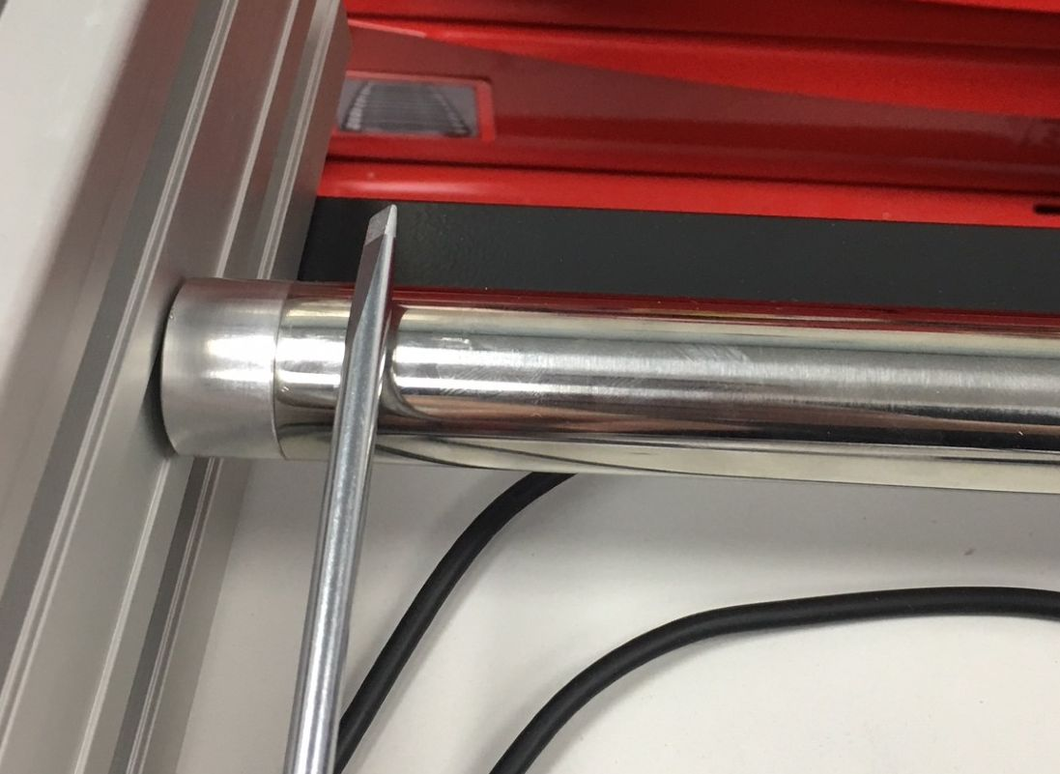orientation_1.jpg | 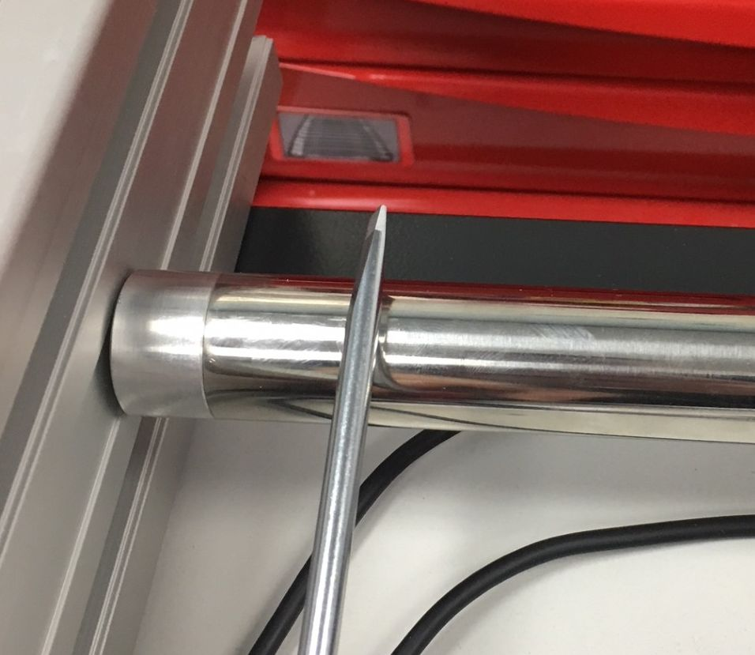orientation_2.jpg
Position when the magnets start. (close to the shaft end)  Yellow point is on this side | Position when the magnets ends.  (Away from the shaft end)

Deviation in mounting the motors
To minimize loss of thrust due to sine error, it is recommended that the mounting position difference between the Linear Shaft Motors [Δx= Δx1- Δx2] be less than the values shown on the table below.
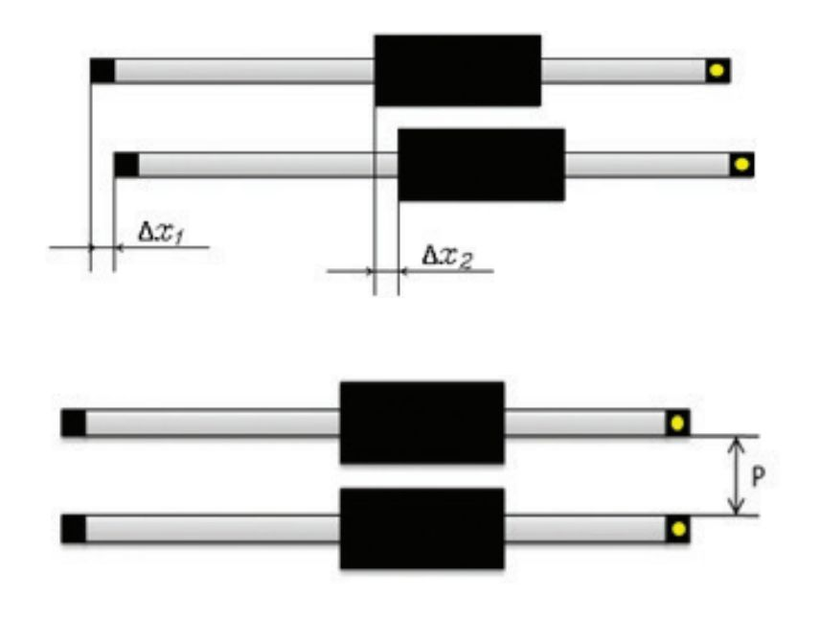misa.jpg
Model | Max Δx  Δx= Δx1- Δx2 [mm] | Minimal distance  P [mm]
GD160 | 0.83 | 60
GD250 | 1.25 | 90
GD350 | 1.67 | 120

