NiLAB EtherCAT Bus Interface
This Gateway device manufactured by NiLAB Gmbh is a device acting as EtherCAT slave for the connection of NLi series to the EtherCAT fieldbus.This device is intended for DIN-RAIL mounting. This BUS Converter is able to manage upto 10 NLi with CanOPEN interface with Profile position, 2 NLi with interpolated position and 10 NLi with MODBUS RTU interface.
ethercat_logo.jpg
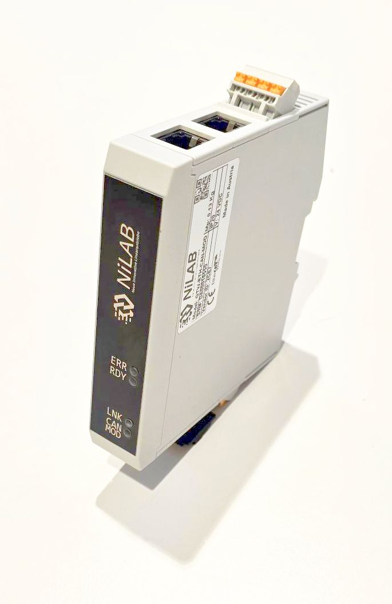gateway_photo.jpg
Two operative modes are programmable: EtherCAT to MODBUS RTU for the NLi without CanOPEN hardware and EtherCAT to CanOPEN. 3 inputs and 3 outputs as a remote EtherCAT I/O are always available.

EtherCAT to CanOPEN DS402 gateway
In this mode, NLi motor share the information using PDI and PDO mapping with EtherCAT fieldbus. The interpolated position point can be sent using EtherCAT PDOs to the CanOPEN PDOs. Control and Status word of the NLi motors are mapped in PDOs synchronized with EtherCAT. Motion is based on DS402 protocol: mode of operation 1 (profile positioning), 7 or 8 (intepolated positioning) are available.

EtherCAT to CanOPEN gateway
In this mode, NLi motor share the information using PDI and PDO mapping with EtherCAT fieldbus. The position table for motion task are mapped using SDO. Control and Status word of the NLi motors are mapped in PDOs synchronized with EtherCAT. Motion synchronization is possible using control word and I/Os.

EtherCAT to MODBUS RTU gateway
In this mode, NLi motor share information using only SDO. Motion synchronization is possible using I/O only.

Status Led
Name | Description
ERR  (RED) | EtherCAT Configuration Error - Led Blinking  NO Error - Led off  Unsolicited State Change - Led single flash  Application Watchdog Timeout - Led Double flash  PDI Watchdog Timeout - Led Active
RDY  (GREEN) | EtherCAT Ready - Led Active  PreOP state - Led flashing  INIT state - Led off  SafeOP - Single flash
LNK  (BLU) | Timer Link - Led Blinking
CAN/MOD  (GREEN) | CAN or MODBUS Communication Link activity - Led Blinking

