Use Cases

Synchronization using CanOPEN PDO (DS402 bridge)
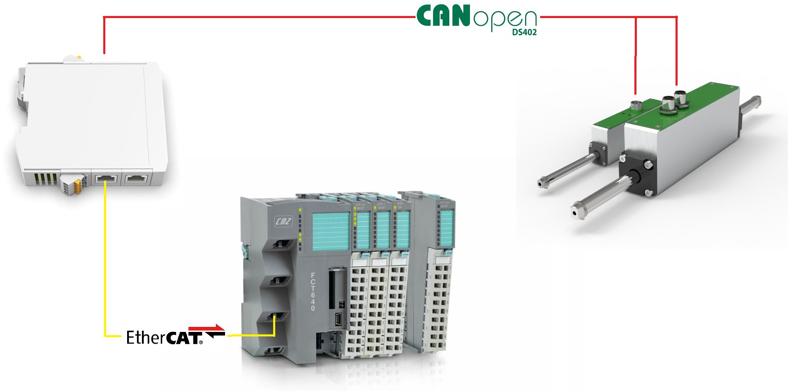scena_1.jpg
In this configuration the interpolated position point are sent throught the PDOs to the NLi motor. The change of the motion table parameters is made by using CanOPEN SDO.
Codesys example project: :gtw_ethercat:gtw_eth_2_axis_pdo_sync_402.zip

Gateway and PDO configuration
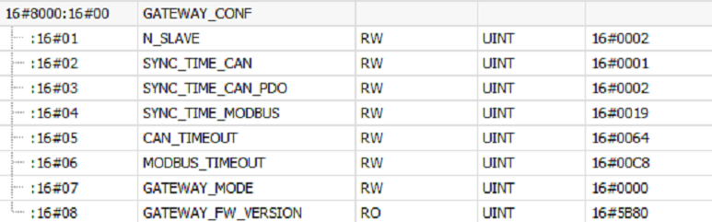
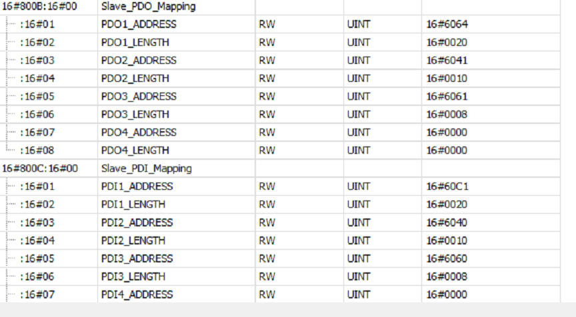

Synchronization using Remote I/O trigger and CanOPEN SDO
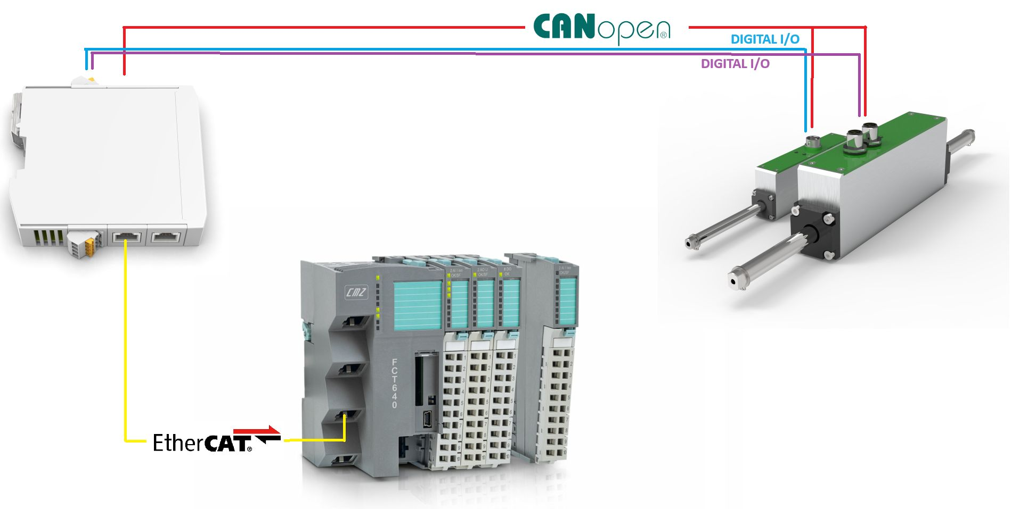scena_2.jpg
In this configuration the Bus Converter generates a synchronization signal (motion trigger) for NLi motor using remote output. The change of the motion table parameters is made by using CanOPEN SDO. CanOPEN PDOs can be used to read status word and current position at every EtherCAT sync time.
Codesys example project: :gtw_ethercat:gtw_eth_2_axis_pdo_io_sync.zip

Gateway and PDO configuration
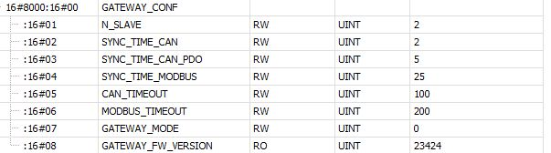use_case_conf_1.jpg
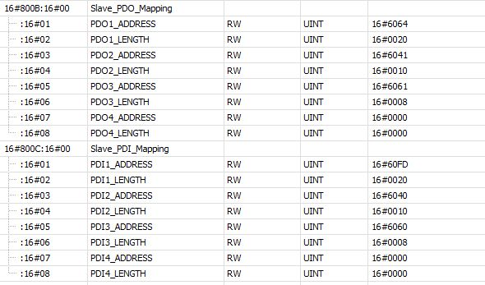use_case_conf_2.jpg

Synchronization using Synch signal and CanOPEN SDO
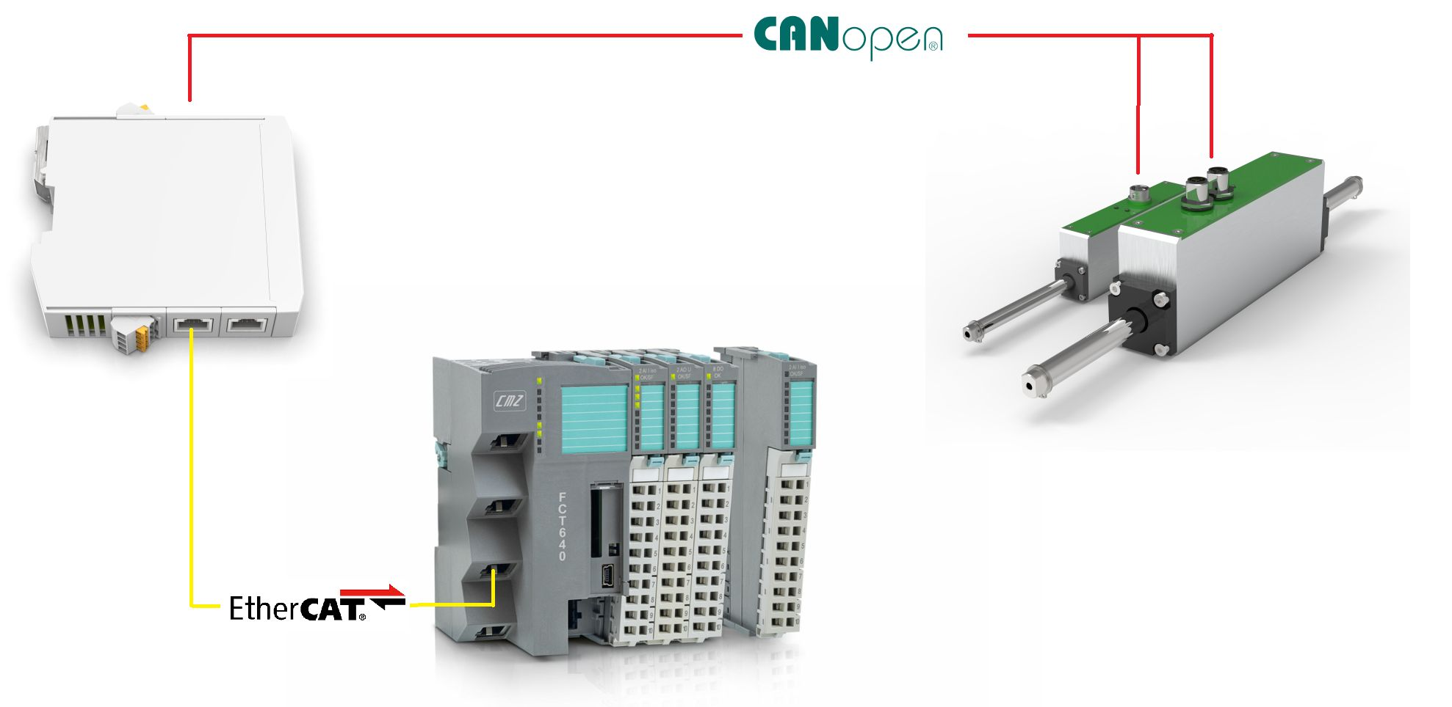scena_3.jpg
In this configuration the Bus Converter is sending a Synch signal to every NLi motors on the CanOpen fieldbus using PDO. The change of the motion table parameters is made by using CanOPEN SDO. CanOPEN PDOs can be used to read status word and current position at every EtherCAT sync time.
In this way, the Sync_value on the PDO (0x7002) can be used to send motion trigger synchronization signal using CAN communication instead of Remote I/O signal. The NLi motor must be configured to trigger this signal instead of Digital Input.
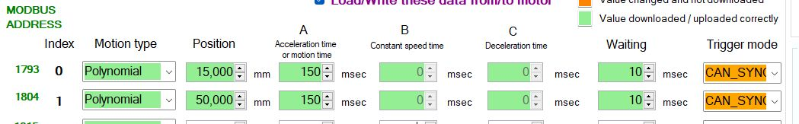sync_signal.jpg
Gateway configuration and PDO mapping remain the same as in the previous use case.

Synchronization using Remote I/O trigger and MODBUS RTU
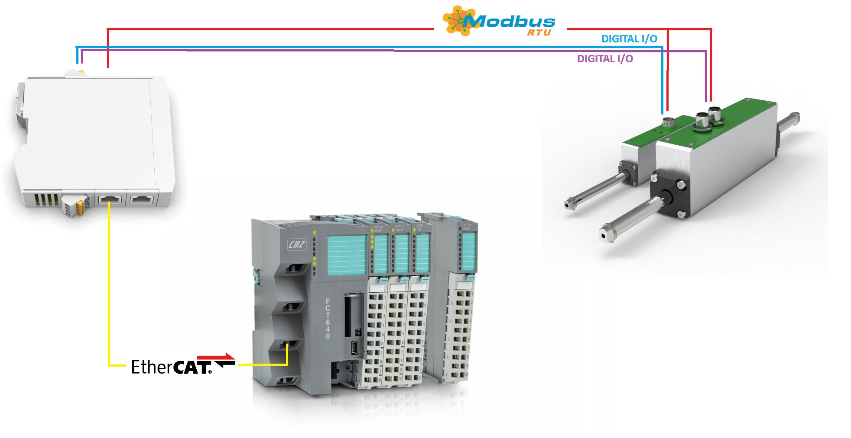
In this configuration the nBus Converter generates a snchronizatiobn signal (motion trigger) for NLi motor using remote output. The cahnge of the motion table parameters is made by using MODBUS RTU communication. Status and control word can be read and write using MODBUS RTU communication. Current position can be read using MODBUS RTU.
Codesys example project using FCT640 PLC : :gtw_ethercat:gtw_eth_slave_modbus.zip

Gateway configuration
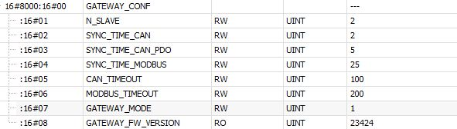use_case_conf_4.jpg

