Accessories

Linear guide antirotational mechanics
The NLi can be equipped with linear guides and ball bushings to create anti-rotation mechanics for horizontal applications. The front flange is available with different holes for fixing the payload.
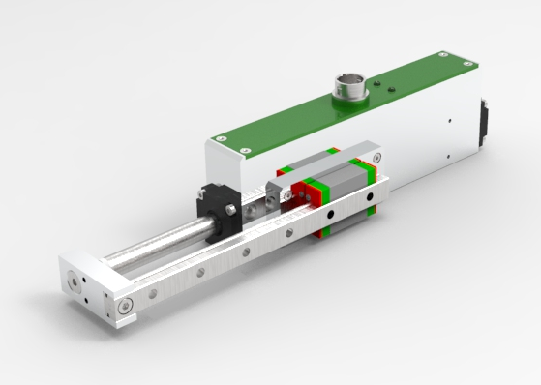
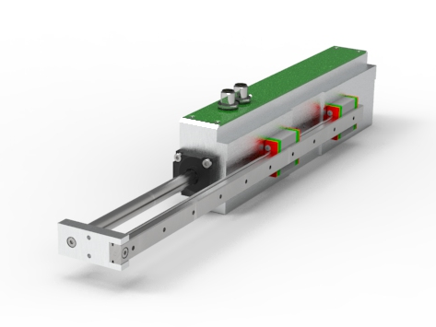

Magnetic spring for vertical application
In vertical applications, when the linear motor is not powered, the linear axis can fall down due to gravity. Using MagLift, the gravitational force is counterbalanced and the linear motor remains in steady state. 6 force sizes are available : 12, 17, 22, 40, 50 and 60 N, respectively MagLift12, MagLift17, MagLift22, MagLift40, MagLift50 and MagLift60.
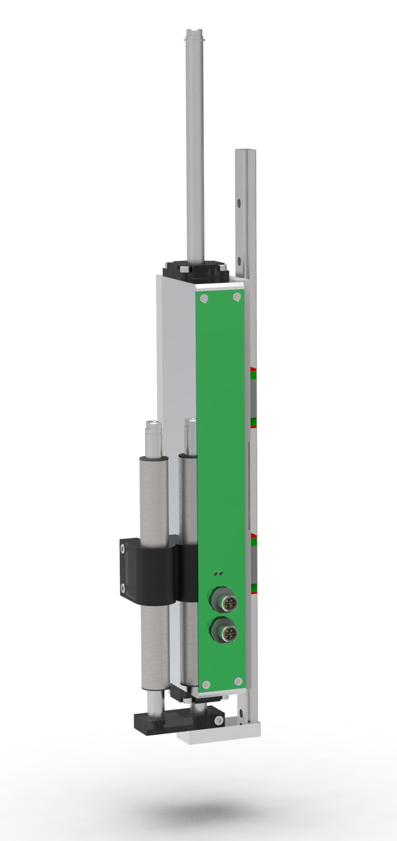

Din rail modules
The accessories in combination with the programming cable and the motor cable with DB15-connector allow a fast and better installation of the NLi080Q/X and NLi120Q/X motors. They are fitted with in- and output DB15 or DB9 connectors and with a terminal block for a fast connection of the digital in- and outputs and for the connection to the MODBUS RTU.

NL-DB9-MG6 - MODBUS RTU or CanOPEN bus terminal block daisychain connections
www.nilab.at_wp-content_uploads_db9_terminal_din.jpg

NL-DB15-MG6 - DIGITIAL INPUT / OUTPUT terminal block for PLC connections
www.nilab.at_wp-content_uploads_db15_terminal_din.jpg

Programming cable
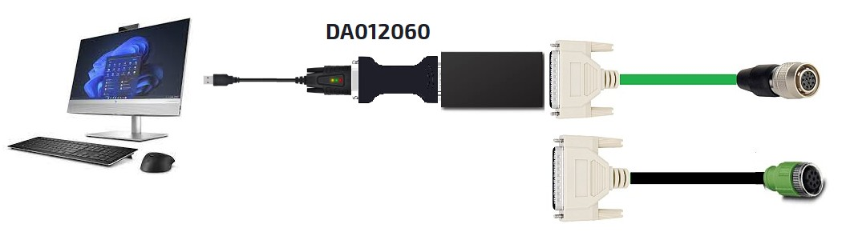programming_cable.jpg

