Antirotation mechanics
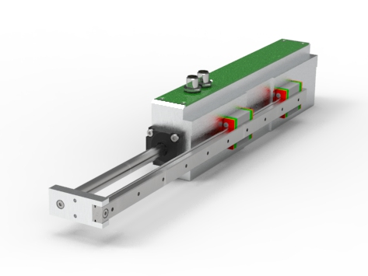 | 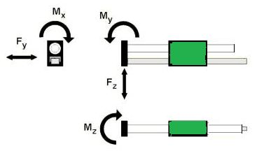
Force and momentum ratings
Parameter | NL080Q/X | NL120Q/X
Fy [N] | 58 | 248
Fz [N] | 58 | 248
Mx [Nm] | 8 | 44
My [Nm] | 14 | 77
Mz [Nm] | 14 | 77
Lifespan [km] | > 50.000 | > 90.000
Note that this lifespan is considering a lubrication interval of 5000 Km each 6 months.
Theoretical value calculated considering miniature linear guide size 9 and size 12.

Bending rating
Extension [mm] | 60 | 160 | 260
Bending [mm] per motor size | NL080Q/X
Fz = 2.5 N | 0.005 | 0.09 | 0.40
Fz = 5 N | 0.011 | 0.016 | 0.70
Fz = 10 N | 0.023 | 0.35 | 1.45
Bending [mm] per motor size | NL120Q/X
Fz = 5 N | 0.004 | 0.081 | 0.34
Fz = 10 N | 0.012 | 0.151 | 0.65
Fz = 20 N | 0.021 | 0.300 | 1.31

