Can Open standard and extended PDOs

Standard PDO configuration - Standard Firmware
This implementation comprising 1 TXPDO and 1 RXPDO. EDS File: :integrated_drive_motors:nli_integrated_motor_standard.zip

Tx PDO - Address 0x1A00
tx_pdo_mapping_default.jpg
Index | Name | Type | Register Address | Value
1 | *PositionActualValue (counts) | DINT | 0x6064 | 0x60640020
2 | Statusword | UINT | 0x6041 | 0x60410010
3 | ModesofOperationDisplay | SINT | 0x6061 | 0x60610008
*Note that in order to have mm you have to multiple the position actual value in counts with the scaling factor F=pole pitch/65535. For NLi080 pole pitch=30000, for NLi120 pole pitch=60000.

Rx PDO - Address 0x1600 - Interpolated positioning & Profile position
rx_pdo_mapping_default.jpg
Index | Name | Type | Register Address | Value
1 | InterpolationDataRecord | DINT | 0x60C1 | 0x60C10120
2 | Controlword | UINT | 0x6040 | 0x60400010
3 | ModesofOperation | SINT | 0x6060 | 0x60600008

Extended PDO configuration - Firmware on Demand
This implementation comprising 3 TXPDO and 3 RXPDO. EDS File: :integrated_drive_motors:nli_integrated_motor_extended.zip
Please contant NiLAB to receive the Firmware.
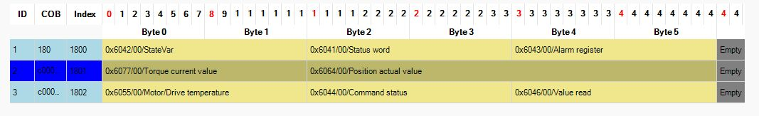new_pdo_1.jpg

TXPDO - From motor to PLC
Description
INTERNAL MACHINE STATE
DS402 STATUS WORD
ALARM REGISTER
TORQUE CURRENT VALUE
POSITION ACTUAL VALUE
MOTOR / DRIVE TEMPERATURE
0=NONE,1=OK_READ,2=OK_WRITE
VALUE READ
*Note that in order to have mm you have to multiple the position actual value in counts with the scaling factor F=pole pitch/65535. For NLi080 pole pitch=30000, for NLi120 pole pitch=60000.
Internal state machine - STATEVAR
Alarm Register Bits
Alarm type | D0 | D1 | D2 | D3 | D4 | D5 | D6 | D7
OVERLOAD I2T | 1 | X | X | X | X | X | X | X
SINCOS OVERRANGE | X | 1 | X | X | X | X | X | X
MOTOR OVERTEMP | X | X | 1 | X | X | X | X | X
DCLINK OVERANGE | X | X | X | 1 | X | X | X | X
MOTOR OVERCURRENT | X | X | X | X | 1 | X | X | X

RXPDO - From PLC to motor
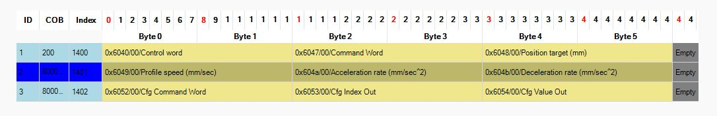new_pdo_2.jpg
Description
DS402 CONTROL WORD
COMMAND WORD
PROFILE POSITION (millimeter)
PROFILE SPEED (mm/sec)
ACCELERATION RATE (m/sec2)
DECELERATION RATE (m/sec2)
0=NO_COMMAND,1=READ_16BIT,2=WRITE_16BIT
REGISTER INDEX TO READ OR WRITE
WRITE VALUE
Command Word
13 | Profile positioning mode (OPMODE = 1)
14 | Jump to Bootloader (FW update)
15 | Internal motion controller (OPMODE = 0)

