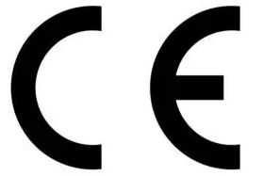ce_logo_small.jpg

EC Declaration of Conformity
Manufacturer: NiLAB GmbH, Hans-Sachs-Strasse 16, 9020 Klagenfurt am Wörthersee - Austria
Declare that:
Products: NILAB integrated miniature tubular linear motors and slider
Models: NLi080Q, NLi080X, NLi120Q, NLI120X
Are in accordance with the following directives:
2006/95/EC | Low Voltage Directive (LVD)
2006/42/EC | Machinery Directive
CEI EN 61000-6-4-:2007 | Generic standard - Emission standard for industrial enivronments
CEI EN 61000-6-2-:2006 | Generic standard - Immunity for industrial environments
Plase, date: Klagenfurt 28.6.2017
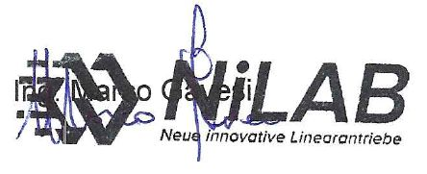signature.jpg

