Connections - NLi120Q or NLi120X

MODBUS RTU only
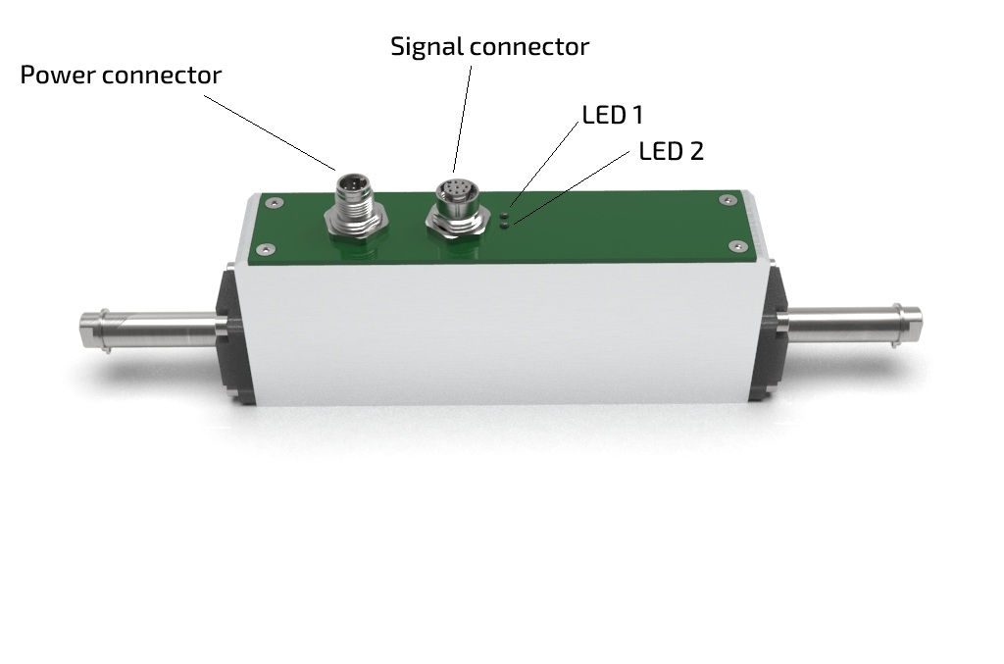nl120q_m12_standard.jpg
Nli120Q/X is equipped with two M12 connectors.
For power connector ⇒ power female DA00022011 flying leads and for signal connector ⇒ signal male DA00012011.
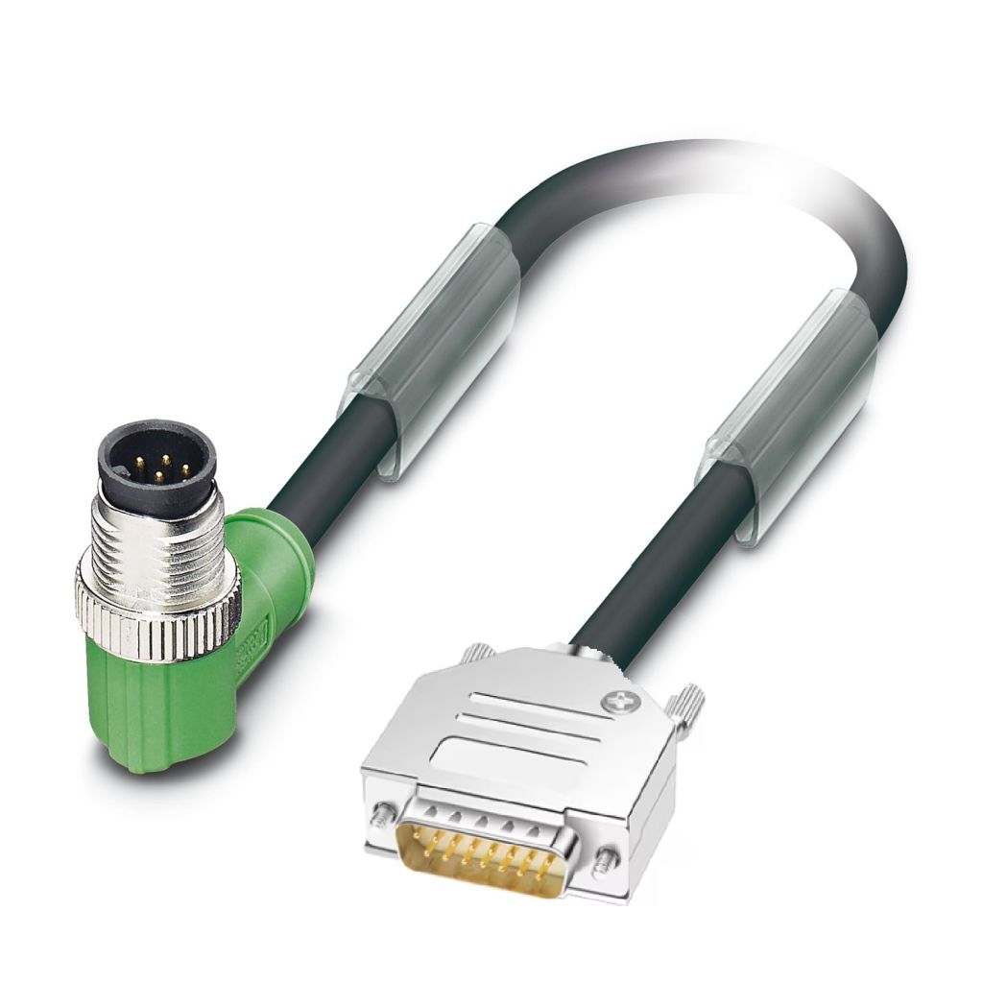da0012011_image.jpg | 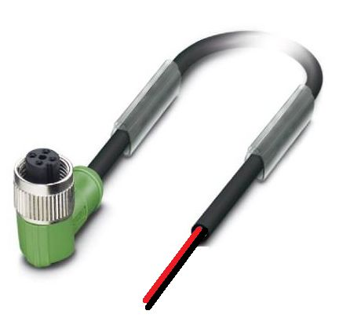da00022011_image.jpg
Signal cable DA00012011 | Power cable DA0022011  The power cable terminates with two wire: RED (+24VDC), BLACK (GROUND).
The signal cable DA00012011 terminates with with D-SUB15 male connector with this pinout:
D-SUB 15  Pinout | SIGNAL | DESCRIPTION | FUNCTION
1 | RS485_B | Modbus B
2 | RS485_A | Modbus A
3 | GND | Ground
4 | NC | Not connected
5 | NC | Not connected
6 | GND | Ground
7 | GND | Ground
8 | DIG_IN_0 | Digital Input 0 (24V logic) | Enable/Homing
9 | DIG_IN_1 | Digital Input 1 (24V logic) | Motion trigger
10 | DIG_OUT_0 | Digital output 0 (24V logic, PNP) | Motor running
11 | DIG_OUT_1 | Digital output 1 (24V logic, PNP) | Motor fault
12 | DIG_OUT_2 | Digital output 2 (24V logic, PNP) | Programmable
The programmable output have the following options:

MODBUS RTU + USB
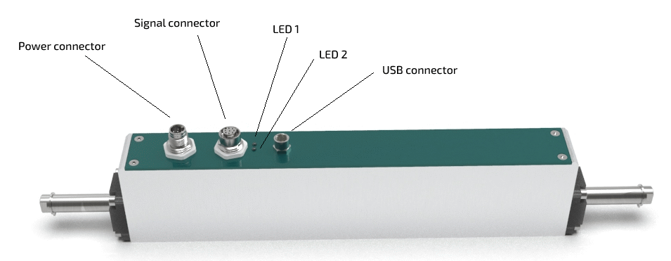
This model has the same connectors and pinout of the MODBUS RTU only except for the additional USB connector for MODBUS over USB connection.

CANOPEN, MODBUS RTU and single rear connector
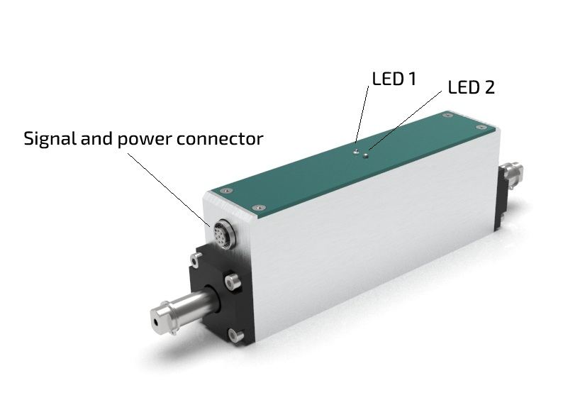nl120q_s_rear.179.jpg
The hybrid for NLi120Q/X M12 and D-SUB9 connector is DA012019-5M
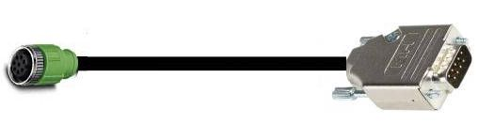da012019.jpg
D-SUB9  Pinout | SIGNAL | SIGNAL | WIRE COLOR
1 | CAN_H | Canbus high | Brown
2 | CAN_L | Canbus LOW | Green
3 | MODBUS_A | Modbus A | Yellow
4 | MODBUS_B | Modbus B | Grey
5 | – | – | –
6 | GND | Ground | Violet
7 | GND | Ground | Blue
8 | 24V | Power | White
9 | 24V | Power | Red

MODBUS RTU and CANOPEN or ANALOG INPUTS
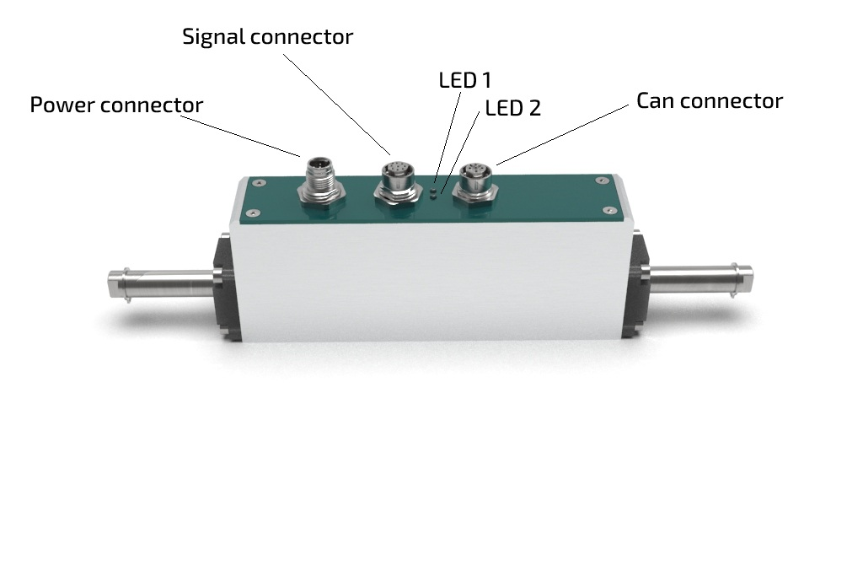nl120q_m12_can.jpg
The Can cable for NLi120Q/X (third connector M12 female) and D-SUB9 connector is DA122011
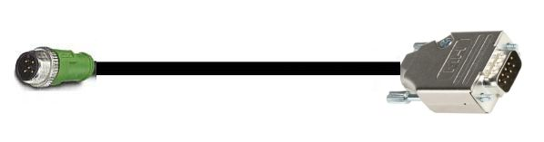can_cable.jpg
D-SUB9  Pinout | SIGNAL | CAN  VERSION | ANALOG  VERSION | CAN VERSION  WIRE COLOR
1 | NC | – | PULSE IN/OUT | -
2 | CAN_L | Canbus LOW | DIR IN/OUT | White
3 | CAN_GND | Canbus Ground | GND | Yellow/Green or Gray
4 | NC | – | - | -
5 | NC | – | ANP (0 to 10V voltage control) | -
6 | NC | – | ANN (4 to 20mA current control) | -
7 | CAN_H | CAN HIGH | - | Brown
8 | CAN_RES | TERMINATION RESISTANCE | - | Black
9 | CAN_H | CAN HIGH | - | Blue
In order to have the termination on the node, please make a jumper between CAN_RES andf CAN_L (Pin 8 and Pin 2)

M12 power connector on the motor side pinout
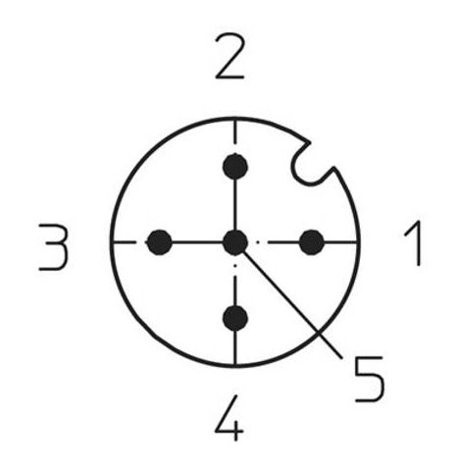m12_power.jpg
Pin | Signal | Description
1 | +24VDC | 24VDC power line
2 | +24VDC | 24VDC power line
3 | GND | Ground
4 | GND | Ground
5 | NC | Not connected

