Mechanical Installation

Slider distance for parallel drive mounting
Whne the application needs tandem parallel configuration of the integrated drive linear motor, the two or more actuator must mounted guarantee the safety distance L3 to avoid the interaction between magnetic sliders.
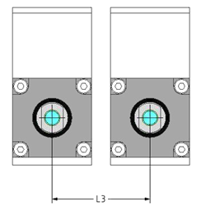
MOTOR MODEL | NO INTERACTION | MEDIUM INTERACTION | STRONG INTERACTION
NLi080 | > 35 mm | > 15 mm to 35 mm | < 15 mm
NLi120 | > 65 mm | > 45 mm to 65 mm | < 45 mm

NLi080Q Fixing points
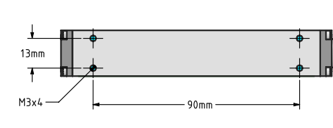

NLi080X Fixing points
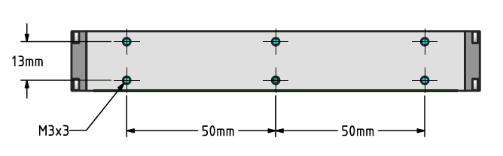

NLi120Q Fixing points
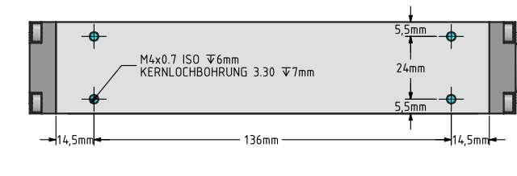

NLi120X Fixing points
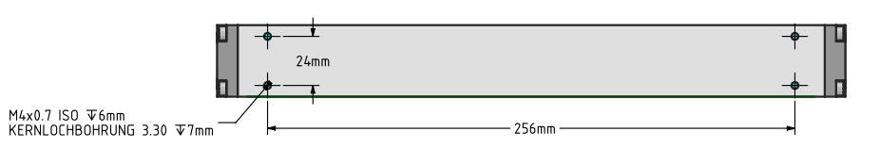

NLi080Q/X slider fixing point
Slider has M4 threaded hole at each slider ends.
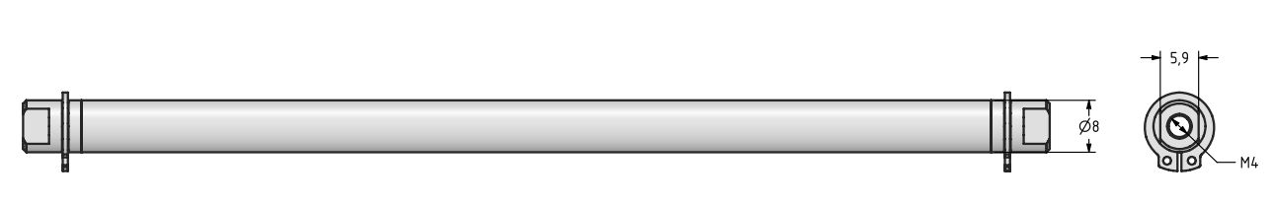slider_8.jpg

NLi120QX slider fixing point
Slider has M4 threaded hole at each slider ends.
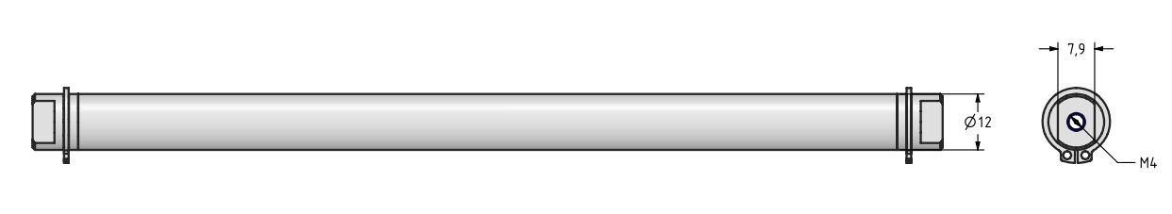slider_12.jpg

