MODBUS RTU Interface

How to set the right NODE ID inside the motor configuration
Using NiLAB Starter, connect to the single motor and store different address inside Motor Parameter window. Then press Download configuration to the motor and Store configuration to Flash to permanently store the node id inside the memory of the motor.
Please use NODE ID starting from 1 to 128. The new node id will be update after a new power cycle.
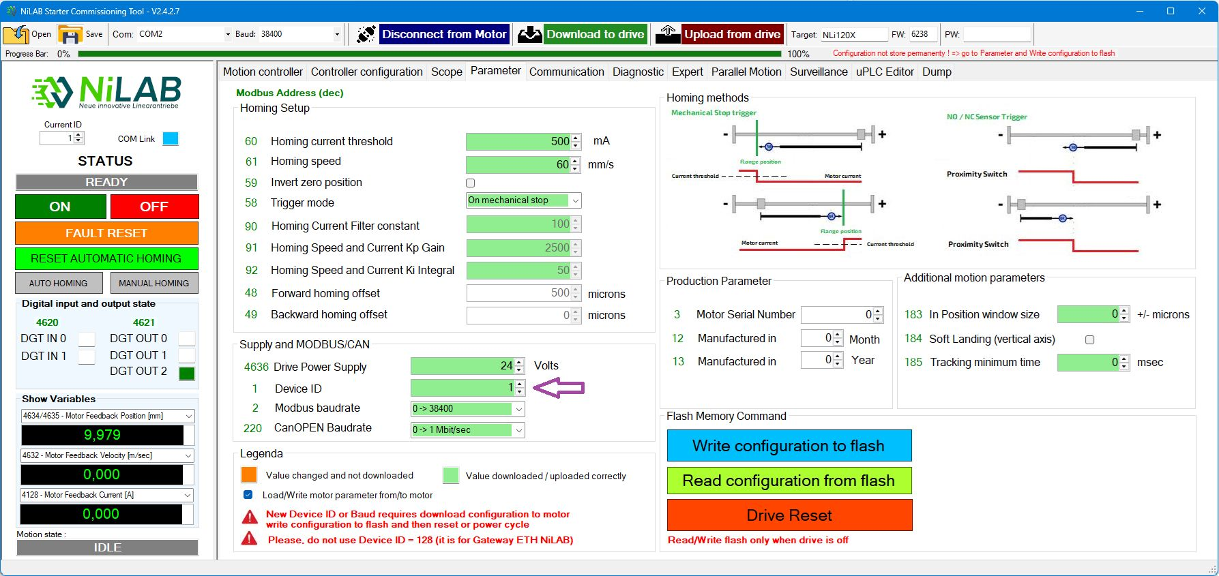

How to connect the motors on the BUS
The NLi integrated miniature linear motors are equipped with MODBUS RTU communication interface.
More information about this type of fieldbus can be read here: https://en.wikipedia.org/wiki/Modbus
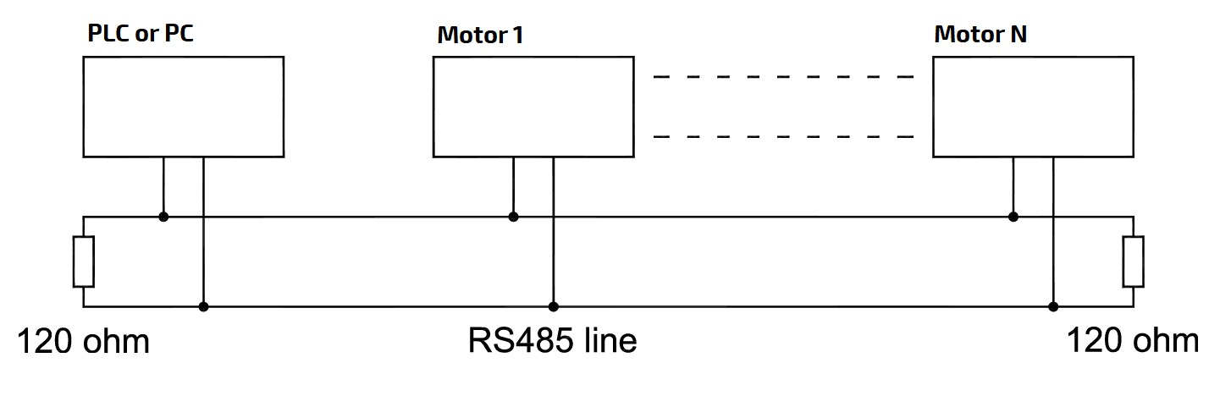modbus_rtu_connection.jpg
As in the schema above, for long connection we suggested to use a terminal resistor of 120 ohm.
If the motor are used with NL-DB15-MG6 terminal block from NiLAB, please connect earth to ground, all ground present must be connected together with the cable length is more than 5 meters.
This connectioin ensure the shielding of the cable.
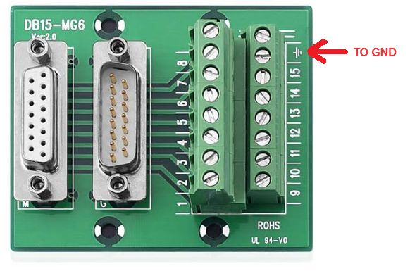terminal_block_connection.jpg
Please note that you can read a maximum of 2 registers per read operation with standard communication speed of 38400 and parity Even. The MODBUS parameters are organized in different area in respect to the function involved.

How to scan the bus looking for motors
It is possible to scan the modbus using NILAB Starter Function call :
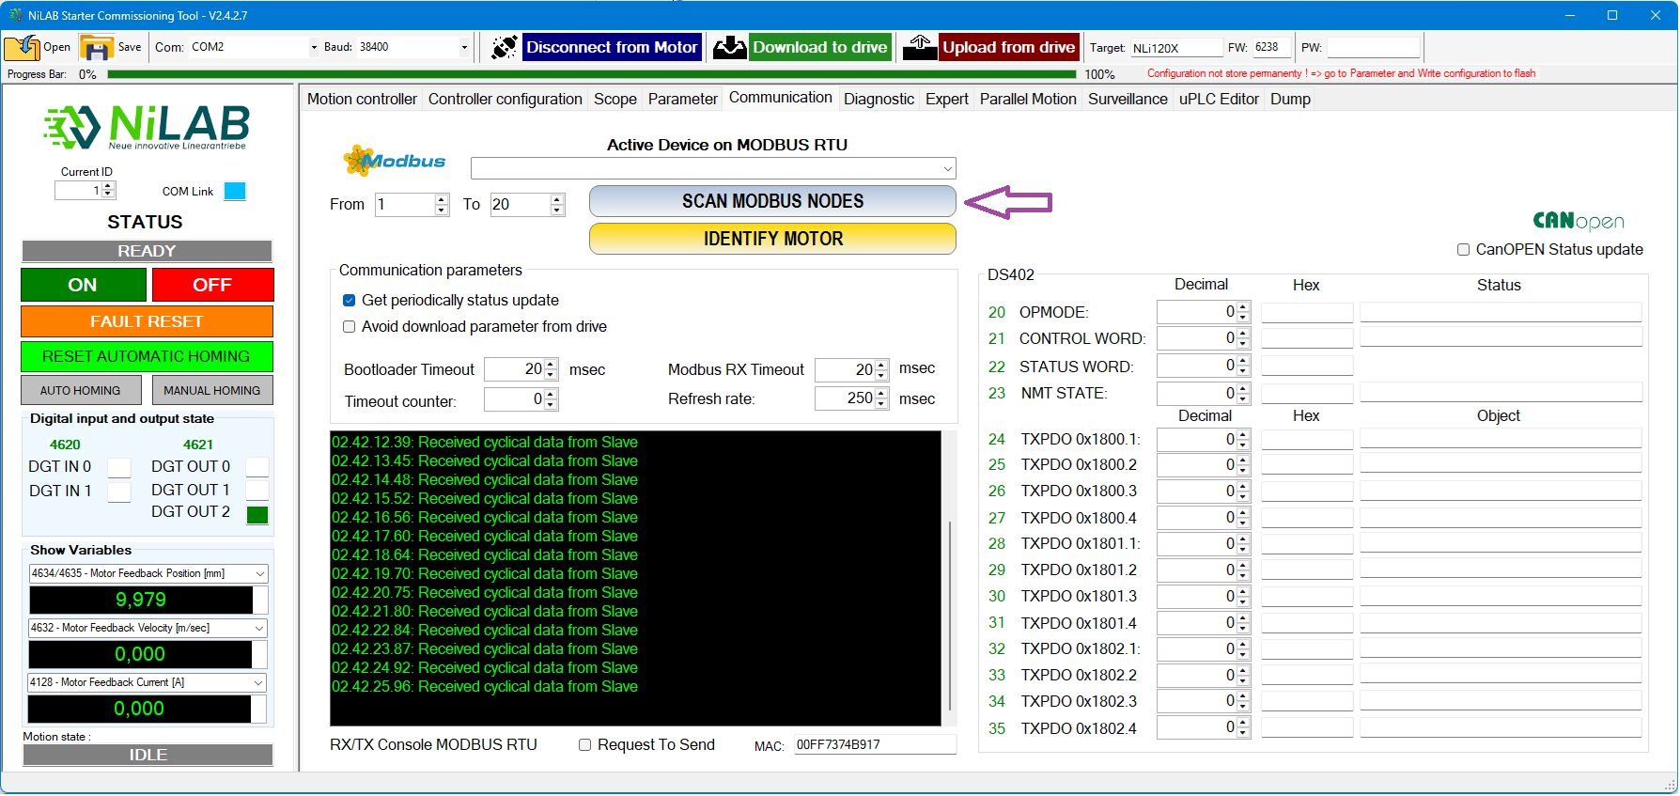

Standard Device for MODBUS Communication with NLi integrated motor

TOP7 PLC Touch
For the programming, diagnosys and parameterization of integrated miniature linear motor is possible to use TOP7 touch panel. NiLAB provide a solution with Software running on this device to be use in industrial automation. Info about TOP7 are available here: http://www.elcoelettronica.it/en/products/products_view.php?name=TOP%207
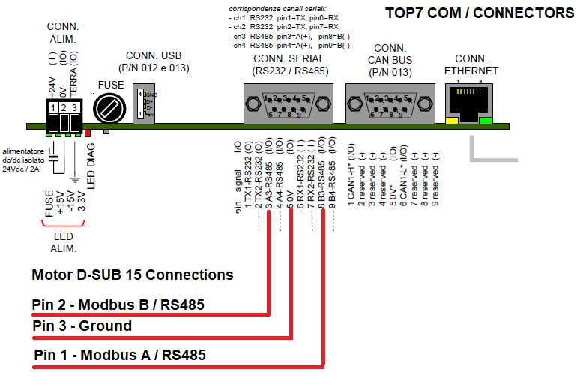top7_modbus.jpg

Helmholz 600-400-7BA31 module
In combination with FCT640 PLC Master controller, it is possible to use this MODBUS RTU interface for communicate with integrated drive miniature linear motor using standard CODESYS program.
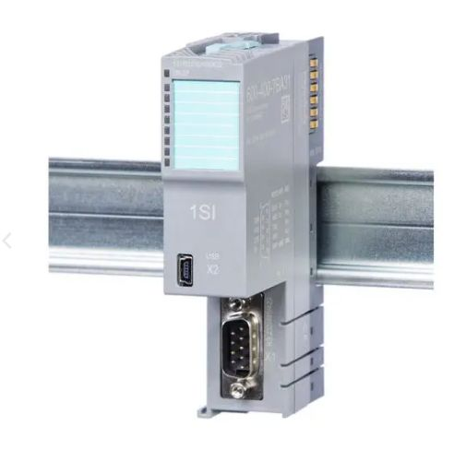600-400-7ba31.jpg

MOXA TCC-100/100I Series
Page link: https://www.moxa.com/en/products/industrial-edge-connectivity/serial-converters/serial-to-serial-converters/tcc-100-100i-series

MOXA UPORT 1100 Series
Page link: https://www.moxa.com/en/products/industrial-edge-connectivity/usb-to-serial-converters-usb-hubs/usb-to-serial-converters/uport-1100-series

WAVESHARE RS485 to EJ45 Ethernet - Rail mount
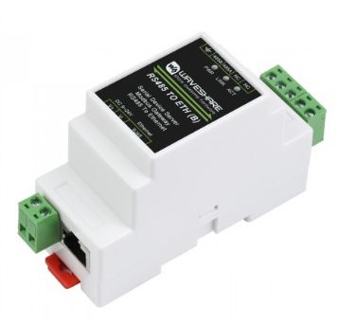waveshare.jpg
Virtual com port drive: https://www.waveshare.com/wiki/File:Virtual-serial-port-control3.5.rar
Vircom software: https://www.waveshare.com/w/upload/4/42/VirCom_en.rar
Please us this configuration:
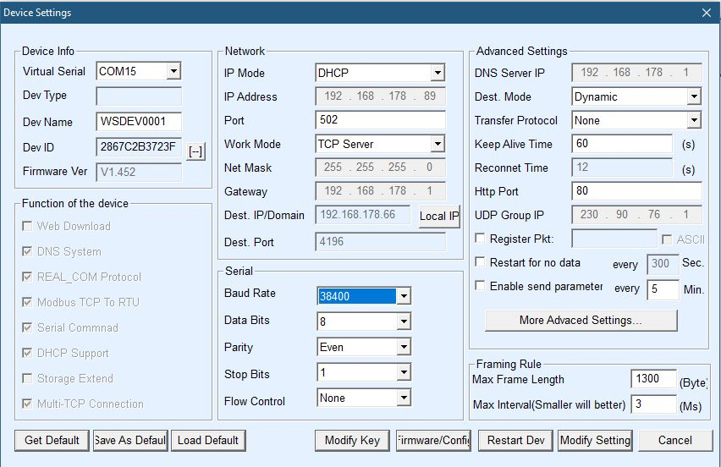config_waveshare_1.jpg
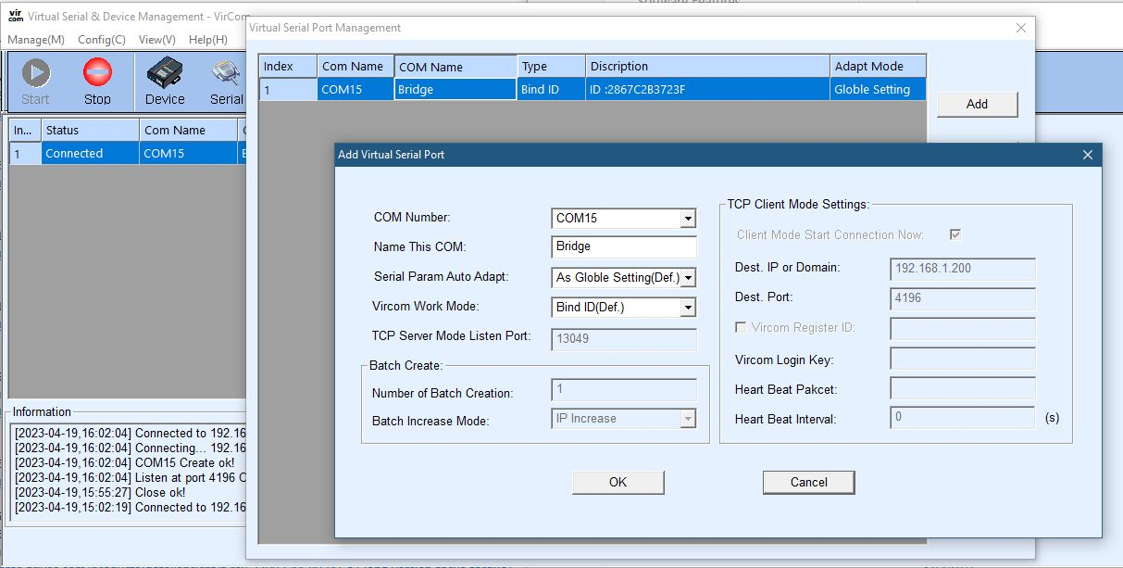config_waveshare_2.jpg

