Safety

Safe Stop condition
If the motor is powered with Digital Input 0 (Enable) and Digital Input 1 (Trigger) set to 24VDC (high level), after boot sequence, the integrated drive goes in a fault condition called SAFE STOP.
In this condition, the internal PLC is disabled and MODBUS RTU debug mode will send a string on the MODBUS. See:https://www.nilab.at/dokuwiki/doku.php?id=integrated_drive_motors:modbus_debug

Soft landing function
For vertical application, it is possible to activate a function call soft landing. This function executes automatically at every switch-off (Disable command via sofwtare or via digital input) an homing procedure.
This to avoid that the motor falls down every time is switched off. Function can be activate using NiLAB Starter Software in Motor parameter windows.
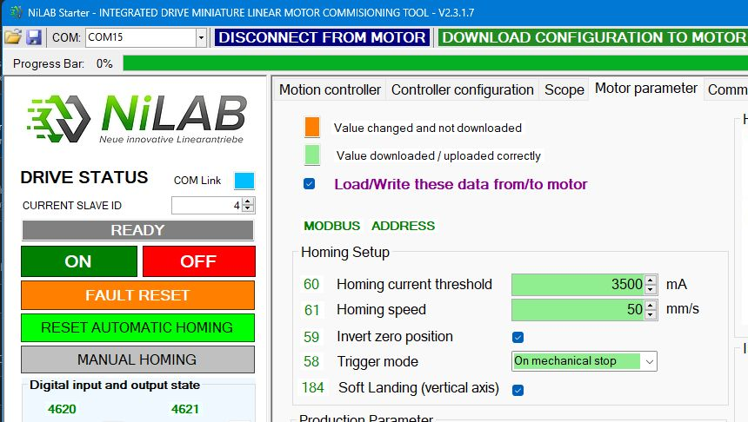soft.jpg

Safety Relais - External STO Function
In order to emulate the STO function, an external safety relais can be used to switch-on and off the 24VDC power to the integrated linear motor.
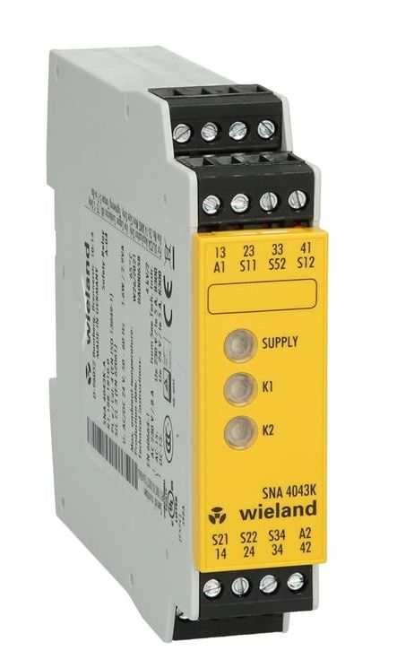safety_relais.jpg
For example using Wieland SNA 4043K (https://eshop.wieland-electric.com/products/en/device-for-monitoring-of-safetyrelated-circuits-sna4043ka-acdc-24v-a/r1.188.1810.0?locale=en)
The connection will be the following:
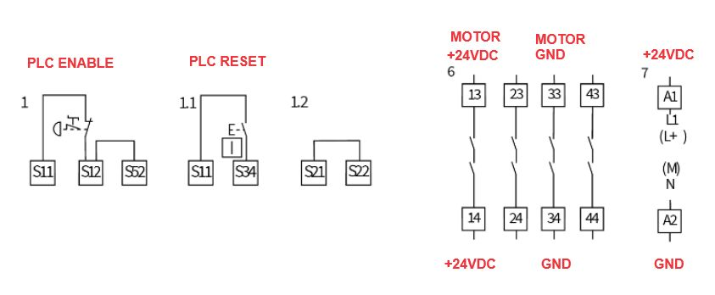safety_conn.jpg
PLC Enable must be set high (Pin S12) and subsequently the PLC Reset signal (Pin 34) must be applied to power on the relais. In case of emergency event, PLC Enable must be set low to switch off the relais cutting off the 24VDC power .

