Control Signals

Signal overview and timing
As explain in the connections description, one signal called TRIGGER SIGNAL from PLC or Sensor is used to start the motion sequence of the pick and place.
This signal must have a period compatible with the total motion time of the pick and place cycle.
Here below one example considering a pick and place speed of 0.6 sec total pick and place time corresponds to 100 pick and place per minutes. The Master sync signal is generated by the master (motor 1) with a small delay (debouncing) of 3 msec after the detection of the rising edge of the Trigger Signal (DIgital Input 1 - Pin 9). This signal is generated for 4 times and it is the motion trigger of the slave (motor 2). The motion task of the motor 2 (slave) is performed at every rising edge of the Master sync received. In position signal is the confirmation of the motion due to the motor 2 (slave). When the In position level is low the motor has reached the position window. In position window tolerance is defined using the parameter 183 (dec). This parameter is present in the Motot parameter window of the NiLAB Starter software.
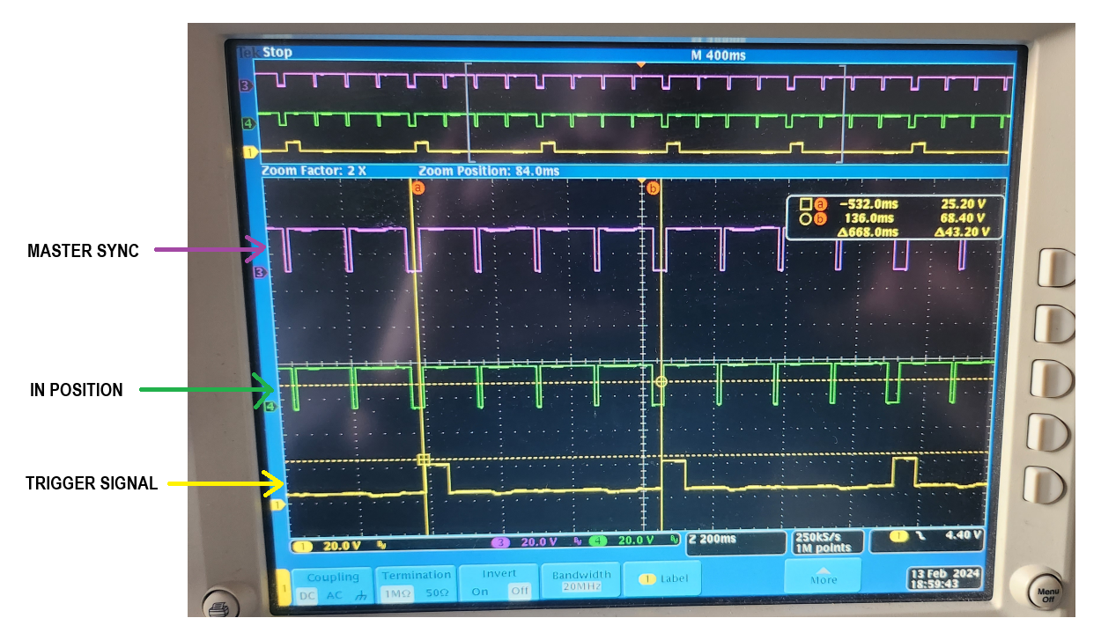

Enable and Disable signal
The Digital IN0 (Enable / Disable) signal must be switched only when the Trigger signal is low !
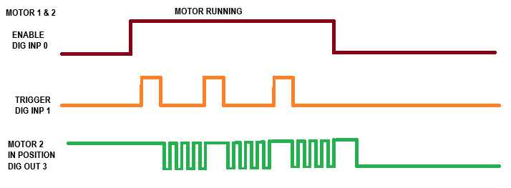
At every Disable, Digital Input 0 low the two motors executes Automatic Homing to reach the parking position.
This function is call Soft Landing and it is enabled by the parameter 184. The corrent sequence of validated by the Motor 2 Digital Output 3 set to In position function. After every Auto Homing the Motor 2 in position must be LOW.
Please, at every disable waiting that the two motors complete the auto homing function waiting 3 secs or looking to the motor state using MODBUS RTU communication. The motor status must be Ready (Status word register 0x1200 value must be 1). During the automatic homing this register is set to 3.

Product deviator Example of motion task configuration using NiLAB Starter

MOTOR 1 - Master
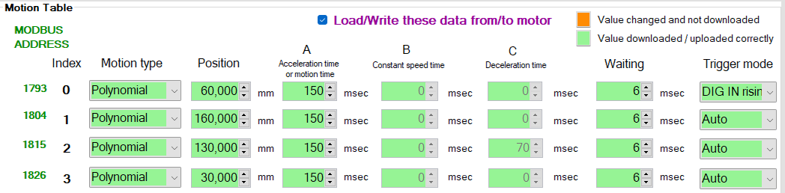

MOTOR 2 - Slave


