How to configure Deviator application using NiLAB Starter

Parallel Motion window overview
Deviator application require that the pick and place push the product in the linear direction, then go vertical after pushing and then go back for successive deviation.
The positions can be programming using NiLAB Starter software in the Parallel motion window.
First step is activate the Dual axis mode (1)to have the online position of the 2 axis. The two axis must have subsequently nod id numbers, for example Motor 1 (Node ID = 1) and Motor 2 (Node ID = 2). When the Dual axis mode is active in the number field (2) and (3) are present the current positions of the two axis.
In order to load the current configuration you need to press the LOAD TARGET POS button (8) and to store the current configuration permanently you have to press the button STORE TARGET POS (9). The number fields (4) and (7) will be used to set the deviator rate in motion per minutes and the number of motion task (typically 4). In order to update the rate press the UPDATE RATE button (5).
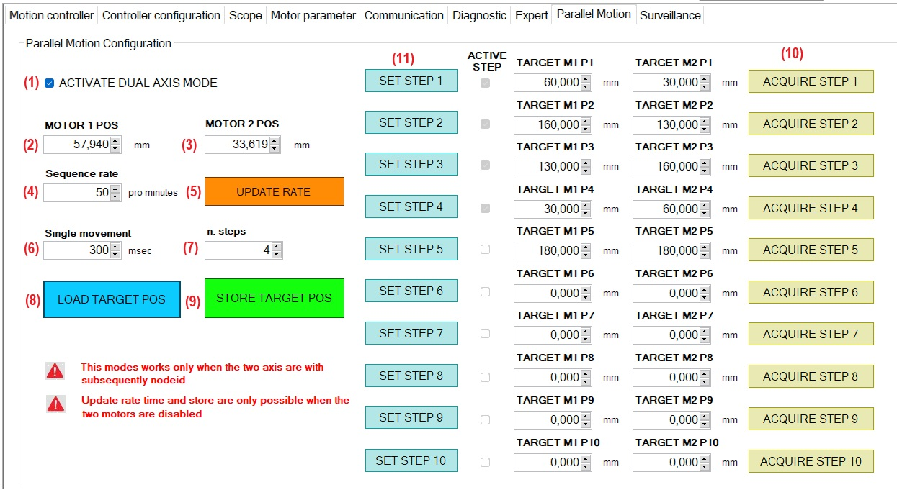

How to acquire and store the motion points
Move the robot in the start position
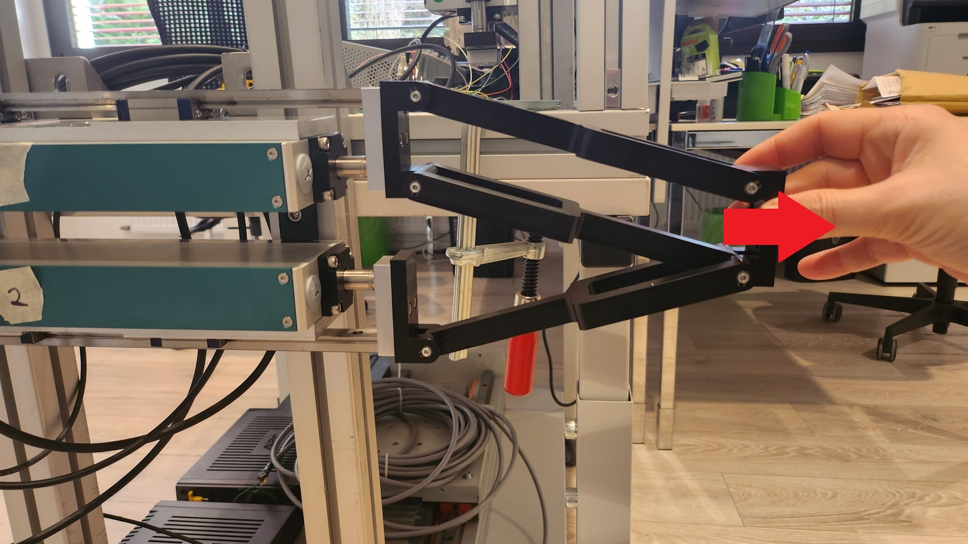photo_1.jpeg | 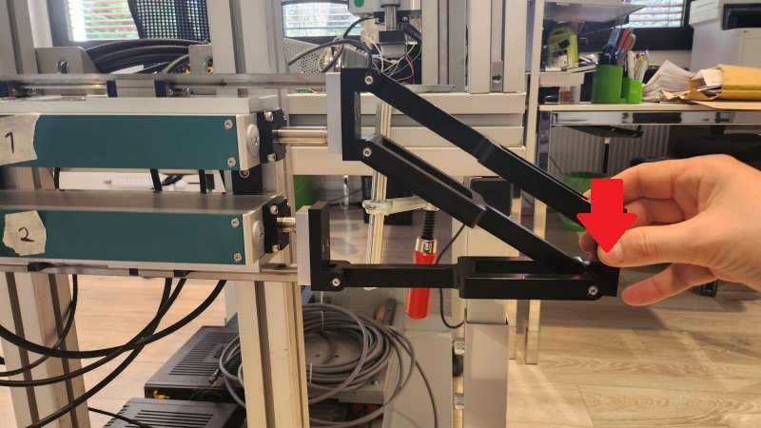
Press button Acquire Step to capture the position of the two axis. If the number are with digits you can correct using the number field and press the SET STEP 1 to store.
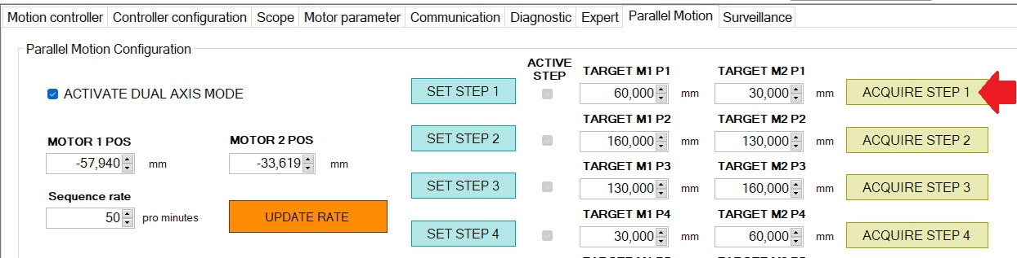step_1.jpg
Move the robot in the push position and store the second positions using ACQUIRE STEP 2 button.
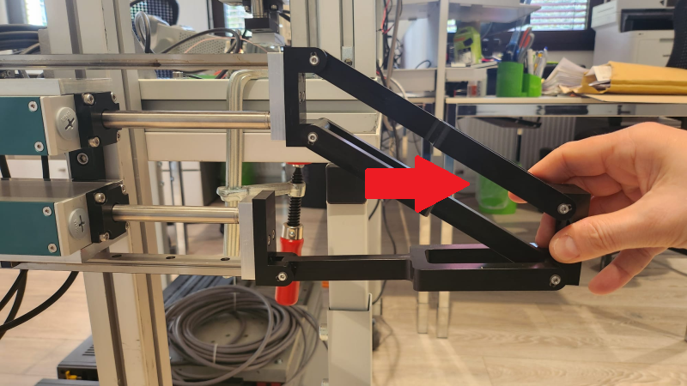
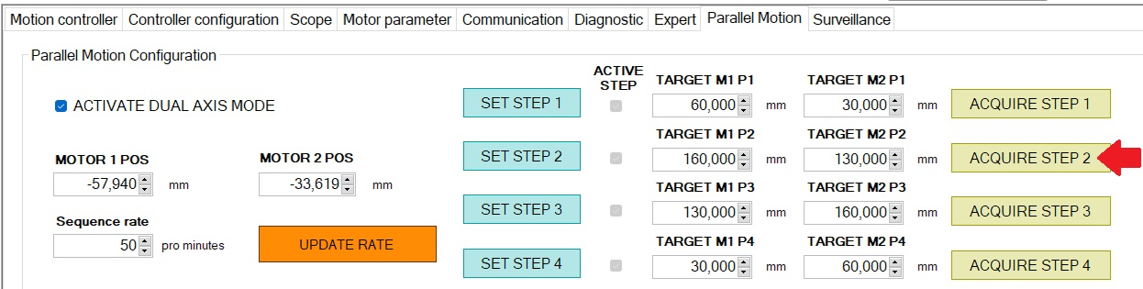step_2.jpg
Move the robot in the upper position and store the third positions using ACQUIRE STEP 3 button.
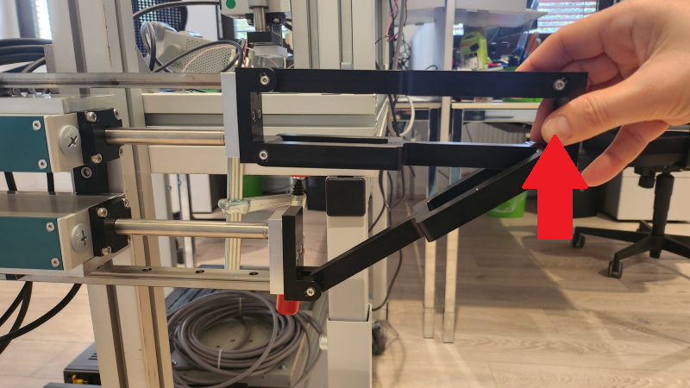
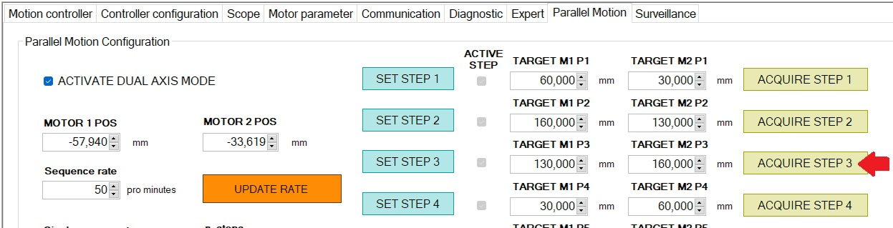step_3_1.jpg
Move the robot in the starting position and store the forth positions using ACQUIRE STEP 4 button.


