Accessories

Magnetic spring for vertical application
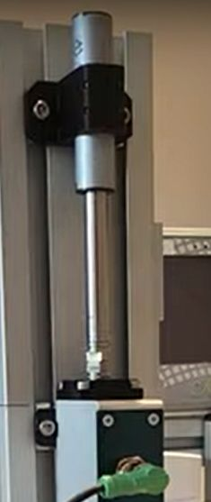maglift_rotolinear.jpg
In vertical applications, when the rotolinear motor is not powered, the linear axis can fall down due to gravity. Using MagLift, the gravitational force is counterbalanced and the linear motor remains in steady state. 6 force sizes are available : 12, 17, 22, 40, 50 and 60 N, respectively MagLift12, MagLift17, MagLift22, MagLift40, MagLift50 and MagLift60.

