Attraction force

Attractive forces between the primary and the secondary part
When it is installed, a synchronous linear motor has a permanently effective attractive force between the primary and the secondary that results from its principle. With synchronous linear motors, this attractive force also exists when the motor is switched off.
These attractive forces must always be taken into account in the mechanical design of the system.
Depending on the motor arrangement, the attractive forces must be accommodated by linear guides and the slide and machine structure.
With an unfavorable arrangement of the motors, the attractive forces can cause deformations (deflection) in the machine structure and unacceptable transverse stress on the linear guides. The following points should therefore be taken into account during the design integration of the motors:
• Arrange the linear guides as close to the motor as possible.
• To compensate the attractive forces, you can use the double-comb parallel arrangement.
Note: When installed, the attractive force must not reduce the air gap between the primary and the secondary. The mechanical design must provide sufficient rigidity.
Note: The attractive forces at the nominal air gap are specified in each data sheet of a motor in “Technical data”.

Air-gap-related attractive forces between the primary and the secondary
The attractive force rises as the distance between the primary and the secondary is reduced. When lowering the primary on the secondary, result by reducing the air gap increasing attractive forces. The curve in the following diagram shows the attractive force as a function of the air gap.
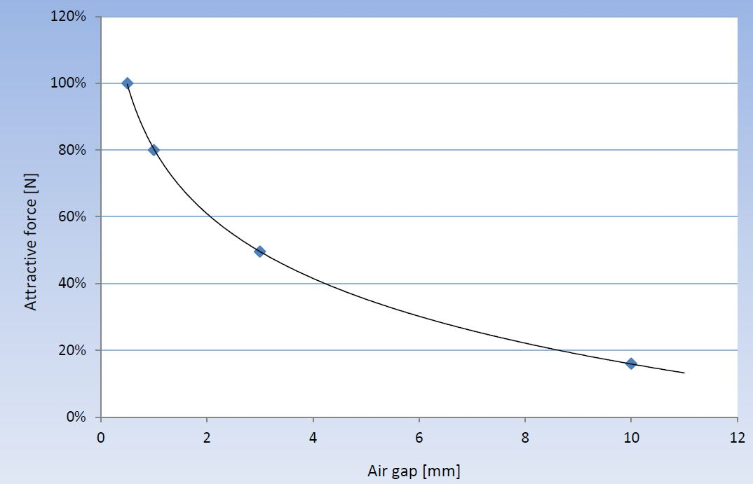l_series_4.jpg

