HSB (Hall sensor Box) linear positioning system

Overview
L-series motors can be provided with a linear encoder which can be mounted together with the primary part, without the need o fan external stripe. Available feedback types are SIN/COS 1 Vpp.
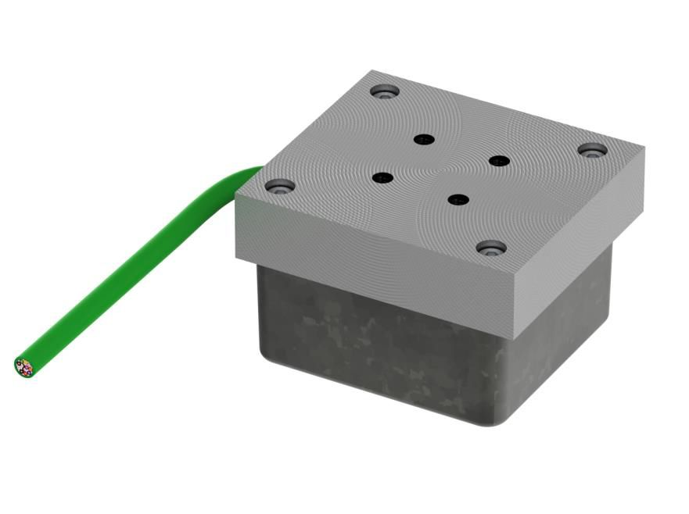hsb.jpg

Type code
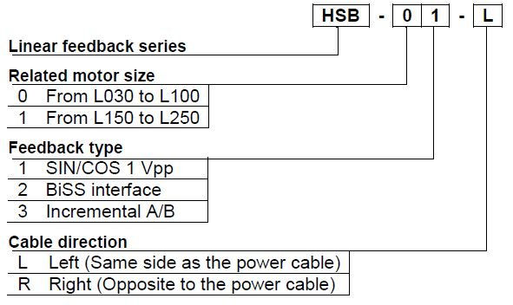hsb_1.jpg

Mounting holes
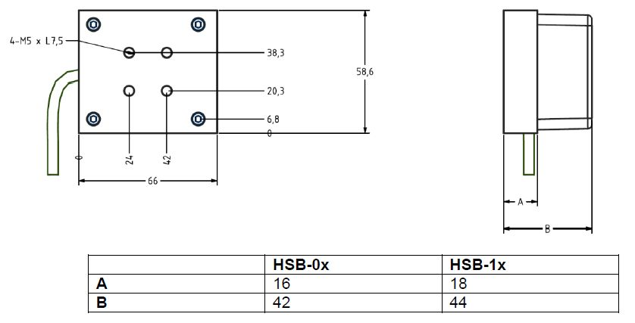hsb_2.jpg

Mounting with the linear motor primary part
The HSB is supposed to be mounted I line with the primary part and overlapping the center of the secondary part. The following scheme shows an example of mounting with left cable direction.
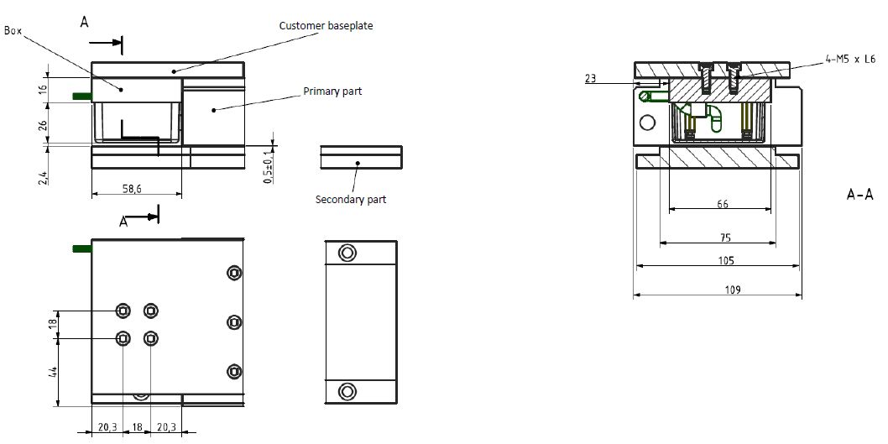hsb_3.jpg

Wire colors
HSB is equipped with PUR cable with lenght of 1 meter
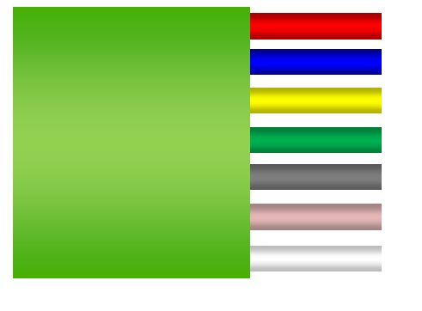hsb_4.jpg
Color | Signal description
Red | +5VDC (Encoder power supply)
Blue | Ground (Encoder ground)
Yellow | SIN+
Green | SIN-
Gray | COS+
Pink | COS-

SIN/COS 1Vpp output signal
The HSB standard signal output type is SIN/COS 1Vpp, with a signal period corresponding to the pole pitch of the motore (32mm).
The signal output is of differential type with an amplitude of 0.5V per channels and a reference level of 2.5V.
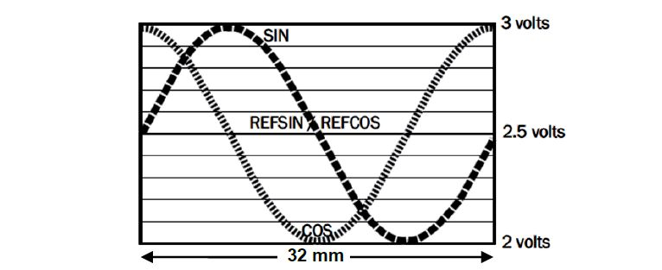hsb_5.jpg

Mounting example

HSB-L version
3D Model file: :ironcore_motors:hsb-01-l.zip
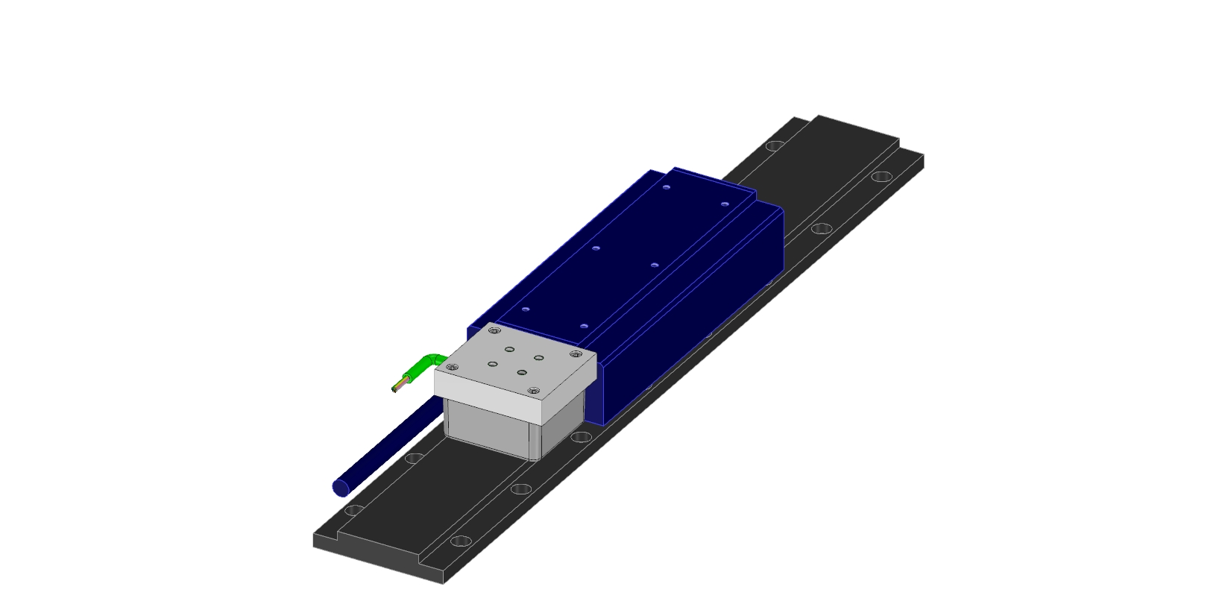hsb-l_mounting_drawing_example.jpg

HSB-R version
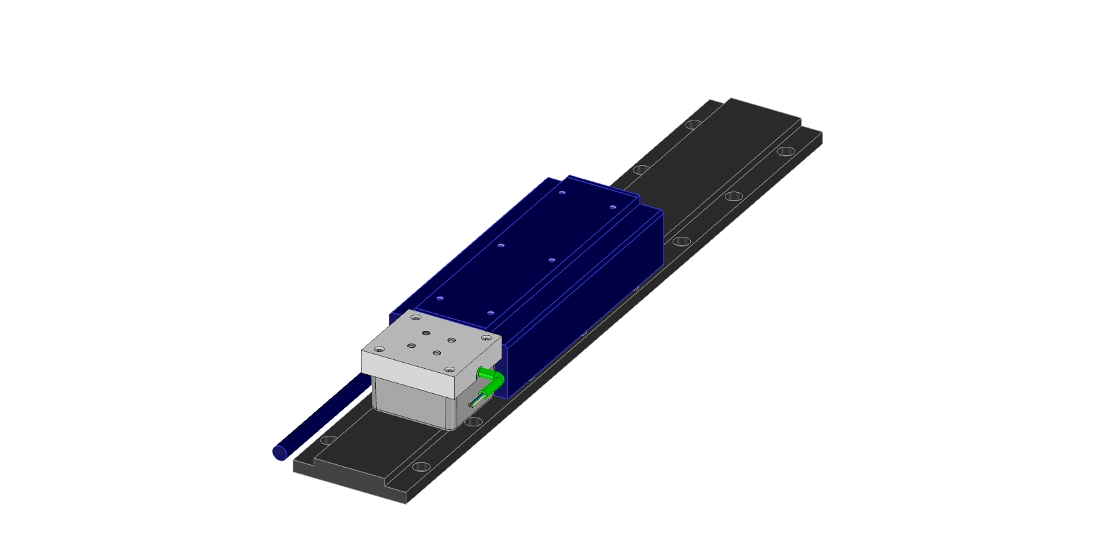hsb-r_mounting_drawing_example.jpg

