Identification of the motor components

Primary part
A nameplate is attached to the back side of the primary. The plate shows the type code, the serial number, the weight, the protection grade and the power supply data. An example of a nameplate is shown below:
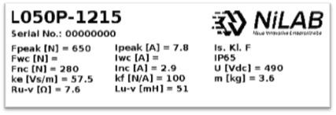label_l.jpg

Secondary part
A nameplate is attached to the upper side of the secondary. The plate shows the NORTH pole position on the magnet track. An example of a name plate is shown below:
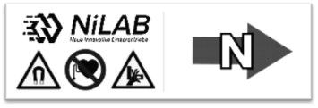label_l_1.jpg
Note: Do not remove the nameplate from the secondary part. Removing the nameplate from the secondary part will void the motor warranty.

