Linear guiding system
To design the linear system NiLAB can provide the correct linear guide type to meet the requirements of the Ironcore linear motors. In the standard mechanical configuration, the linear system is composed of two rails and at least 4 carriages connected to the axes.
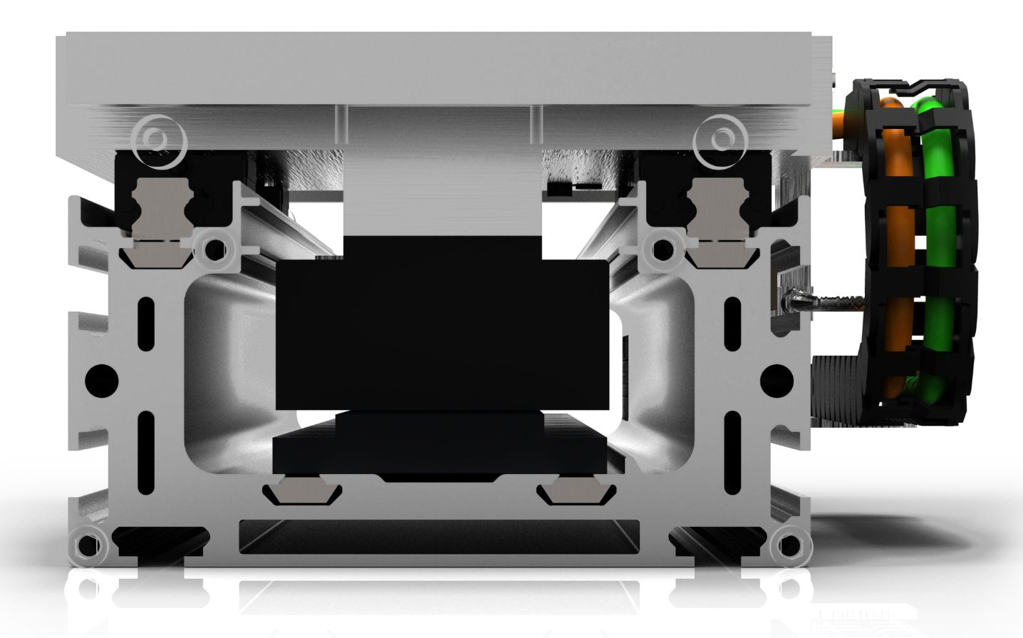linear_guide.jpg | 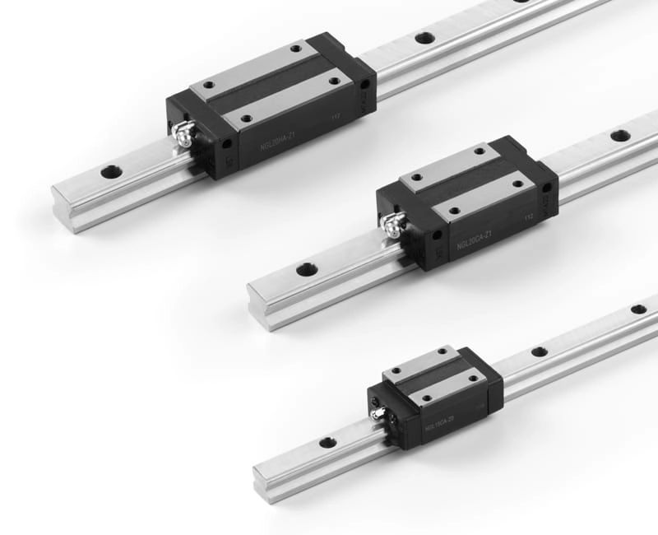guide.jpg
Motor Size | Guide type | Number of carriage
L030P | Size 15 | 4
L050P | Size 20 | 4
L075P | Size 20 (long) or Size 25 (standard) | 4 / 6
L100P | Size 30 (long) | 4 / 6
L150P | Size 35 (long) | 4 / 6
L200P | Size 45 (standard) | 4 / 6
L250P | Size 45 (long) | 4 / 6

