Motor components arrangement

Single arrangement
The single arrangement of the primary is the most common arrangement.
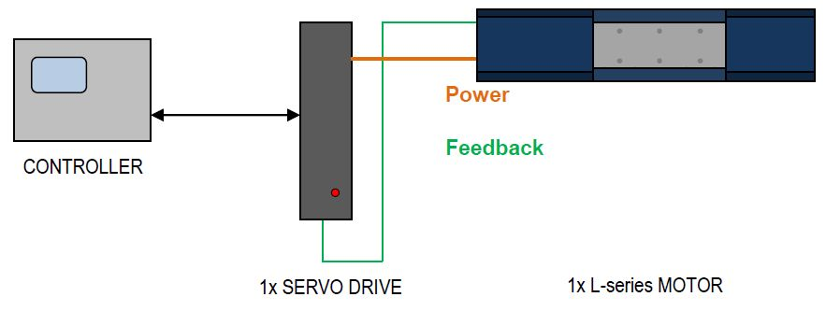single_1.jpg
The independent operation of two or more primaries on a secondary is possible too.
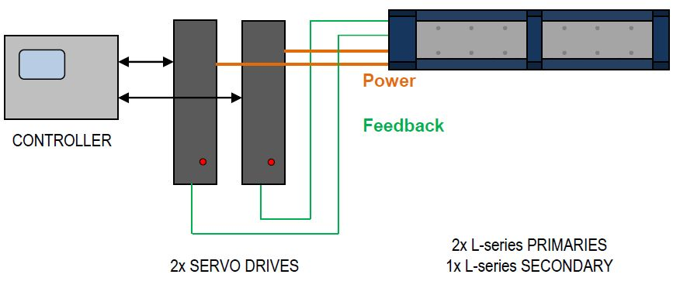single_2.jpg

Gantry arrangement
Operation with two linear scales and drive controllers (gantry arrangement) should be planned if there are load conditions that are different with respect to place and time, and sufficient rigidity between the motors cannot be ensured. This is frequently the case with axis in a gantry structure, for example.
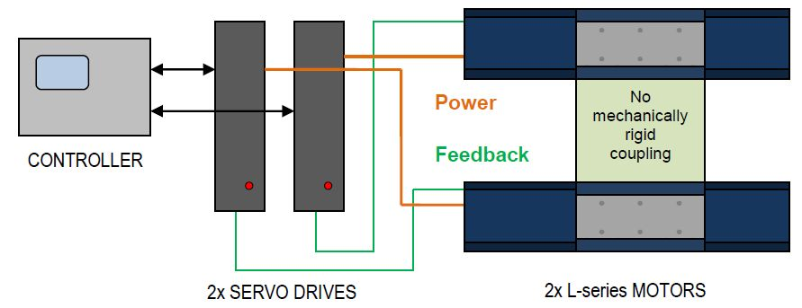single_3.jpg
With gantry arrangements the motors may be stressed asymmetrically, although the position offset is minimized. As a consequence, this permanently existing bas load may lead to a generally higher stress than in a single arrangement. This must be taken into account when the drive is selected.
Note: The asymmetric stress can be reduced to a minimum by exactly aligning the length measuring system and the primary and secondary parts to each other, and by a drive-internal axis error compensation.

Parallel arrangement
Parallel arrangement consists in two or more motors on one drive controller. It is possible if the coupling between the motors can be very rigid.
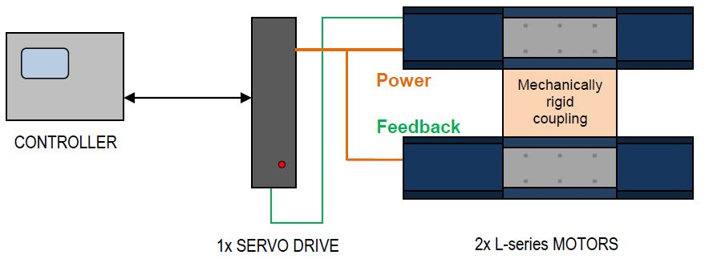single_4.jpg
To ensure successful operation, the axis must fulfill the following requirements in parallel arrangement:
• Very rigid coupling of the motors within the axis
• Position offset between the primary parts <1 mm in feed direction
• Position offset between the secondary parts <1 mm in feed direction
• Same pole sequence of the secondary parts
• If possible, load stationary and arranged symmetrically with respect to the motors
In a parallel arrangement, the primaries in feed direction can mechanically be coupled and be arranged in the form of a “double comb arrangement” by just joining the bottom side of the two secondary parts together. In addition to the force multiplication, the attractive forces between primary and secondary are compensated towards the outside. With the corresponding arrangement, the linear guides are not stressed additionally, and may even be sized smaller.

Parallel arrangement on one secondary
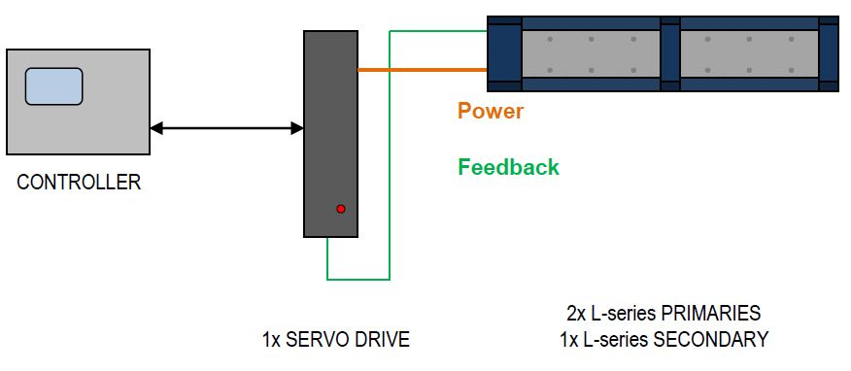single_5.jpg
In a parallel arrangement the primaries in feed direction can mechanically be coupled and be arranged in succession. To ensure successful operation, the primaries must be arranged in a specific grid. The determination of the grid sizes that must be adhered to depends on the direction of the cable entry and the permissible bending radius of the power cable.
If the primaries are arranged behind each other with the cable entries in the same direction, an integer multiple of twice the electrical pole pitch must be adhered to.
Note: When you determine the correct primary distance with cable entries in the same direction, you must always use the same reference point for both primaries (e.g. the same mounting hole).

