L/LK Ironcore linear motors
The ironcore flat linear motors series L/LK/L1S provides an outstanding force-dimension ratio. The primary and secondary parts are covered by a strong epoxy protective resin to be resistant to shock and aggressive substances. 7 different primary frame sizes and up to 5 different primary part lengths are available to provide continuous forces from 150 N to 7500 N and peak forces from 440 N to 15750 N. The ironcore standard L motor is provided with power cable with flying leads or with circular connector. We offer different exit cable direction (X,Y and Z). Furthermore, the winding can be provided with different nominal speed values and with different integrated thermal sensors like Thermoswitch, PTC, KTY or NTC. To increase the nominal force, the LK series is available with integrated cooling option. The L1S model type is available to reduce at a minimum the frame size of the motor.
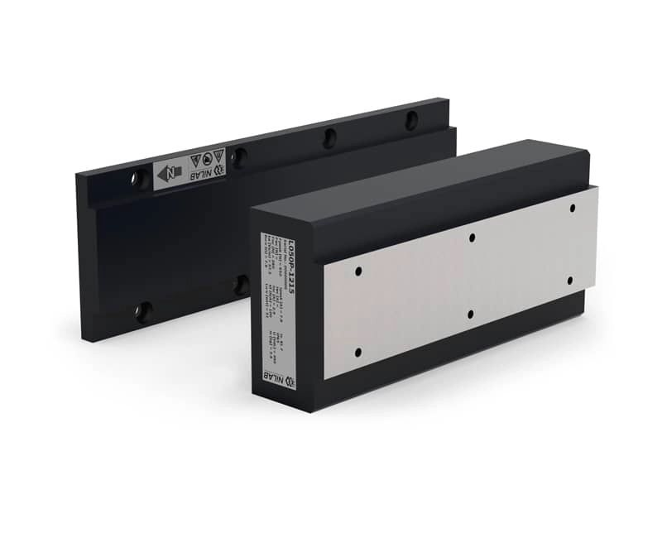l_series.jpg

