Technical data
For detailed information about motor parameter, please use the Datasheet Engine tool.
Link: Datasheet Engine
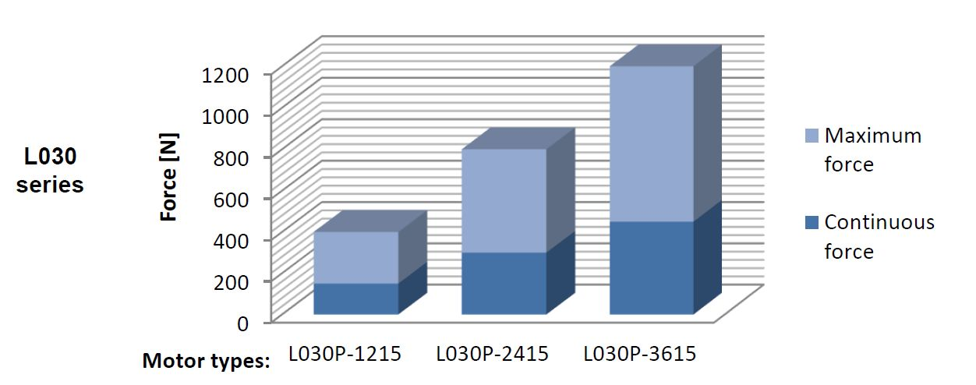l030_perf.jpg
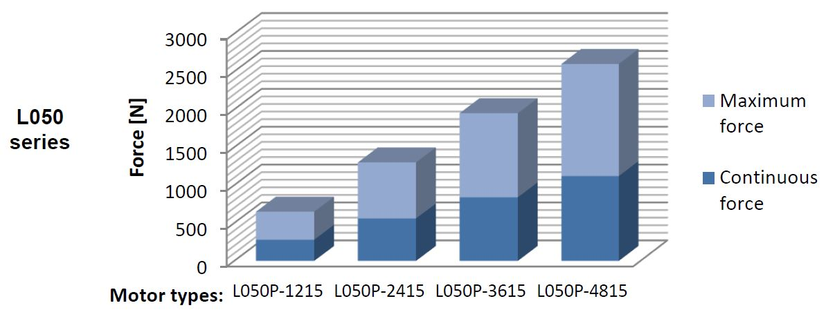l050_perf.jpg
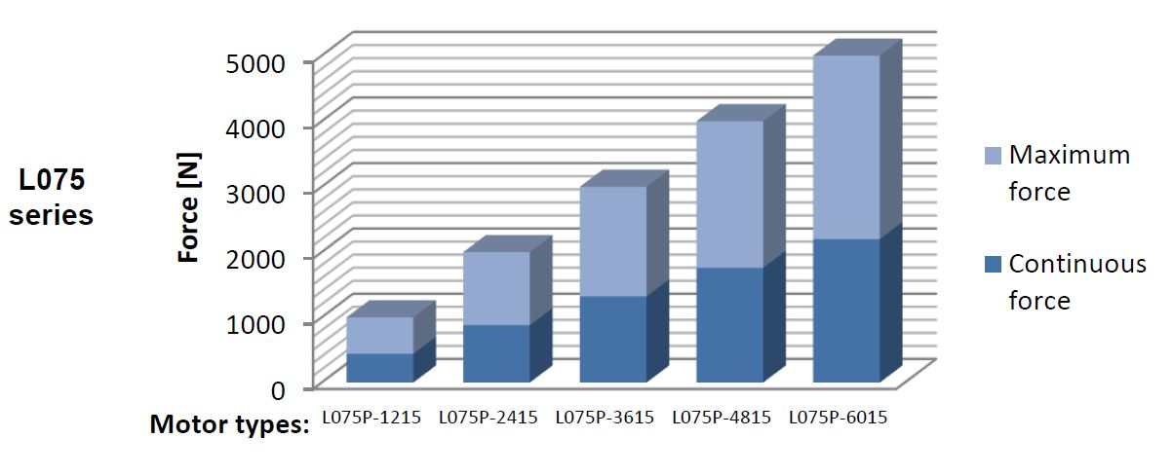l075_perf.jpg
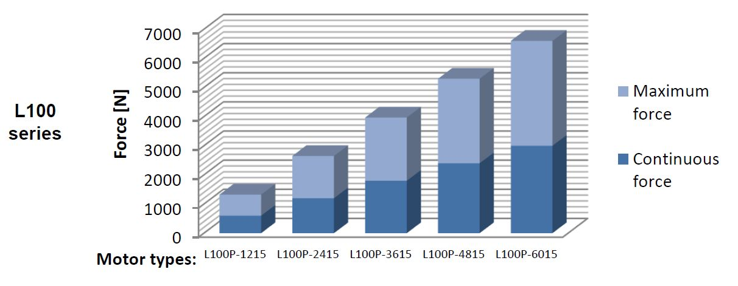l100_perf.jpg
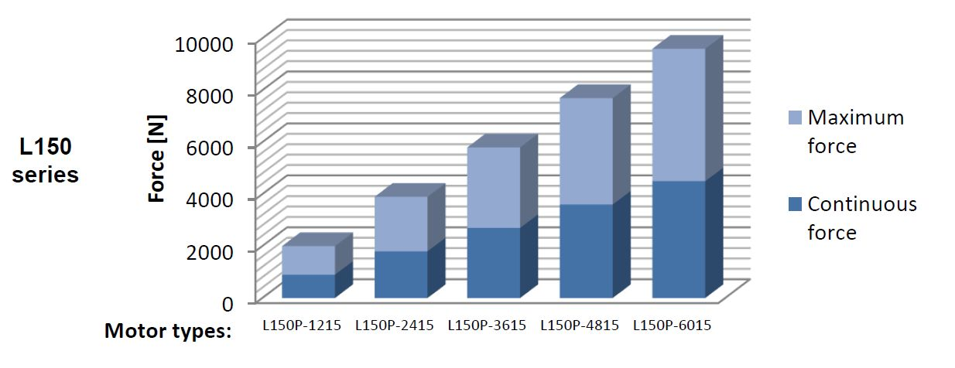l150_perf.jpg
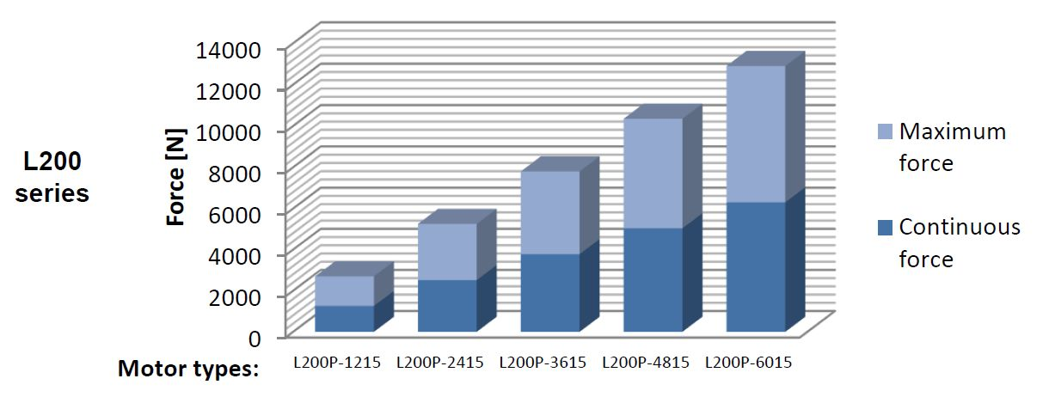l200_perf.jpg


