Accessories - Mounting set

Clips
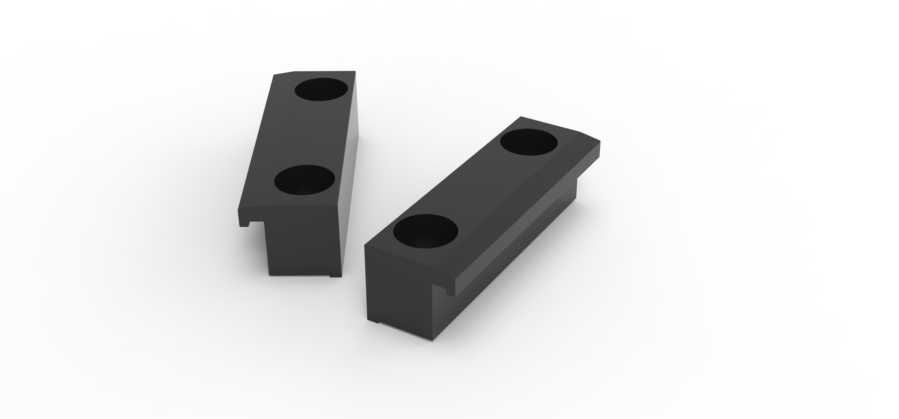untitled.169.jpg

Pneumatic brake
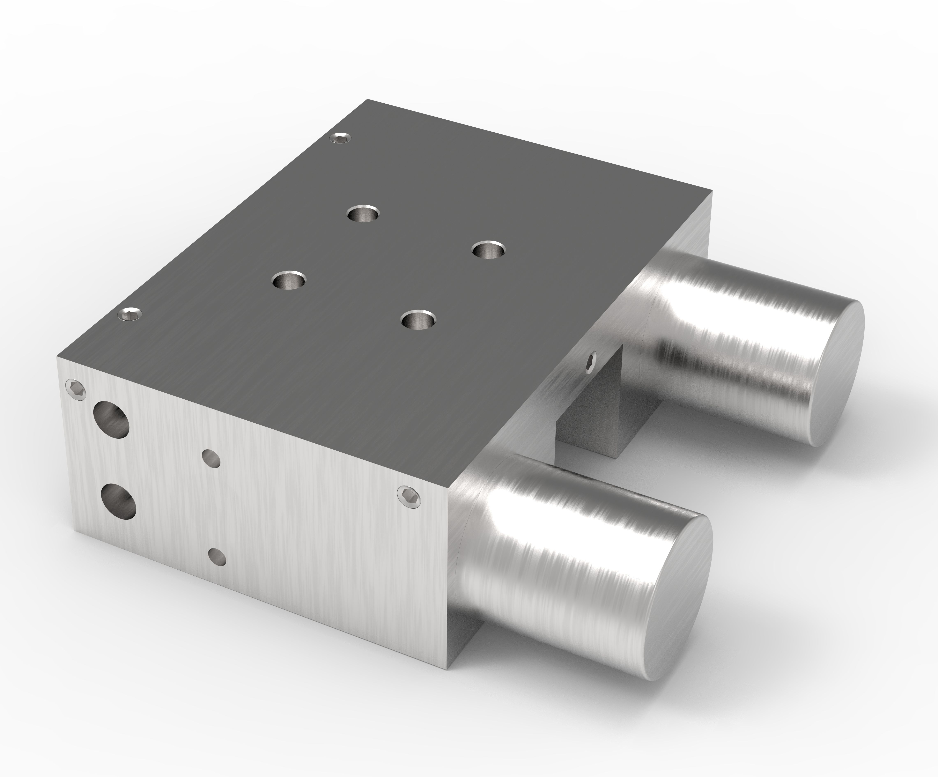brake.jpg

Flanges


