Mounting examples

2D Gantry
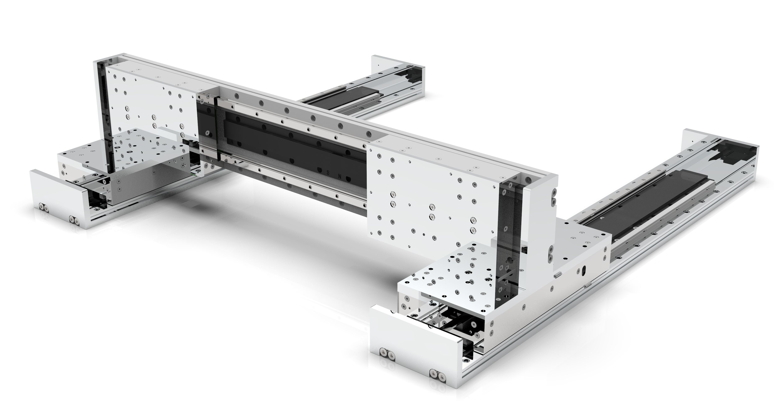a_mount.jpg

Dual Carriage
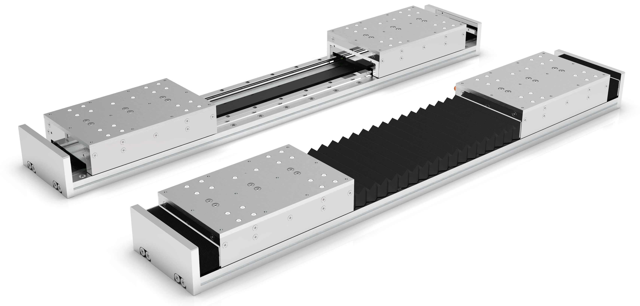b_mount.jpg

Cantilevel
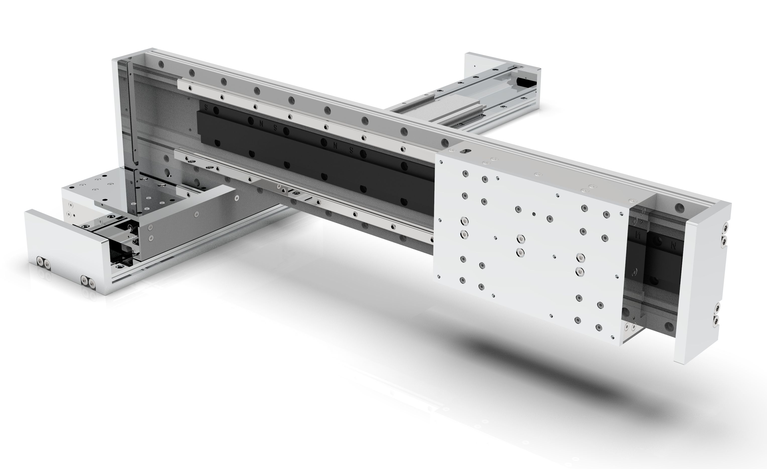c_mount.jpg

Crossed Axes
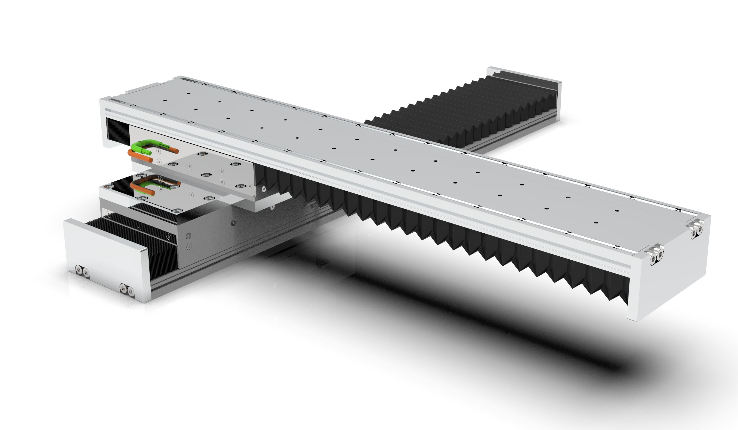d_mount.jpg

3 x Crossed axes
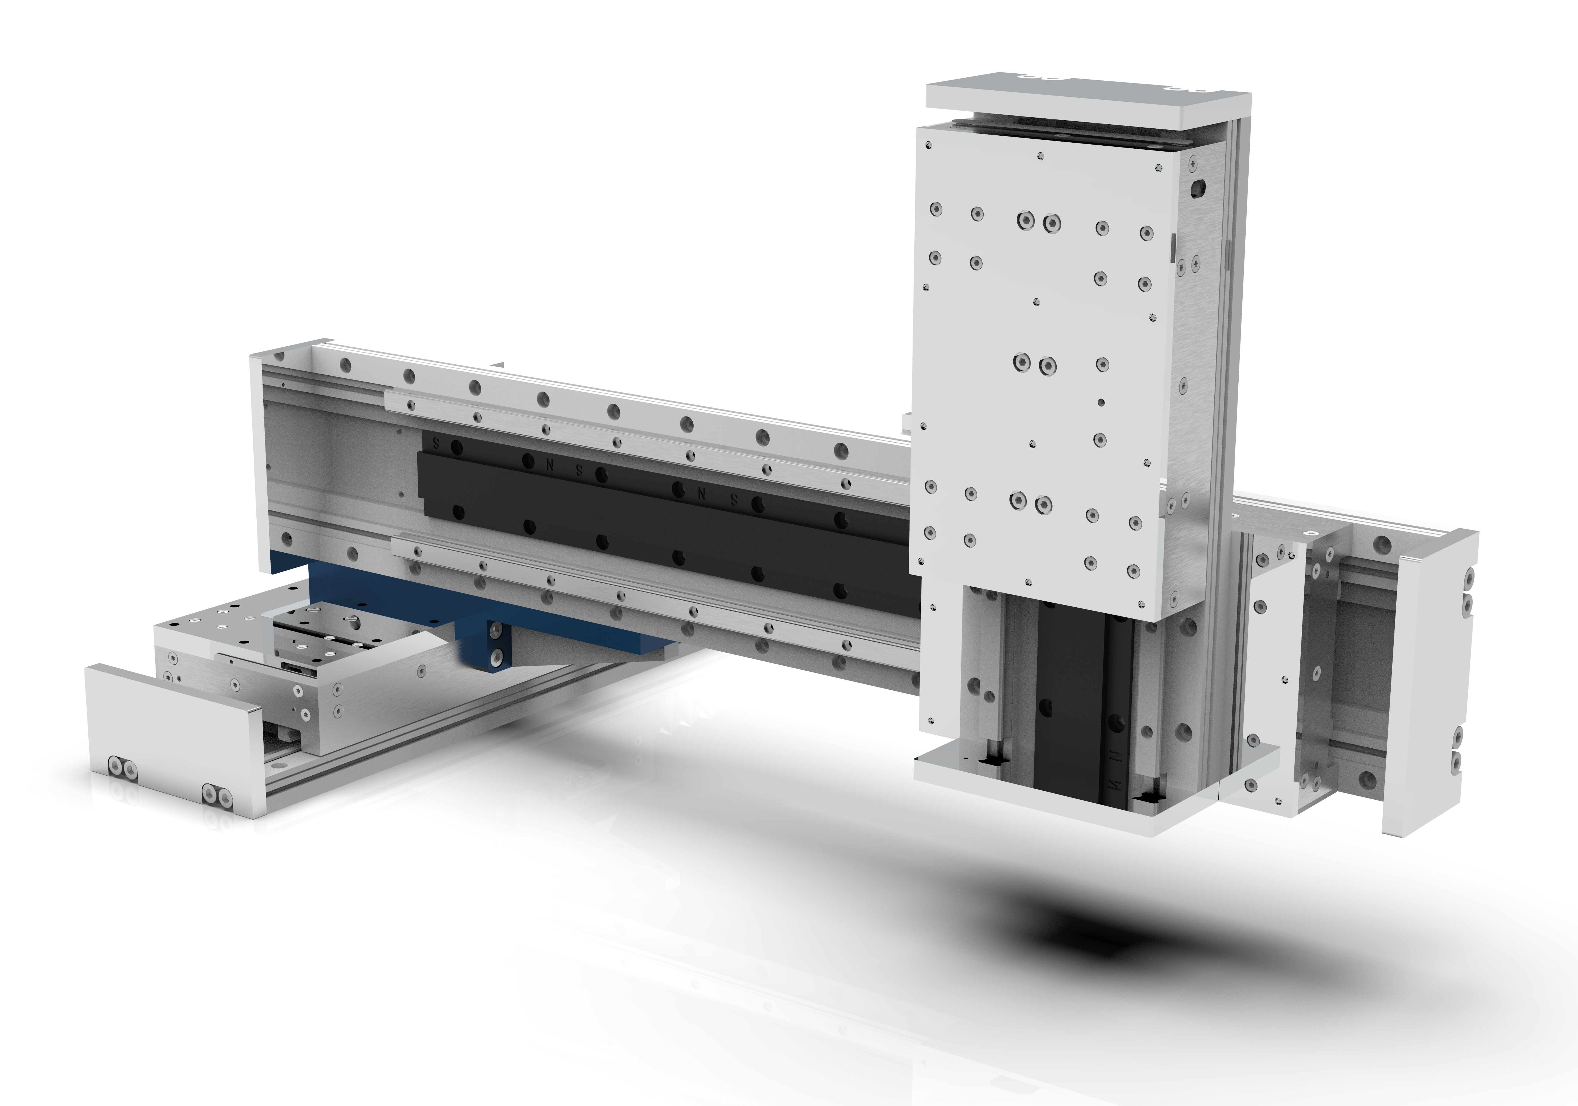e_mount.jpg

Side crossed axes


