LM Linear Stage
The linear axes LM are a complete solution for the linear motion based on an aluminum profile, linear guides, ironcore linear motors L-series, encoder, M23 / M17 connectors and cable chain (on request).
The LM axes are high-performance linear stages LM 030 / 050 / 075 with peak forces up to 3000 N and nominal forces up to 1320 N. The length of the axes is up to 8500 mm.
For the integrated encoder different options are available: SIN/COS 1Vpp, Digital ABZ, Absolute Hiperface, Absolute SSI, Absolute driveCliq.
For the linear guiding system high-performance, ball recirculating linear guides WON are used. Thanks to their integrated lubrication tank LF they are free of maintenance. Variants with protection bellows PEI for high-speed applications are also available. Flying connectors are used, otherwise the connectors are mounted on the carriage.
The axes are available with power and signal cables ready to be used with the servo drives from: Siemens, B&R, Rockwell, Bosch, Schneider Electric,
Panasonic, Omron, Emerson or Beckhoff.
NiLAB is able to deliver the servo-drive with one of the following fieldbuses: EtherCAT, ProfiNET or CanOPEN with UL certified linear motors for the USA market.
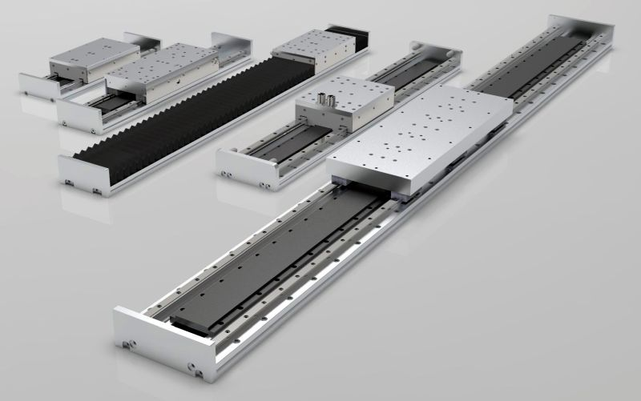lm.jpg

