Connectors Pinout

Connector type

Speedtec 2 x M23 (power) and M17 (signal encoder)
PIN | FUNCTION | CONNECTOR VIEW FRONT | PIN | FUNCTION
12 | SIN | 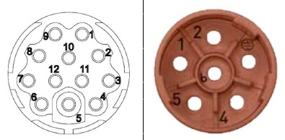m23_m17_connector.jpg | 1 | U
11 | REFSIN |  | 2 | V
10 | COS |  | Earth | PE
9 | REFCOS |  | 4 | TSW or PTC+
8 | - |  | 5 | TSW or PTC-
7 | - |  | 6 | W
6 | +7..12VDC
5 | GND
4 | DATA+
3 | DATA-
2 | -
1 | SHIELD

Signal type
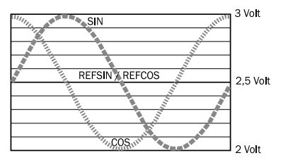sin_sign.jpg
Oscilloscope acquisition of SIN and COS signals (REFCOS and REFSIN are 2.5V constant voltage).
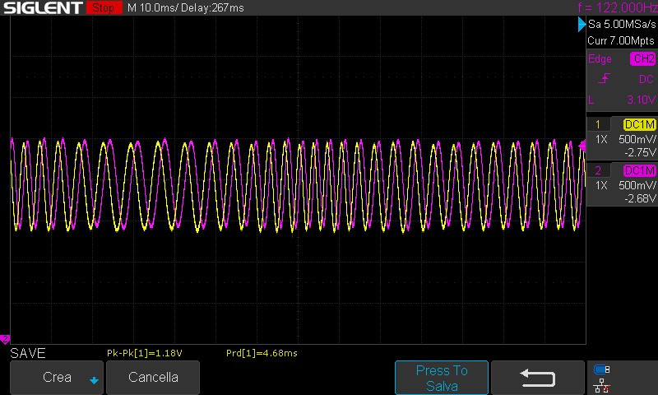sds00002.jpg | 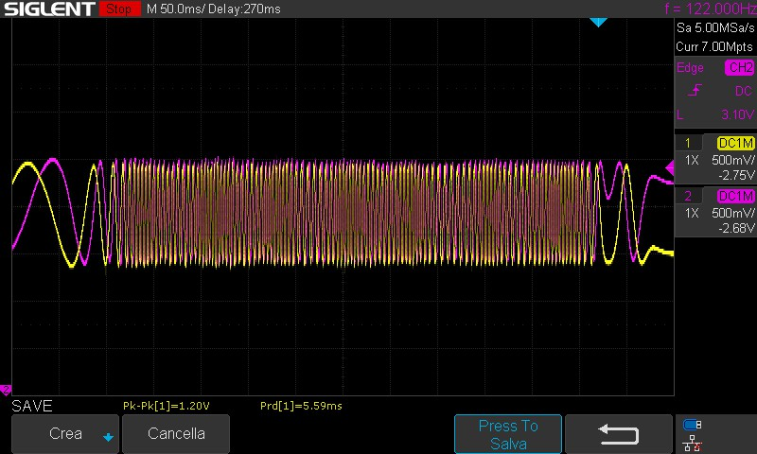sds00001.jpg
Signal | Value
Peak value | 0,9 V … 1,1 V
Signaloffset REFSIN, REFCOS | 2,2 V … 2,8 V

PTC Thermal sensor
LMA actuator integrates Thermal switch (normally closed, open at maximum winding temperature) or PTC600 thermal sensor. This thermal sensor is composed by 3 x PTC series connected mounted in each primary part of the integrated linear motor. In order to map the PTC curve inside the drive please use DN44082 thermistor type curve, with 1800 Ohm of thermistor reset threshold and 3300 ohm of thermistor trip threshold.

