LMA Linear actuator
The LMA linear actuator is a complete linear unit composed by L series linear motors mounted as a sandwich arrangement.
This arrangement guarantees the minimum magnetic preload on the linear guide and optimizes the force/stroke ratio.
The moving magnet part uses two magnet tracks guided with recirculating balls linear guide where the payload will be connected.
The LMA actuators can generate forces of 12000 N rated and 25200 N peak without water cooling or 19200 N rated force using water cooling.
The LMA actuators are available with integrated SIN/COS 1Vpp relative or absolute Hiperface magnetic encoder and they are suggested for realizing material testing machines: dynamic and static test.
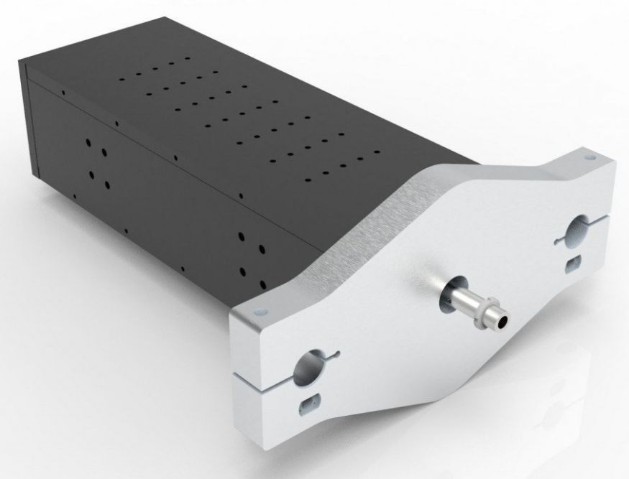lma_photo_.jpg
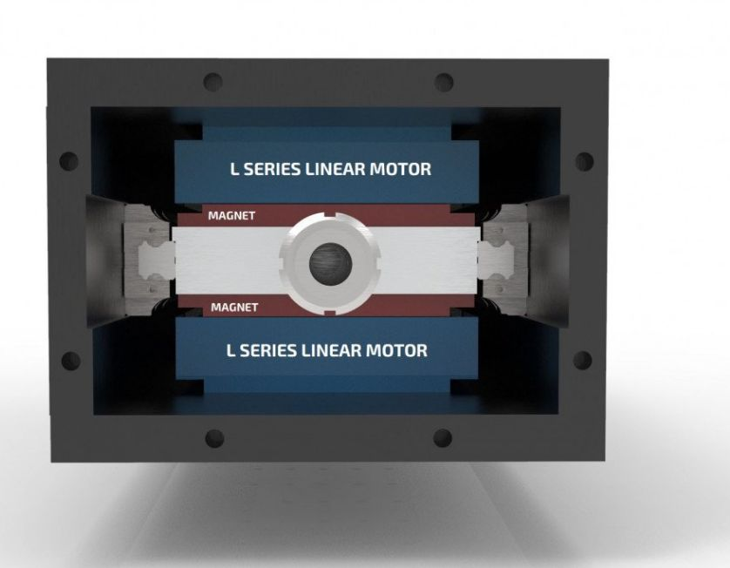lma_photo_2.jpg

