Maglift - Vertical counterbalance
In vertical applications, when the linear motor is not powered, the linear axis can fall down due to gravity. Using Maglift, the gravitational force is counterbalanced, and the linear motor remains in steady state.
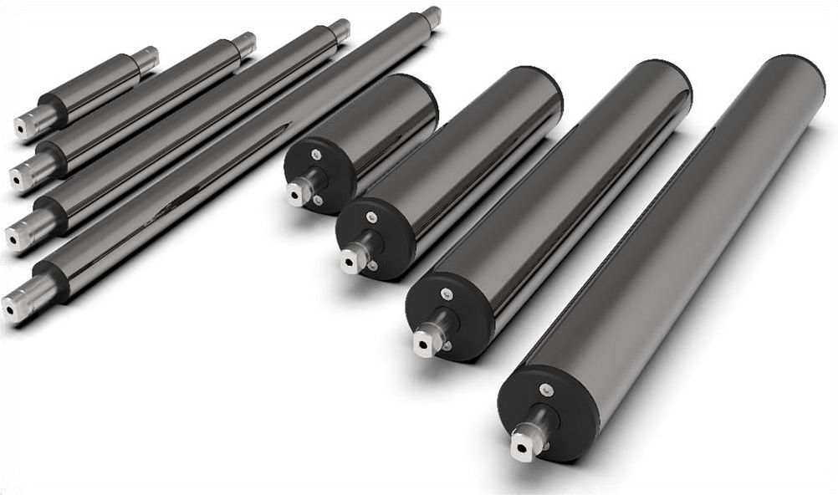maglift.jpg

Characteristics
• Constant force on the stroke
• Stroke up to 290 mm
• Forces: +/- 10% tolerance
• No electronic control needed, no compressed air
• Especially design for compensating gravitational force in vertical applications
• For high dynamic movements
• Push or pull movement possible (symmetrical operation)
• Set of accessories for fixing in combination of NiLAB Linear motors

