OPMODE “Analog Speed”: software setting
Using TKSED Software (link: https://www.nilab.at/download/tksed-software-pc-tool/?wpdmdl=2126&refresh=637351b08fa4b1668501936), set the OPMODE selector into position “3”: Analog Speed
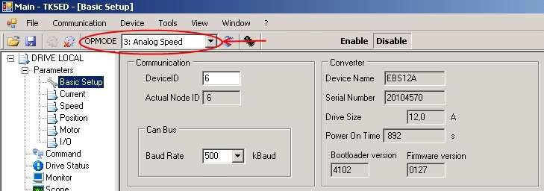ana_1.jpg
In this mode, the acceleration ramp (Acc Ramp and Dec.Ramp) is enabled. If you drive the device by a NC, you have to disable the ramps by setting the “Acc Ramp ”(default 500ms) and Dec. Ramp” (default 500ms) parameters to 0.
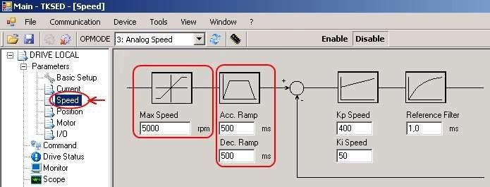ana_2.jpg
N.B.: at the end of the parameters setting procedure, press the icon Save parameters in drive memory to make the changes permanent.
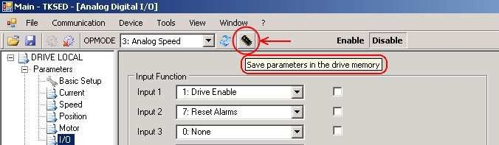ana_3.jpg

Input and Output window settings
In this window there are the settings for the programmable digital inputs and analog input 1.
Digital inputs setting:
Example:
Setting Input 1 in position 1: Enable Drive and providing 24V on digital input 1 the servo amplifier is enabled.
Setting Input 2 in position 7: Reset Alarms and providing 24V digital input 2; any servo amplifier alarm is reseted.
Setting the analog input 1 scaling.
Example:
Setting Analog In1 Scale = 9000mV and supplying the analog input with a voltage of 9V, motor will rotate at a speed equal that is seted in “Max Speed” parameter on Speed Window, in our example, the motor will rotate at 5000rpm. By providing -9V, the motor will rotate at-5000rpm. The values range allowed by the analog input is ± 10V.
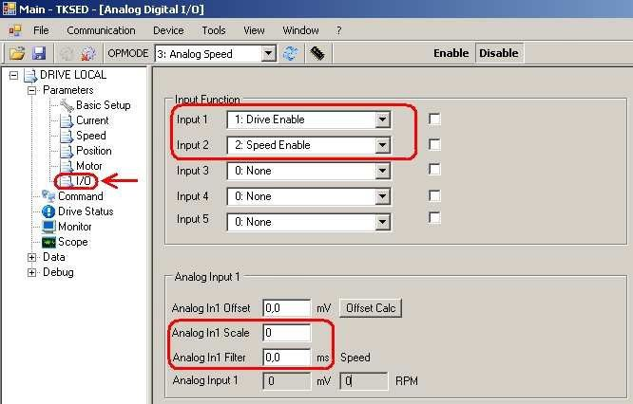ana_4.jpg

Automatic calculation of the Analog Input Offset
Provide a 0V analog reference from a NC. Press 'Calc Offset'; after 1.5 s the analog input offset will be captured and displayed, in mV, in the Analog In1 Offset box.
Is it possible to perform a fine tuning of the offset with a manual editing of the 'Analog In1 Offset' parameter.
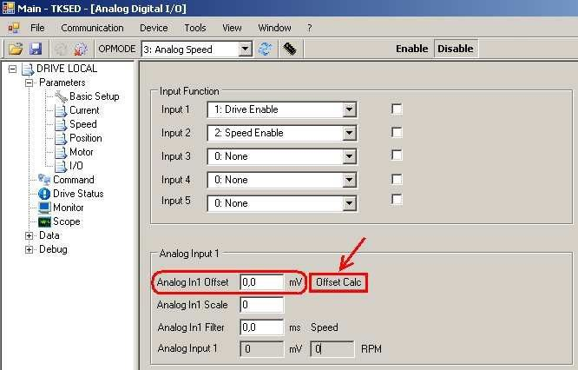ana_5.jpg
N.B.: at the end of the parameters setting procedure, press the icon Save parameters in drive memory to make the changes permanent.

