CanOPEN PDO Example
The mode of operation is mapped at index 0x6060 subindex 0 with size of 1 byte. For example: Profile position is 1, Profile velocity is 3, Torque profile is 4, Interpolated position is 7.
The communication is with DS402 Profile on CiA 301 (CAN in Automation). Reference: https://en.wikipedia.org/wiki/CANopen
PDOs must be transmitted and received at every Sync, COB ID = 0x80. Master can access the parameter inside the slave using SDO read and write.
See here: https://www.nilab.at/dokuwiki/doku.php?id=mbd_servo_drive:registers|

How to program using SDO write - Position control - Interpolated position

Configuration of PDO from Slave to Master
COB ID | D0 | D1 | D2 | D3 | D4 | D5 | D6 | D7 | Comment
0x600+(nodeid) | 0x23 | 0x00 | 0x1A | 0x01 | 0x20 | 0x00 | 0x64 | 0x60 | Position actual value
0x600+(nodeid) | 0x23 | 0x00 | 0x1A | 0x02 | 0x10 | 0x00 | 0x41 | 0x60 | Status word
0x600+(nodeid) | 0x23 | 0x00 | 0x1A | 0x03 | 0x08 | 0x00 | 0x61 | 0x60 | Mode of operation display

Configuration of PDO from Master to Slave
COB ID | D0 | D1 | D2 | D3 | D4 | D5 | D6 | D7 | Comment
0x600+(nodeid) | 0x23 | 0x00 | 0x16 | 0x01 | 0x20 | 0x00 | 0xC1 | 0x60 | Interpolated data record
0x600+(nodeid) | 0x23 | 0x00 | 0x16 | 0x02 | 0x10 | 0x00 | 0x40 | 0x60 | Control word
0x600+(nodeid) | 0x23 | 0x00 | 0x16 | 0x03 | 0x08 | 0x00 | 0x60 | 0x60 | Mode of operation

How to program using SDO write - Torque control

Configuration of PDO from Slave to Master
COB ID | D0 | D1 | D2 | D3 | D4 | D5 | D6 | D7 | Comment
0x600+(nodeid) | 0x23 | 0x00 | 0x1A | 0x01 | 0x10 | 0x00 | 0x77 | 0x60 | Torque actual value
0x600+(nodeid) | 0x23 | 0x00 | 0x1A | 0x02 | 0x10 | 0x00 | 0x41 | 0x60 | Status word
0x600+(nodeid) | 0x23 | 0x00 | 0x1A | 0x03 | 0x08 | 0x00 | 0x61 | 0x60 | Mode of operation display

Configuration of PDO from Master to Slave
COB ID | D0 | D1 | D2 | D3 | D4 | D5 | D6 | D7 | Comment
0x600+(nodeid) | 0x23 | 0x00 | 0x16 | 0x01 | 0x10 | 0x00 | 0x71 | 0x60 | Target Torque
0x600+(nodeid) | 0x23 | 0x00 | 0x16 | 0x02 | 0x10 | 0x00 | 0x40 | 0x60 | Control word
0x600+(nodeid) | 0x23 | 0x00 | 0x16 | 0x03 | 0x08 | 0x00 | 0x60 | 0x60 | Mode of operation
Additional parameter are 0x6087 ⇒ Torque Slope and 0x6088 ⇒ Torque profile type (0 = Linear ramp)

STATUS WORD Register
BIT Number | Description | Mode of operation
11
12 |  | Interpolated positioning
12 |  | Profile velocity
13 |  | Profile velocity
12 |  | Homing
13 |  | Homing
12 |  | Profile positioning
13 |  | Profile positioning

CONTROL WORD Register
BIT Number | Description | Mode of operation
1
2
3
4 |  | Homing
4 |  | Interpolated positiong
4 |  | Profile positioning
5 |  | Profile positioning
6 |  | Profile positioning
7
8

DS402 State Machine
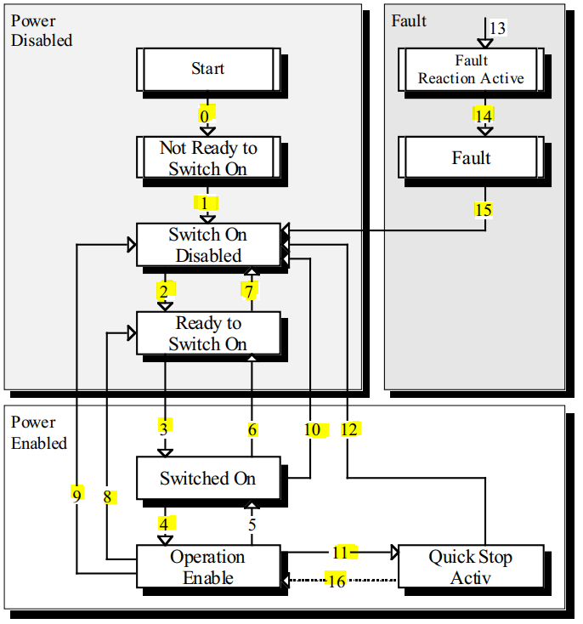

Enabling the drive
SERVO-ON: is procedure that Master should read Statusword from driver and send corresponded Controlword (command) to driver to make it change to final state, Operation Enable. The common SERVO-ON path in CiA 402 state machine is: (1) → (2) → (3) → (4) or (13) → (14) → (15) → (2) → (3) → (4)

Disabling the drive
SERVO-OFF: is procedure to switch off servo drive, that is moving its state to 'Switch On Disabled' state. The shorted path is transition (9) in which Master send Controlword of 0 to an operating driver.

EDS (CanOPEN) and XML (ETHERCAT) files
EDS File: https://www.nilab.at/download/mbd-tbs1-eds-file/?wpdmdl=2134&refresh=637351b05ed9d1668501936
XML File: https://www.nilab.at/download/mbd-tbs1-ethercat-eds-file/?wpdmdl=3335&refresh=637351b0868111668501936

