Connectors

Connectors for up to 12/24A size.
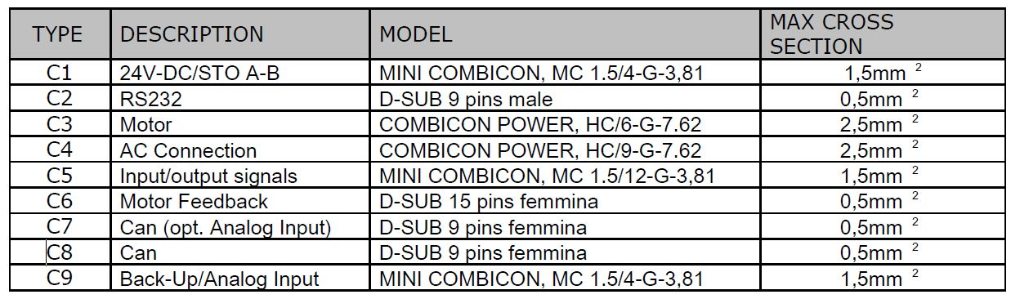conn_1.jpg

Connectors for 30/60A and 42/84A sizes
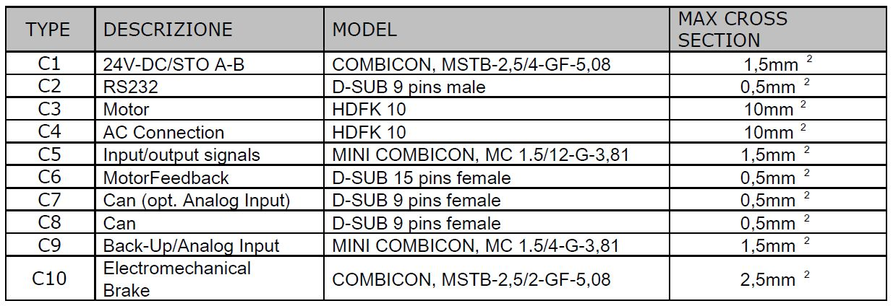conn_2.jpg

