MODBUS RTU
MBD servo drive implements Modbus RTU protocol on a RS232 serial point to point communication interface.

Available functions
Function name | Function code
Read Holding Register | 0x03
Write Single Register | 0x06
Write Multiple Registers | 0x10

Modbus register areas
Parameter type | MODBUS address
Servo parameter | 0x00 to 0x3FF
Input variables | 0x1000 to 0x103F
Output variables | 0x1200 to 0x123F

Basic command
Enabling, disable and set the speed
Command | Address | Data Write | Unit | NOTE
Opmode | 0x0010 | 2 | - | 2 = digital speed
Enabling | 0x1000 | bit 0 = 1 | -
Disabling | 0x1000 | bit 0 = 0 | -
Speed setpoint | 0x1026 | xxxx | RPM
Reading the status and the current
Command | Address | Data Write | Unit | NOTE
Enabling OK | 0x1200 | Bit 0 = 1 | - | if enabled bit 0 is set to 1 otherwise is set to 0
Read speed | 0x1218 | xxxx | -
Read Q current | 0x1210 | xxxx | Amper x 10

Input Variable table
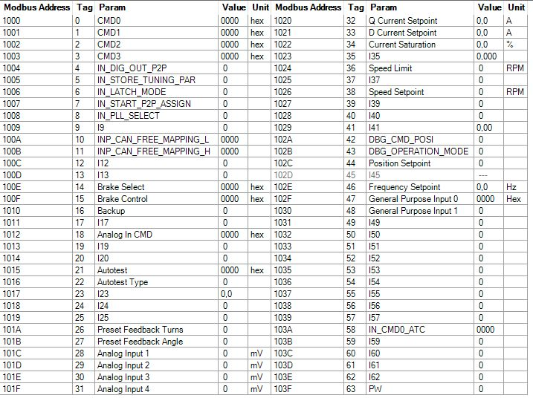input_param.jpg

Output Variable Table
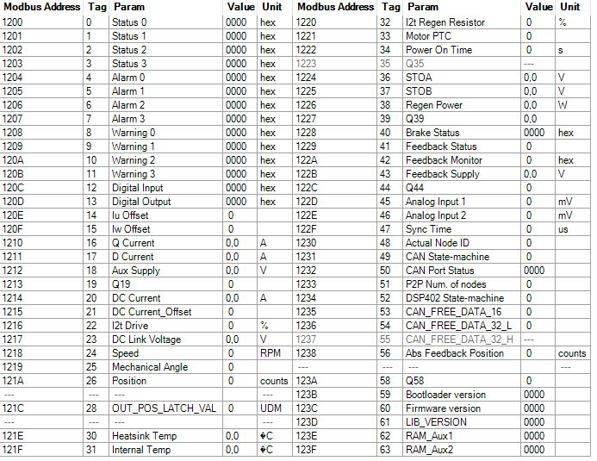var_out.jpg

