Technical characteristics
The servo amplifier MBD has been designed to drive brushless sinusoidal servomotors. The DSP digital architecture allows to handle a fieldbus and to control the motor in its main variables: power, speed, position. The device can also be driven by a differential analog input.

Servo amplifier MBD

The hardware interface, in the standard version, includes the following devices:
• 5 opto-isolated digital inputs.
• 2 inputs for disabling security STO A, STO B (under approval)
• 3 opto-isolated digital outputs.
• 1 Drive OK relay
• CANopen interfacing
• RS232 interface, protocol Modbus RTU, gateway RS232/CAN (including
in the CANopen)
• Motor feedback input
• Electromechanical motor brake control
• Management of braking circuit with internal or external braking
resistor.
The device is supplied of two slots for expansion cards.

Power supply
The MBD Servo amplifier must be powered by: a 24V auxiliary voltage for operation of control circuits, of electromechanical brakes and of ventilation (if present) and by 3-phase grounded current at 230/400 VAC, 50/60 Hz
All shielding connections are made directly to the amplifier. Output Stage: IGBT module with insulated current measurement on the motor
phases. Protection against overcurrent.

Operation and parameter setting
TKSED software allows you to communicate with the amplifier through ModBus RTU RS-232. Through the interface you can configure the product completely, save and load a configuration of parameters and update the firmware of the amplifier.
TKSED Software donwload: https://www.nilab.at/download/tksed-software-pc-tool/?wpdmdl=2126&refresh=637351b08fa4b1668501936

Control
The control is full-digital, internally the three control loops (power, speed and position) can be managed.The insertion of one or more control loops is determined by the used operating mode.

Technical data
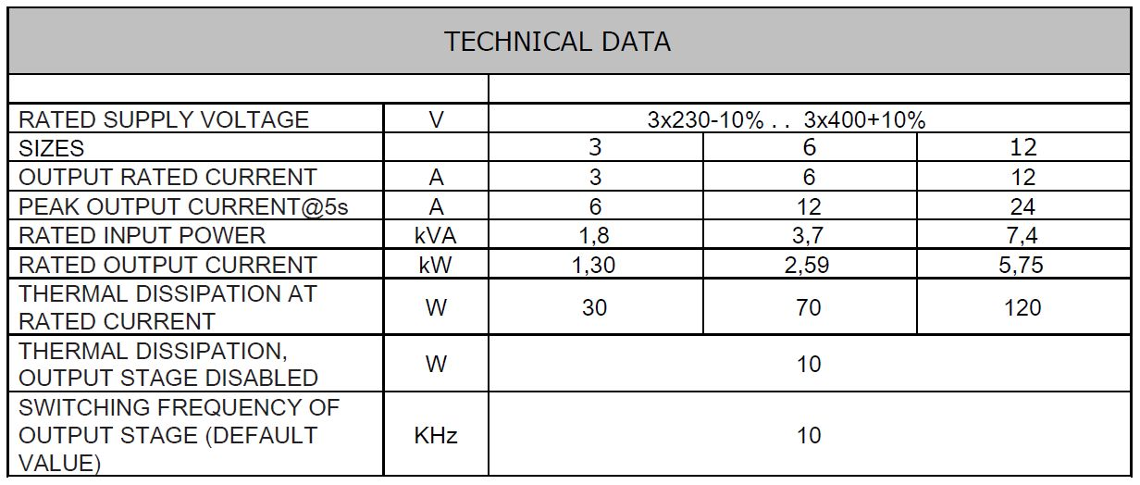tech_data_1.jpg
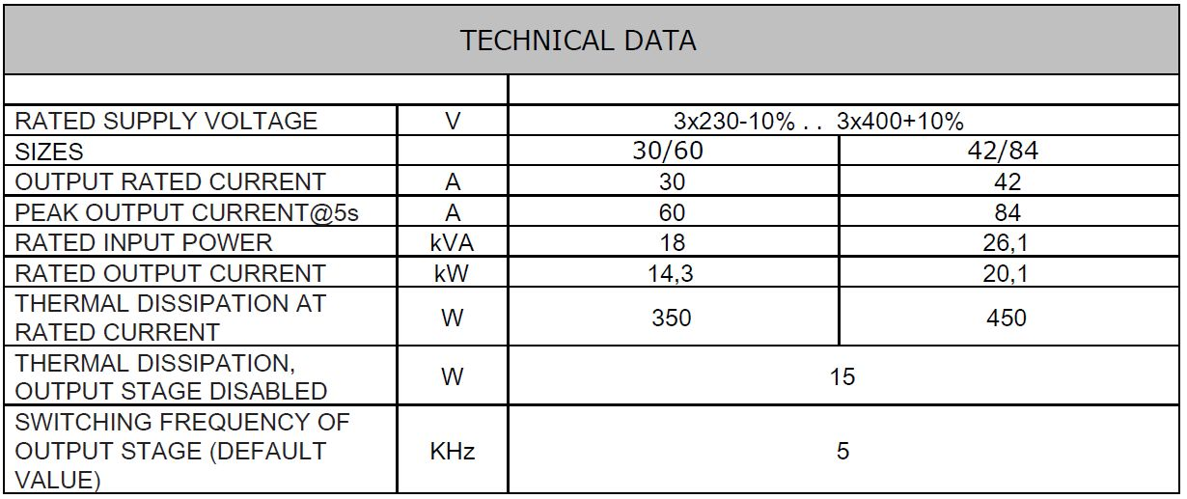tec_data_2.jpg

Environmental data
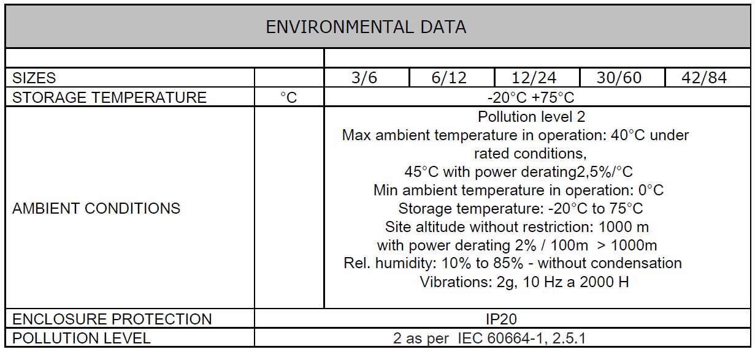tec_data_3.jpg

Brake Circuit
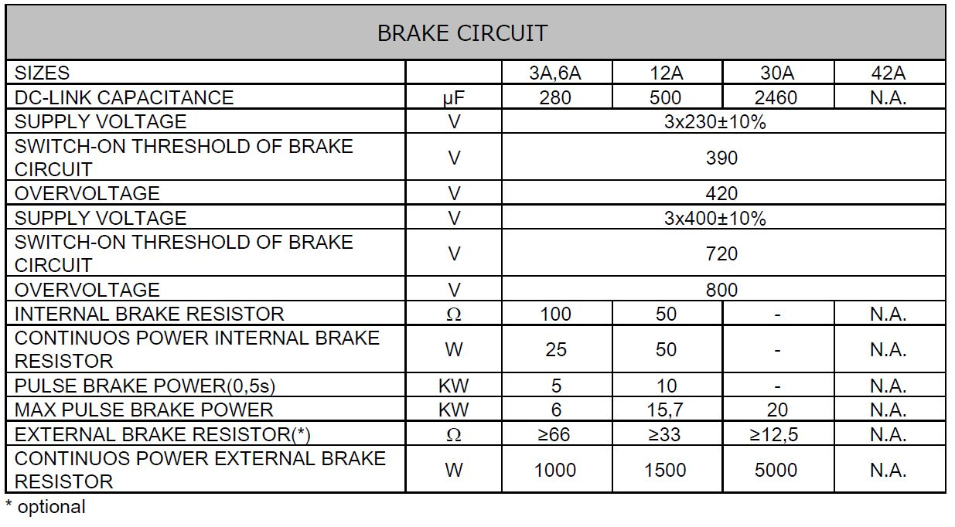tec_data_4.jpg

Fusing


