MBM Connectors on motor side

M17 type connectors
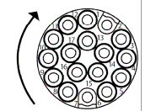m17_1.jpg | 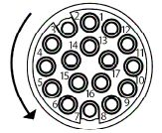m17_2.jpg | 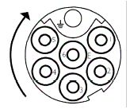m17_3.jpg | 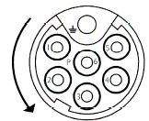m17_4.jpg
Fixed side  Feeedback E - external view | Flying side  Feedback P - external view | Fixed side  Motor phases - external view | Flying side  Motor phases - external view
 | ASTA 876 - 09010002 |  | BSTA 861 - 09020002

M23 type connectors
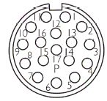m23_1.jpg | 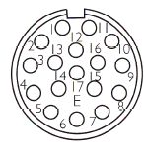m23_2.jpg | 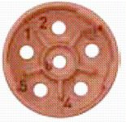m23_3.jpg | 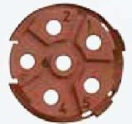m23_4.jpg
Fixed side  Feeedback E - external view | Flying side  Feedback P - external view | Fixed side  Motor phases - external view | Flying side  Motor phases - external view
 | ASTA 014 - 09010005 |  | BSTA 085 - 09020004

M40 type connectors (Power only)
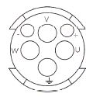m40_1.jpg | 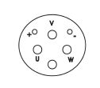m40_2.jpg
Fixed side  Motor phases - external view | Flying side  Motor phases - external view
 | CSTA 263 FR5244 - 09020005

